Dissolution Profile Analysis and Quality Assessment of Ibuprofen Tablets Using UV Spectroscopy

**Anandaraj Pennamuthiriyan1* Ajithkumar Murugan2, and Seeralan Nagarajan3**

*1K. Ramakrishnan College of Engineering, Department of Chemistry, Samayapuram, Tiruchirappalli – 621 112, Tamilnadu, India.* ***E-mail****:* [*anandarajp1596@gmail.com*](mailto:anandarajp1596@gmail.com)

*2Loyola Institute of Technology, Department of Chemistry, Chennai – 600 123, Tamilnadu, India.*

*3* *Bharathidasan University, School of Chemistry, Tiruchirappalli – 620 024, Tamilnadu, India.*

ABSTRACT

Ibuprofen is commonly used to alleviate pain associated with conditions such as dental pain, menstrual cramps, muscle aches, and arthritis. It is also effective in reducing fever and relieving minor aches and pains from colds or the flu. As a non-steroidal anti-inflammatory drug (NSAID), ibuprofen works by inhibiting the production of prostaglandins. Ibuprofen is available under various brand names, including Advil, Motrin, and its generic form. In this study, the focus is on analyzing the quantity and quality of ibuprofen's dissolution over time, confirmed through UV spectroscopy. The analysis includes solubility studies, loss on drying (LOD), and drug release time. For the solubility study, a dissolution apparatus was employed. To determine the moisture content in the tablet, a loss on drying (LOD) experiment was conducted. The concentration of the drug released at different time intervals was calculated from the optical density values. The drug release profile was monitored using UV spectroscopy.

**Keywords**: *Ibuprofen, Dissolution, Ultraviolet spectra, Time intervals.*

### INTRODUCTION

Ibuprofen is a widely utilized medication renowned for its role in managing pain, inflammation, and fever. As a member of the non-steroidal anti-inflammatory drug (NSAID) class, it alleviates discomfort associated with conditions such as muscle pain, dental pain, joint pain, and inflammation. Its effectiveness stems from its ability to inhibit the enzymes responsible for prostaglandin production, the chemical compounds that trigger pain, inflammation, and fever. This makes ibuprofen an essential component in both over-the-counter (OTC) and prescription-based therapeutic regimens. Its high prevalence in pharmaceutical formulations found in over 70% of drug products is attributed to its versatile pharmacological properties, including anti-inflammatory, analgesic, and antipyretic effects. Ibuprofen is available in various dosage forms, such as tablets, capsules, chewable tablets, suspensions, and liquid-filled preparations, catering to diverse patient needs. As an OTC drug, it offers convenient access for managing common ailments like headaches, muscle aches, menstrual cramps, toothaches, and cold-related discomforts, further emphasizing its significance in self-care (1-2).

To ensure optimal therapeutic outcomes, it is vital to continually explore and refine ibuprofen formulations. One critical aspect of this is dissolution testing, which evaluates how efficiently a drug is released from its dosage form and absorbed into the bloodstream. Dissolution directly affects bioavailability, the fraction of the drug that reaches systemic circulation to exert its therapeutic action. By optimizing dissolution, the efficacy and speed of drug absorption can be significantly enhanced, ensuring better patient outcomes (3).

Dissolution testing serves multiple roles in pharmaceutical development. It helps predict the drug’s behavior within the gastrointestinal tract, assesses consistency across production batches, and ensures regulatory compliance. Factors influencing dissolution include the drug’s physicochemical properties, formulation components like excipients, and physiological variables such as pH and enzyme activity within the gastrointestinal system.

A major hurdle in drug development is the poor solubility of many new molecular entities (NMEs), which can compromise their therapeutic potential. Nearly half of newly synthesized drugs face solubility challenges, impacting their bioavailability. To overcome this, pharmaceutical scientists employ various strategies to improve solubility and dissolution rates. Techniques such as particle size reduction, salt formation, crystal engineering, and the use of solid dispersions are commonly utilized. Additionally, surfactants and complexing agents can enhance solubility, ensuring that the drug dissolves more readily in bodily fluids (4).

This research focuses on the dissolution characteristics of ibuprofen, examining its solubility and drug release profile at different intervals. The study highlights the relationship between dissolution rates and bioavailability, providing insights into how these factors influence the drug’s overall therapeutic effectiveness. By optimizing these parameters, the efficacy of ibuprofen can be further enhanced, ultimately benefiting patients who rely on it for pain and inflammation management (5).



Figure 1. Various application of ibuprofen drug

**EXPERIMENTAL METHOD**

All the chemicals and solvents used were of Analytical Grade (AR), sourced from MERCK Ltd., ensuring high purity and accuracy for the experiments conducted. The Brufen 400mg tablets used for this analysis were purchased from Abbott India Limited, Himachal Pradesh, with Batch No. BFB7029, manufactured in October 2017. The Active Pharmaceutical Ingredient (API) for this research was provided by Dr. Reddy's Laboratories, Hyderabad, specifically for study purposes.

The quantitative analysis of the drug was performed using UV-Vis spectroscopy method. The UV instrument model used for the spectroscopic analysis was a model 3092, while the dissolution testing was conducted using the DISSO 8000 apparatus from Lab India, based in Bombay. The Brufen tablets were purchased from a local medical shop and compared against the API to evaluate the drug release and dissolution characteristics (6).

Ibuprofen is known for its partial solubility in water, which can affect its bioavailability and therapeutic effectiveness. To further characterize the chemical structure and properties of the ibuprofen samples, Fourier-Transform Infrared (FT-IR) spectroscopy was employed. The FT-IR spectra were recorded using a PerkinElmer 597 spectrophotometer, covering the range of 4000–400 cm⁻¹, to analyze the functional groups and molecular structure of the compound. As well, the melting point of ibuprofen was determined using a Boetius micro heating table apparatus. The melting points obtained were uncorrected and provided an insight into the physical properties of the drug. These characterization methods allowed for a thorough evaluation of the drug’s physicochemical properties, essential for understanding its dissolution behavior and overall performance in pharmaceutical applications.

**STOCK SOLUTION PREPARATION**

Accurately weigh 50 mg of Ibuprofen Active Pharmaceutical Ingredient (API) and transfer it into a 100 mL volumetric flask. Add 50 mL of ethanol to the flask, ensuring complete dissolution of the API. To facilitate the dissolution process, sonicate the mixture for 5 minutes. After sonication, allow the solution to cool to room temperature. Once cooled, dilute the solution to the 100 mL mark with additional ethanol to achieve the desired concentration. Finally, filter the solution through a 0.22 µm nylon filter to remove any particulate matter, ensuring a clear and refined sample for further analysis.

**STANDARD SOLUTION**

Pipette out the 10 mL of prepared stock solution into a 100 mL volumetric flask. Add dissolution medium (water) to the flask and dilute the solution to the 100 mL mark to achieve the desired concentration. Prepare two separate standard solutions by repeating the process to ensure accuracy and reliability of the results.

**Dissolution Apparatus and Methods: USP Apparatus 1 and 2**

Over the past few decades, two primary techniques have been established for in vitro dissolution testing: the stirred beaker method and the flow-through method. The stirred beaker method, adopted as the official dissolution method in the United States Pharmacopeia (USP) XVIII in 1970, includes the rotating basket (USP Apparatus 1) and rotating paddle (USP Apparatus 2). These methods involve placing the drug sample in a vessel containing a fixed volume of dissolution medium, with mechanical agitation provided by either a basket or paddle.

The rotating basket apparatus consists of a stainless steel shaft with a 40-mesh basket used to hold the sample, which is immersed in a 1000 mL vessel. The vessel typically contains 900 mL of dissolution medium, maintained at a controlled temperature. The basket rotates at speeds generally between 50 to 100 rpm, suitable for testing capsules. Speeds below 50 rpm may result in poor hydrodynamic conditions, while speeds above 150 rpm can cause turbulence, affecting test reliability.

The USP Apparatus 2 uses a paddle instead of a basket. Both apparatus share similar vessel specifications: a hemispherical glass or inert material vessel, usually 98–106 mm in diameter and 160–210 mm in height. Larger vessels, such as 2-liter and 4-liter versions, are available for testing poorly soluble drugs. Handling and maintenance of baskets are critical, as damage or wear can lead to inaccurate results. The USP basket design uses 0.010-inch wire for a 40-mesh grid, producing 0.381 mm apertures. Variations exist between pharmacopeias; for example, the Japanese Pharmacopeia specifies a 36-mesh basket with a slightly larger aperture, potentially causing significant differences in dissolution outcomes. Standardization across pharmacopeias is essential to ensure consistency and reliability in dissolution testing (7).

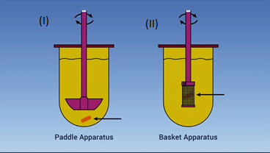

Figure 2. USP Apparatus

**DISSOLUTION METHOD**

|  |  |
| --- | --- |
| **Medium** | Water |
| **Volume** | 900 ml |
| **USP Apparatus 2** | Paddle |
| **Temperature** | 37°C |
| **RPM** | 75 |
| **Time intervals** | 5,10.15,20,30,45 and 60 minutes |

**CALCULATION**

$\frac{sample absorbance}{ standard absorbance} ×\frac{standard weight}{100}$ $×\frac{900}{400}$ $×\frac{10}{100}×\frac{99.3}{100}$ $×100$

For 30 mts 1st sample

=2.614/3.284*5100*10*100*900/100*99.3/100*100

=0.796*0.5*0.1*9*0.993*100

**=**92.0

Similarly, the time intervals of 5,10,15,20,30,45 and 60 minutes to calculates absorbance by using the above equation.

**Current Physical Parameters and Tolerances:**

|  |  |
| --- | --- |
| Wobble | ±1 mm basket lower rim |
| Dimensions | per USP |
| Height | 25 ± 2 m m |
| Centering | ±2 mm center line |
| Speed | ± 4% of set speed |
| Vessel Temp. | 37± 0.5 C |
| Timepoints | ±2% of speciﬁedtime |



**Figure 3**. Various dissolution vessels.

In addition to the current physical parameters, some pharmaceutical laboratories have adopted more stringent parameters gleaned from a PhRMA Subcommittee on Dissolution Calibration proposal to the USP (3) to maintain a higher degree of control over the rotating basket apparatus.

**Optional Parameters and Tolerances**:

|  |  |
| --- | --- |
| Shaft wobble | ≤ 0.5 mm total runout |
| Basket wobble | ≤ 1.0 mm total runout |
| Basket exam | No defects at time of use |
| Shaft verticality  Level | ≤ Vertical using bubble |
| Speed | ± 2% set speed |
| Vibration | ≤ 0.2-mil displacement |

The rotating basket apparatus is commonly used to test various pharmaceutical products, including capsules, tablets, floaters, modified-release formulations, beads, and suppositories. For suppository testing, a slotted Palmieri basket, optionally with glass beads, can be used. There are several variations of the standard 40-mesh basket, one of which includes a gold-coated basket with a 2.5-micron (0.0001-inch) thick gold layer. Additionally, larger vessels, such as those that hold up to two or four liters, are now accepted under the USP guidelines, providing a solution for the dissolution testing of poorly soluble drugs (8).

The standard basket, non-official variations are also available for specialized applications. These include baskets made of Teflon, baskets equipped with O-rings, and baskets with mesh sizes ranging from 10-mesh to 2300-mesh (5 microns). Other variations include three-fin baskets, mini baskets, and bolus baskets, which are often used for veterinary products. For testing low-dose, high-potency drugs, a small-volume apparatus may be required. This typically consists of a mini-basket design based on USP Apparatus 1, with 100- or 200-mL vessels, and a minimum operational volume of about 30 mL. These variations help accommodate different product types and dissolution requirements in pharmaceutical testing.

**QUALITY CONTROL ANALYSIS**

**DESCRIPTION**

The sample was taken in a clean a watch glass. The appearance and color of the sample was examined under sufficient light. The odour of the material was examined by smelling it. The observations were noted (9-10).

**SOLUBILITY**

|  |  |
| --- | --- |
| **Solvent** | **Solubility** |
| Ethanol | Highly soluble |
| Water | Insoluble |

**pH of 1% w/v aqueous solution**

A sample of 25 mg was dissolved in 100 ml of Milli-Q water. The pH of the solution was measured using pH meter. After analysis, the electrode was lifted, cleaned property and kept immersed in Milli-Q water.

**pH determination**

pH of the Ibuprofen was determined by the use of pH meter which is atomized and the pH was found to be 6.64

**LOSS ON DRYING (LOD)**

A clean, previously dried (for 30 minutes) and cooled LOD bottle was weighed accurately (w1). About 1g of the sample was mixed and weighed accurately with the LOD bottle (w2). The loaded bottle was placed in the drying chamber. The sample was dried at the temperature of 120­° C for 2 hours at a pressure of 5mm. After drying, the vacuum was released gradually and the chamber door was opened. Upon opening the door, the bottle was closed promptly. The LOD bottle was taken and kept inside the desiccator (11-13). It was allowed to attain the room temperature and weighed (w3).

Loss of weight (w2-w3)

Loss On Drying (% w/w) = ------------------------------- × 100

Weight of sample (w2-w1)

Where,

W1 = Empty weight of the LOD bottle

W2 = Weight of the LOD bottle and sample before drying

W3 = Weight of the LOD bottle and sample after drying.

**Calculation**

Loss on drying (LOD) :

Weight of LOD bottle with sample (w2) : 63.4316 g

Weight of empty LOD bottle (w1) : 62.4264 g

------------------

Weight of sample : 1.0052 g

**After drying:**

Weight of LOD bottle with sample after drying : 93.682 g

Weight of empty LOD bottle : 93.9663 g

--------------

Loss of weight : 0.0019 g

--------------

Loss of weight

Loss on drying = ------------------------- × 100

Weight of sample

0.0019

= ------------ x 100

1.0019

= 0.18 % (w/w)

**RESULTS AND DISCUSSION**

Based on the study of quality control of Ibuprofen by UV –Methods.

|  |  |
| --- | --- |
| Description | Pink color round shaped tablet convex on both side. |
| Solubility | Highly soluble in ethanol, insoluble in water |
| UV Absorption | 263nm and 213 nm |
| pH (1%w/v aqueous solution) | 6.64 |
| Loss on drying | 0.18%(w/w) |
| Drug release % | Within 45 minutes not more 85% Drug release |

### Ibuprofen dissolution with various time intervals

The dissolution study (14-17) of ibuprofen was conducted at different time intervals (5, 10, 15, 20, 30, 45, and 60 minutes) to evaluate the drug release profile from the tablet. The percentage of drug released at each time interval is summarized as follows:

The data and graph clearly indicates a progressive increase in the drug release over time, with the highest drug dissolution observed at the 60-minute mark, where nearly 94% of ibuprofen was released. This release pattern is typical of ibuprofen tablets, which generally show a rapid dissolution rate initially, followed by a slower release as time progresses.

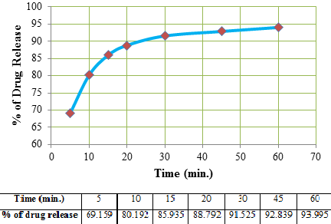

Figure 4. Ibuprofen dissolution with various time intervals

In the context of USP standards, it is essential for a drug to release at least 85% of its content within 45 minutes for it to be considered pharmacologically effective. As seen in the results, the ibuprofen tablet met this criterion with 92.84% of the drug released by the 45-minute mark, confirming that the tablet's dissolution profile complies with the established quality standards.

#### Spectroscopic information of Ibuprofen

#### IR spectroscopy

The FT-IR analysis (Fig. 5) of the ibuprofen sample revealed several key functional group absorptions, confirming its chemical structure. The peak at 1706.06 cm⁻¹ corresponds to the stretching of the carbonyl group (C=O) in the acid functional group, indicative of ibuprofen’s carboxylic acid moiety. Absorptions at 2924.47 cm⁻¹ and 2858.25 cm⁻¹ reflect the stretching vibrations of –CH groups, typical of aliphatic hydrocarbons. The band at 1504 cm⁻¹ is attributed to the deformation of the –CH2 group, while the peak at 1699 cm⁻¹ further supports the presence of the acid group. Additionally, the peaks at 1504.77 cm⁻¹ and 1122.26 cm⁻¹ correspond to the deformation of the –CH3 and –CH2 groups, and the absorption at 1319 cm⁻¹ is characteristic of the germinal-dimethyl group (-CH3). Lastly, the peaks at 2926.72 cm⁻¹ and 2860.72 cm⁻¹ confirm the presence of alkane groups and –CH stretching. Overall, the FT-IR spectrum of ibuprofen aligns with the expected functional groups, confirming the drug’s identity and structural integrity (18-19).

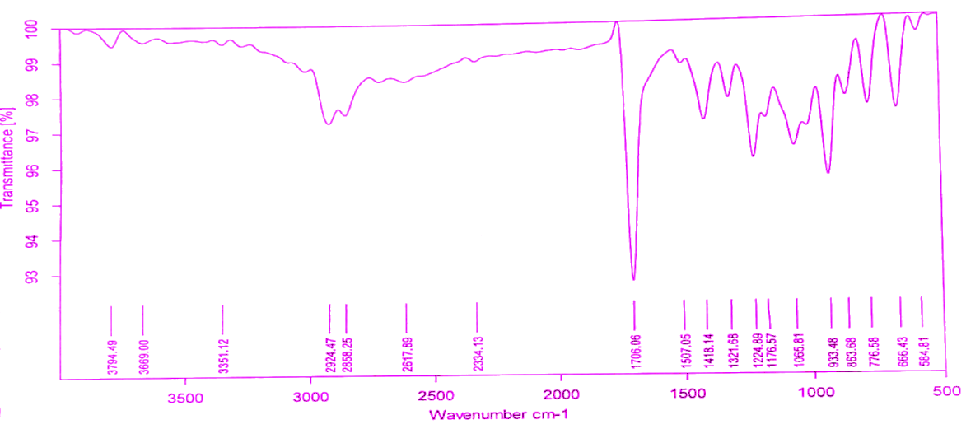

Figure 5. FT-IR analysis of the ibuprofen

**UV spectroscopy**

The UV spectroscopy analysis of the Homoanulardiene (Fig. 6) sample provided an observed absorbance value of 263 nm, which matches the calculated value of 263 nm, indicating the accuracy and consistency of the measurement. The base value for the sample was determined to be 253 nm, and considering the ring residue of two (2*5), which adds 10 nm to the base value, the calculated value is confirmed as 263 nm. This alignment between the calculated and observed values suggests that the sample exhibits the expected absorbance characteristics at 263 nm, which is consistent with the molecular structure and properties of Homoanulardiene. The results further validate the reliability of the UV spectroscopic method used for the analysis (20).

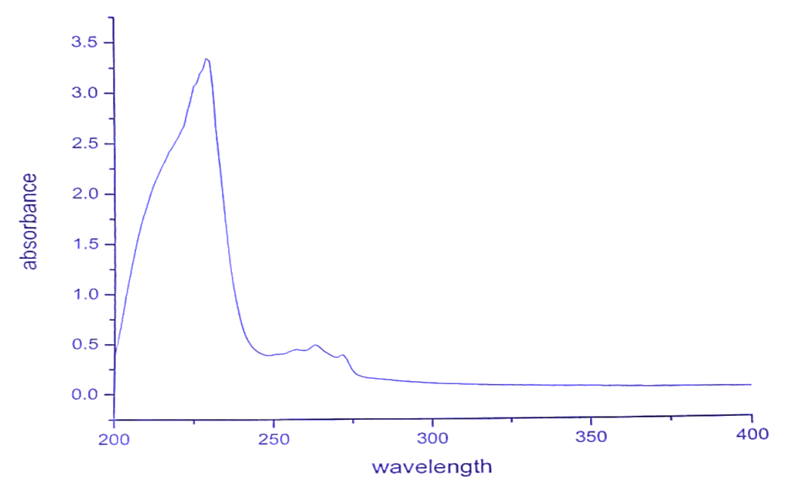

Figure 6. UV spectroscopy analysis of the ibuprofen

**Conclusion**

The study involved the analysis of an ibuprofen tablet obtained from a local medical store, manufactured by Abbott Pvt. Ltd. in Himachal Pradesh. The drug release was carefully monitored using ultraviolet (UV) spectroscopy, measuring absorbance at 213 nm across several time intervals: 5, 10, 15, 20, 30, 45, and 60 minutes. The dissolution data revealed that after 15 minutes, approximately 85.94% of the drug had been released, and by the 60th minute, 94% of the ibuprofen had dissolved. According to the standards set by the United States Pharmacopeia (USP), a drug release exceeding 85% within 45 minutes is deemed acceptable for therapeutic purposes. These results confirm that the ibuprofen tablet adheres to the required dissolution specifications and is suitable for medical use. Furthermore, the identity and purity of the ibuprofen were confirmed through both UV and infrared (IR) spectroscopy, more validating the tablet’s compliance with quality standards.

**ASSOCIATED CONTENT**

Complete details of materials, methods, and dissolution procedure and calculation have been provided in supporting information.

**AUTHOR INFORMATION**

**Corresponding Author**

**Anandaraj Pennamuthiriyan**, *aK. Ramakrishnan College of Engineering, Department of Chemistry, Tiruchirappalli – 621 112, Tamilnadu, India.* ***E-mail****:* [*anandarajp1596@gmail.com*](mailto:anandarajp1596@gmail.com)*.*

Notes

The authors declare no conflict of interests.

DATA AVAILABILITY STATEMENT

The data that supports the findings of this study are available in the supplementary material of this article.

**REFERENCES**

1. Schiermeier, S.; Schmidt, P. C. Fast dispersible ibuprofen tablets. *European journal of pharmaceutical sciences*, **2002**, *15*, 295-305. (b) Sádecká, J.; Čakrt, M.; Hercegová, A.; Polonský, J.; Skačáni, I. Determination of ibuprofen and naproxen in tablets. *Journal of pharmaceutical and biomedical analysis*, **2001**, *25*, 881-891. (c) Fini, A.; Bergamante, V.; Ceschel, G. C.; Ronchi, C.; de Moraes, C. A. F. Fast dispersible/slow releasing ibuprofen tablets. *European journal of pharmaceutics and biopharmaceutics*, **2008**, *69*, 335-341. (d) Hoang, V. D.; Ly, D. T. H.; Tho, N. H.; Minh Thi Nguyen, H. UV spectrophotometric simultaneous determination of paracetamol and ibuprofen in combined tablets by derivative and wavelet transforms. *The Scientific World Journal*, **2014**, *2014*, 313609. (e) Pozzi, Alessandro, and Luca Gallelli. "Pain management for dentists: the role of ibuprofen." *Annali di stomatologia* 2.3-4 Suppl (2011): 3.
2. (a) Rainsford, K. D. Ibuprofen: pharmacology, efficacy and safety. *Inflammopharmacology*, **2009**, *17*, 275-342. (b) Rainsford, K. D. (Ed.). **2015**, *Ibuprofen: discovery, development and therapeutics*. John Wiley & Sons. (c) Higton, F. The pharmaceutics of ibuprofen. *Ibuprofen: Discovery, development and therapeutics*, **2015**, 51-80.
3. Rainsford, K. D. **2013**, *Ibuprofen: pharmacology, therapeutics and side effects*. Springer Science & Business Media.
4. Upadhyay, A.; Amanullah, A.; Joshi, V.; Dhiman, R.; Prajapati, V. K.; Poluri, K. M.; Mishra, A. Ibuprofen-based advanced therapeutics: Breaking the inflammatory link in cancer, neurodegeneration, and diseases. *Drug metabolism reviews*, **2021**, *53*, 100-121.
5. Lamprecht, A., Saumet, J. L., Roux, J., & Benoit, J. P. Lipid nanocarriers as drug delivery system for ibuprofen in pain treatment. *International journal of pharmaceutics*, **2004**, *278*, 407-414.
6. (a) Chen, C. Y.; Chen, C. S. Stereoselective disposition of ibuprofen in patients with compromised renal haemodynamics. *British journal of clinical pharmacology*, **1995**, *40*, 67-72. (b) Klueglich, M.; Ring, A.; Scheuerer, S.; Trommeshauser, D.; Schuijt, C.; Liepold, B.; Berndl, G. Ibuprofen extrudate, a novel, rapidly dissolving ibuprofen formulation: relative bioavailability compared to ibuprofen lysinate and regular ibuprofen, and food effect on all formulations. *Journal of clinical pharmacology*, **2005**, *45*, 1055-1062.
7. Brocks, D. R.; Jamali, F. The pharmacokinetics of ibuprofen in humans and animals. In *Ibuprofen*, **1999**, 87-142, CRC Press.
8. Varrassi, G.; Pergolizzi, J. V.; Dowling, P.; Paladini, A. Ibuprofen safety at the golden anniversary: are all NSAIDs the same? A narrative review. *Advances in therapy*, **2020**, *37*, 61-82.
9. Seymour, R. A.; Ward-Booth, P.; Kelly, P. J. Evaluation of different doses of soluble ibuprofen and ibuprofen tablets in postoperative dental pain. *British Journal of Oral and Maxillofacial Surgery*, **1996**, *34*, 110-114.
10. KANTOR, T. G. Ibuprofen. *Annals of Internal Medicine*, **1979**, *91*, 877-882.
11. (a) Romero, A. J.; Grady, L. T.; Rhodes, C. T. Dissolution testing of ibuprofen tablets. *Drug Development and Industrial Pharmacy*, **1988**, *14*, 1549-1586. (b) Stead, J. A.; Freeman, M.; John, E. G.; Ward, G. T.; Whiting, B. Ibuprofen tablets: dissolution and bioavailability studies. *International Journal of Pharmaceutics*, **1983**, *14*, 59-72. (c) Schiermeier, S.; Schmidt, P. C. Fast dispersible ibuprofen tablets. *European journal of pharmaceutical sciences*, **2002**, *15*, 295-305.
12. Fini, A.; Bergamante, V.; Ceschel, G. C.; Ronchi, C.; de Moraes, C. A. F. Fast dispersible/slow releasing ibuprofen tablets. *European journal of pharmaceutics and biopharmaceutics*, **2008**, *69*, 335-341.
13. (a) Uddin, R.; Saffoon, N.; Sutradhar, K. B. Dissolution and dissolution apparatus: a review. *Int. J. Curr. Biomed. Pharm. Res*, **2011**, *1*, 201-207. (b) Salve, P. M.; Sonawane, S. V.; Patil, M. B.; Surawase, R. K. Dissolution and Dissolution Test Apparatus: A Review. **2021**.
14. Sirasitthichoke, C.; Patel, S.; Reuter, K. G.; Hermans, A.; Bredael, G.; Armenante, P. M. Computational determination of hydrodynamics in the USP dissolution testing Apparatus 1 (rotating basket). *Chemical Engineering Science*, **2023**, *280*, 118946.
15. Sirasitthichoke, C.; Patel, S.; Reuter, K. G.; Hermans, A.; Bredael, G.; Armenante, P. M. Influence of basket mesh size on the hydrodynamics in the USP rotating basket dissolution testing Apparatus 1. *International Journal of Pharmaceutics*, **2021**, *607*, 120976.
16. (a) Baichwal, M. R.; Deshpande, S. G.; Shetty, U. C. Comparative evaluation of four dissolution apparatus. *Drug Development and Industrial Pharmacy*, **1985**, *11*, 1639-1656. (b) Shah, A. C.; Peot, C. B.; Ochs, J. F. Design and evaluation of a rotating filter—stationary basket in vitro dissolution test apparatus I: Fixed fluid volume system. *Journal of pharmaceutical sciences*, **1973**, *62*, 671-677.
17. Skripnik, K. K. S.; Riekes, M. K.; Pezzini, B. R.; Cardoso, S. G.; Stulzer, H. K. Investigation of the dissolution profile of gliclazide modified-release tablets using different apparatuses and dissolution conditions. *AAPS PharmSciTech*, **2017**, *18*, 1785-1794.
18. Sunaric, S.; Petkovic, M.; Denic, M.; Mitic, S.; Pavlovic, A. Determination of ibuprofen in combined dosage forms and cream by direct UV spectrophotometry after solid-phase extraction. *Acta Poloniae Pharm. Drug Res*, **2013**, *70*, 401-411.
19. Patel, N.; Madan, P.; Lin, S. Development and evaluation of controlled release ibuprofen matrix tablets by direct compression technique. *Pharmaceutical development and technology*, **2011**, *16*, 1-11.
20. Eraga, S. O.; Arhewoh, M. I.; Chibuogwu, R. N.; Iwuagwu, M. A. A comparative UV− HPLC analysis of ten brands of ibuprofen tablets. *Asian Pacific Journal of Tropical Biomedicine*, **2015**, *5*, 880-884.