**Uvular Edema Due to Ecballium Elaterium Use: A Case Report of Biphasic Anaphylaxis**

**Özge ATİK1, Ramazan S. AKTAŞ², Mert KARTAL²**

**Corresponding Author: Özge ATİK,**

1Division of Immunology and Allergic Diseases, Department of Internal Medicine, University of Health Sciences, Van Training and Research Hospital, Van, Türkiye

²Emergency Medicine Department of Internal Medicine, University of Health Sciences, Van Training and Research Hospital, Van, Türkiye

**Tel: 0090 5334685700 Fax: 0090 432 212 1954**

**E-Mail:** **drozgeatik@gmail.com**

**ABSTRACT**

In recent years, the use of herbal medicine has gained popularity among the public as an alternative treatment option. Various individuals use various plants and herbs to ease disease symptoms. However, many cases of severe side effects associated with these remedies have been documented in the literature. Ecballium elaterium, commonly known as the squirting cucumber, is a plant species that belongs to the Cucurbitaceae family. The juice is commonly used by people in the eastern Mediterranean region to treat sinusitis, thanks to its natural anti-inflammatory properties. This study presents a case of a patient who applied Ecballium elaterium liquid to her nose for sinusitis treatment and subsequently developed uvular edema.

Keywords: Biphasic Anaphylaxis, Ecballium elaterium, Emergency department, Uvular edema

**INTRODUCTION**

Since all societies around the world frequently use alternative treatment methods other than medical drugs for many diseases, sufficient cases of serious side effects related to these treatments have been reported in the literature (¹).

Ecballium elaterium is the scientific name of a plant that belongs to the Cucurbitaceae family (¹). The fruit is ovoid and fleshy, measuring about 4 cm (Figure 1). When unripe, it is pale green and covered with many unserried glandular hairs (²). The root and fruit of this plant have been utilized in traditional medicine since ancient times. In the Anatolia region, the juice of E. elaterium has been employed for inflammatory conditions such as rhinosinusitis because of its strong cathartic, analgesic, and anti-inflammatory properties (³)

Ecballium elaterium, which has bactericidal and cytotoxic effects of unknown mechanism, has been reported to cause life-threatening anaphylactic reactions, bloody diarrhea and hypovolemic shock, as well as side effects such as sore throat, irritation, increased secretion, edema and necrosis of the nose, mouth and respiratory tract (⁴‾⁵). We present a case of a patient who developed uvular angioedema after applying a few drops of fresh E. elaterium fruit juice into her nostrils to treat her chronic rhinosinusitis.

**CASE**

A 52-year-old woman was admitted to the emergency department with complaints of burning sensation, sore throat, and difficulty in breathing. It was learned that she had instilled 3-4 drops of a plant extract named Ecballium elaterium into both nostrils without diluting it for the treatment of sinusitis due to nasal congestion approximately 10-20 minutes before admission. Blood pressure arterial (TA): 130/70 mmHg, pulse rate: 81/minute, respiratory rate: 18/minute, body temperature: 36ºC and oxygen saturation was 95%. The uvula and pharynx appeared edematous and hyperemic (Figure 2) Auscultation revealed normal lung sounds and other system examinations. There was no history of comorbidities other than sinusitis, no known food allergy, and no history of drug use. There was no familial history of allergy in his family history. On laboratory examination, complete blood count and blood biochemistry were within normal limits. There was no evidence of oropharyngeal or laryngeal compression on non-contrast neck CT.

The patient was administered 0,3 mg of a 1:10,000 epinephrine solution, 80 mg of methylprednisolone, and 50 mg of diphenhydramine intravenously. She remained in the observation unit for 2 hours and was discharged in her previous state of health. After 2 hours of treatment, the patient left the emergency department voluntarily and went home, saying that she felt better. 6 hours after the first allergical reaction, she was again admitted to the emergency department with difficulty in breathing and edema of the uvula. Againly, the patient was administered 0,3 mg 1:10.000 epinephrine solution, 80 mg methylprednisolone and 50 mg diphenhydramine intravenously. The patient was followed up in the allergy and immunology clinic for 24 hours and discharged after regression of uvular edema (Figure 3). No pathology was detected in the subsequent follow-up of the patient.

**DISCUSSION**

Rhinosinusitis is among the most prevalent medical issues worldwide. Conventional treatments typically involve prolonged courses of antibiotics, surgical interventions, or supportive care. However, none of these methods have proven effective for long-term management (⁶). This situation prompts individuals to seek alternative treatment options, as showed in our case.

The liquid got from the Ecbalium elaterium plant has been used since ancient times because of its cathartic and anti-inflammatory effects (⁷) The most known active component of elaterium is elaterin. Elaterin is a cathartic agent with potent hydragogue effect, and for this reason, it has been used in traditional medicine. Another component of elaterium is cucurbitacine B which is a derivative of triperten and acts as an active anti-inflammatory agent (³).

An experimental study by Uslu et al. investigated the anti-inflammatory effects of aqueous extracts of E. elaterium applied topically for the treatment of rhinosinusitis. The findings showed that E. elaterium extracts significantly reduced inflammation in rabbits with rhinosinusitis compared to the control group. However, elaterin and cucurbitaceous can lead to allergic reactions, direct toxic effects, or systemic side effects. Uvular angioedema is one of the most common adverse reactions and can present with symptoms such as a sore throat, hoarseness, and dyspnea. If left untreated, it may progress to complete airway obstruction (⁹). Uvular edema may result from an immunoglobulin E (IgE)-mediated allergic reaction or from a direct toxic effect. Since these reactions occurred during the first uses of the undiluted form of elaterium, and repeated after 6 hours, the uvular edema observed in our case was considered an IgE-mediated hypersensitivity reaction. Tryptase level could not be checked in the first 1 hour in the emergency department, but baseline tryptase level was requested in the allergy clinic. The initial tryptase level was 3.95 ng/ml (range 0-11.5 ng/ml)

In our country, Ekici et al. (⁹) reported that the Ecbalium elaterium plant is beneficial. In their study on 50 patients with clinical and radiologic diagnosis of sinusitis, they dripped 3 drops of the liquid prepared from Ecbalium elaterium plant into the nostrils of the patients for 15 days and reported that 62% radiologic and 16% clinical improvement.

In studies on patients who developed side effects or allergies after using this herb for rhinosinusitis, it was observed that there was a history of food, drug allergy or asthma (²‾¹º‾¹¹‾¹²). Here, there was no previous history of drug or food allergy or diagnosis of asthma.

Kavalcı et al. (¹³) used adrenaline besides steroid and antihistaminic treatment in the treatment of a patient who developed angioedema.

In the present study, similar to the literature, the patient used the extract of Ecbalium elaterium for the treatment of sinusitis and developed uvular edema. The patient's symptoms did not resolve with intravenous steroid and antihistamine treatment, and adrenaline was required twice due to biphasic anaphylaxis (¹⁴).

Since the allergic reaction in this case occurred as biphasic anaphylaxis with uvular edema for the second time 6 hours later, we think these cases should be kept under observation for at least 24 hours.

**CONCLUSIONS**

Despite the rapid advances in modern medicine, people still use alternative traditional medicine methods very often. All aspects of society should be informed and mass media should be used.

**REFERENCES**

1. Mantle D, Gok MA, Lennard TW. Adverse and beneficial effects of plant extracts on skin and skin disorders. Adverse Drug React Toxicol Rev 2001; 20: 89-103.
2. Kloutsos G, Balatsouras DG, Kaberos AC, Kandiloros D, Ferekidis E, Economou C. Upper Airway Edema Resulting From Use of Ecballium elaterium. Laryngoscope, 2001; 111: 1652–1655.
3. Raikhlin-Eisenkraft B, Bentur Y. Ecbalium elaterium (squirting cucumber)--remedy or poison? J Toxicol Clin Toxicol. 2000; 38:305–308.
4. Tunçok Y, Kalyoncu Nİ. T.C. Ministry of Health Poisoning Diagnosis and Treatment Guidelines 2008. Özkan Matbaacılık Ankara. Pf:171.
5. Bozkurt Ş. Poisonings Caused by Plants and Seeds. Clinical Toxicology in Emergency. Ed. Satar S. pg:655. 2009 Adana Nobel Kitabevi.
6. Bomer K, Brichta A, Baroody F, Boonlayangoor S, Li X, Naclerio RM. A mouse model of acute bacterial rhinosinusitis. Arch Otolaryngol Head Neck Surg. 1998; 124:1227–1232
7. Eken C, Özbek K, Yıldırım CK, Eray O. Severe uvular edema and nasal mucosal necrozis due to Ecbalium elaterium (squirting cucumber): An allergic reacti on or direkt toxic effect. Clinical Toxicology 2008; 46: 257-8.
8. Kuo DC, Barish RA. Isolated uvular angioedema associated with ACE inhibitor use. J Emerg Med. 1995; 13:327–330. doi: 10.1016/0736-4679(95)00003-s.
9. Ekici M, Satılmış A, Ay YD. Use of Ecbalium Elaterium (L.) Fruits Against Sinusitis.Journal of Ecology Environment 1998; 7: 24-5.
10. Mazokopakis E, Karefilakis CM, Starakis IK. The Safety and Efficacy of the Fruit Juice of Ecballium elaterium in the Treatment of Acute Rhinosinusitis. The Journal of Alternative and Complementary Medicine 2009; 2: 1273-4. [CrossRef]
11. Satar S, Gökel Y, Toprak N, Sebe A. Life-threateing uvular angioedema ca used by Ecbalium elaterium. Eur J Emerg Med 2001; 8: 337-9. [CrossRef]
12. Eray O, Tuncok Y, Eray E, Günerli A, Güven H. Severe uvular angioedema caused by intranasal administration of Ecbalium elaterium. Emerg Med J 2009; 26: 566.
13. Kavalcı C, Durukan P, Çevik Y, Özer M. Angioedema Due To Ecballium Elaterium. JAEM 2007; 3: 139-401
14. Kraft, M., Scherer Hofmeier, K., Ruëff, F., Pföhler, C., Renaudin, J. M., Bilò, M. B., Treudler, R., Lang, R., Cichocka-Jarosz, E., Fernandez-Rivas, M., Christoff, G., Papadopoulos, N. G., Ensina, L. F., Hourihane, J. O., Maris, I., Koehli, A., García, B. E., Jappe, U., Vogelberg, C., Ott, H., … Worm, M. (2020). Risk Factors and Characteristics of Biphasic Anaphylaxis. *The journal of allergy and clinical immunology. In practice*, *8*(10), 3388–3395.e6.

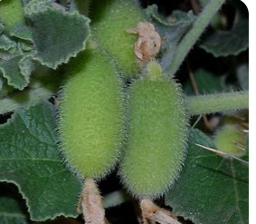

Figure 1: Ecballium elaterium

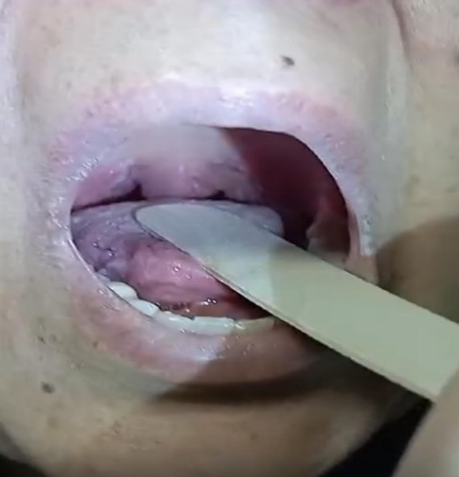

Figure 2: Erythema and edema on the uvula

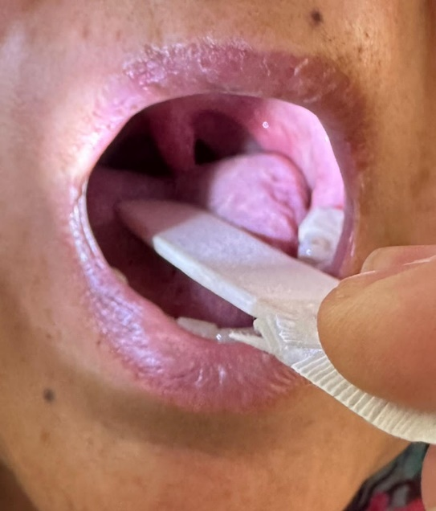

Figure 3: After treatment 24 hours later