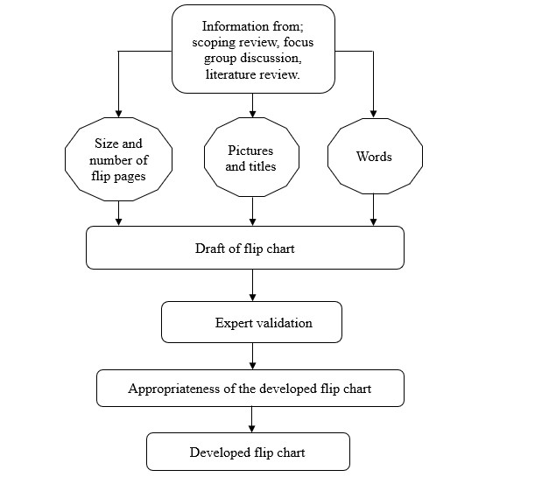 **Fig 1 Schematic framework for the development of Health Education Material on anaemia prevention in pregnancy**

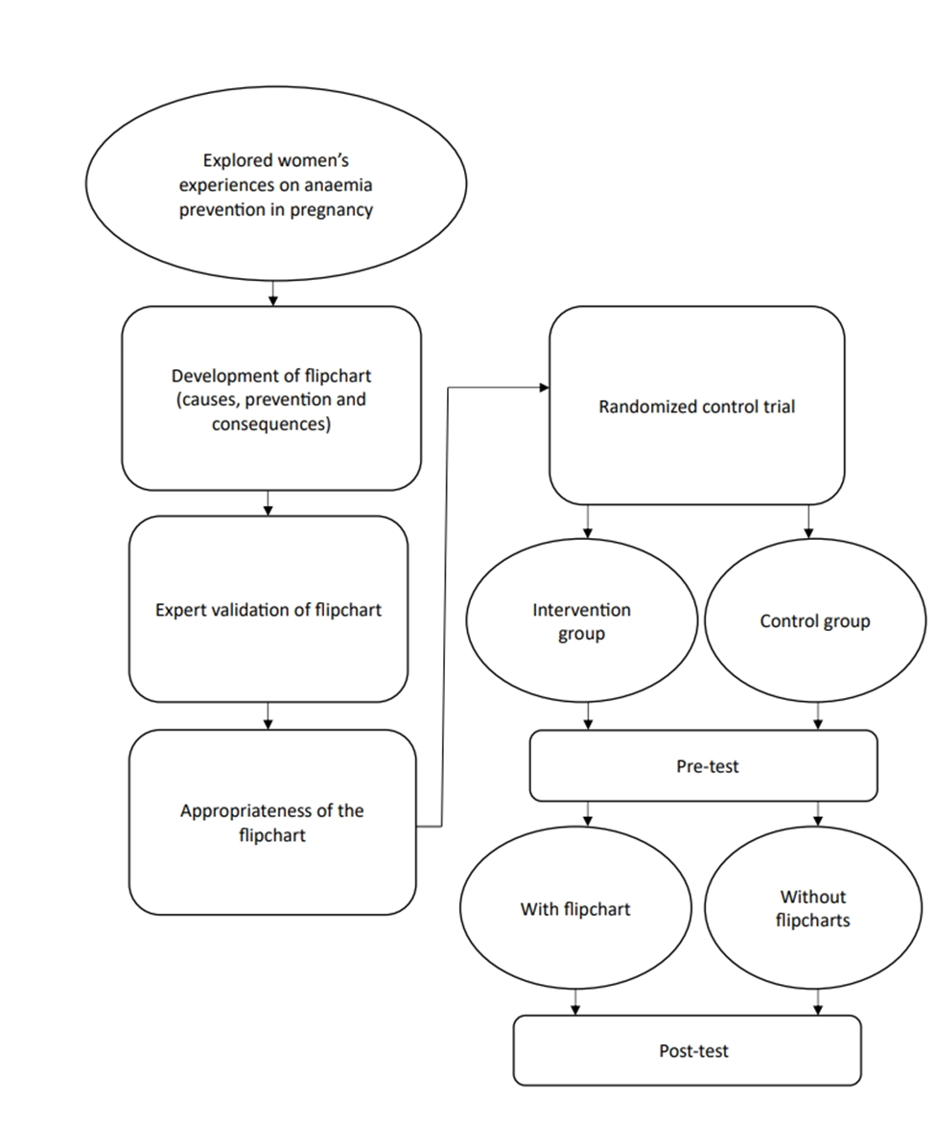**Fig 2 Flowchart diagram of the development and validation of health education material**

**TABLES**

**Table 1:** **Themes and subthemes on the experience of pregnant mothers on anaemia prevention**

|  |  |  |
| --- | --- | --- |
| **Themes** | **Sub-Themes** | **Report based on general comments more than 60%** |
| Knowledge of Anaemia | Awareness | Adequate |
| Causes | Inadequate |
| Symptoms | Inadequate |
| Dietary | Balanced diet | Inadequate |
| Financial status | Inadequate |
| Prevention methods | Non-pharmacological | Inadequate |
| Pharmacological | Inadequate |
| Health Seeking behaviour | Adherence to ANC medication | Inadequate |
| Use of injections | Mixed report |
| Blood transfusion | Many disagreed |
| Socio-cultural | Family income | Inadequate |
| Culture and religion | Very true |
| Lived Experiences in pregnancy | Challenging | Yes |
| Favourable | Fairly reported |

**Table 2:** **Experts socio-demographic information**

|  |  |  |  |  |
| --- | --- | --- | --- | --- |
| **Experts** | **Sex** | **Age** | **Speciality** | **Rank** |
| Expert 1 | Female | 48 | Nursing | ADNS |
| Expert 2 | Female | 45 | Nursing | CNO |
| Expert 3 | Female | 32 | Infographer | Principal infographer |
| Expert 4 | Male | 46 | Nutritionist | Assistant Chief Nutritionist |
| Expert 5 | Male | 58 | Family Medicine | Consultant |
| Expert 6 | Female | 44 | Obstetrics and Gynaecology | Snr. Registrar |
| Expert 7 | Male | 54 | Obstetrics and Gynaecology | Consultant |
| Expert 8 | Male | 39 | Health Educator | Lecturer 1 |

**Table** **3: Expert panel consensus rating of the newly developed flipchart**

|  |  |  |  |  |
| --- | --- | --- | --- | --- |
| Health Education Material on Anaemia | **Sub-scale** | S-CVI | S-CVI/UA | Significant |
| **Round 1**  **Round 2**  **Round 3** | Degree of Relevance (figure) | 1.00 | 1.00 | Very Good |
| Degree of Relevance (Script) | 0.96 | 0.92 | Very Good |
| Clarity (figure) | 0.97 | 0.83 | Very Good |
| Clarity (script) | 1.00 | 1.00 | Very Good |
| Ease of understanding (figure) | 1.00 | 1.00 | Very Good |
| Ease of understanding (script) | 0.97 | 0.75 | Good |
| Applicability to practice (figure) | 0.98 | 0.83 | Very Good |
| Applicability to practice (script) | 1.00 | 1.00 | Very Good |

**Effectiveness of Two Educational Methods (With and Without Flipchart) among Pregnant Women**

**Table 4:** **A 2 x 2 Classification table for McNemar analysis for the effectiveness of two educational methods**

|  |  |  |  |  |  |  |  |  |
| --- | --- | --- | --- | --- | --- | --- | --- | --- |
| **Intervention * Control Cross tabulation** | | | | |  | **Risk Estimate** | |  |
|  | | **Without flipchart** | | **Total** | **McNemar Test value** | **Odds Ratio for post-test** | **The odds Ratio for the Pretest** | **Decision** |
| **Correct response** | **Incorrect response** |
| **With flipchart** | **Correct response** | 265 | 55 | 320 |  |  |  |  |
| **Incorrect response** | 172 | 148 | 320 | .000** | 7.458 | 1.963 | Significant |
| Total | | 437 | 203 | 640 |  |  |  |  |