PREVENTION OF BACTERIAL INVASION AS AN IMPORTANT PROGNOSTIC FACTOR IN TOOTH AVULSION AND REPLANTATION - CASE REPORTS
ABSTRACT
Tooth Avulsion is a significant traumatic injury in children, replantation and follow up care is the treatment of choice. Maxillary incisors are most affected and sometimes over treated or left untreated.
Aim: To understand the relation between of bacterial contamination and the survival of avulsed permanent maxillary incisors after replantation.
Case Report: Three case reports describes the treatment stages for the survival of avulsed permanent incisors. Pulp & periodontal damage and its tissue responses to bacterial invasion are discussed through various clinical factors responsible for good prognosis.
Result & Observations: Preserving alveolar bone width, retaining aesthetics and function even for an interim period is a favorable outcome. It helps in the replacement of tooth at a convenient period of late adolescence or young adult stage.
Conclusion:
Immediate replantation is always recommended for good prognosis of tooth avulsion in children.
Key Words: Tooth avulsion, Replantation, Physiopathology, children.

INTRODUCTION
Avulsion is defined as the complete displacement of tooth from its socket in the alveolar bone owing to trauma.¹ Avulsion of permanent teeth varies from 0.5% to 16% of all traumatic injuries. The maxillary central incisors in the age of 7-14 years are commonly affected.² Replantation is the treatment which restore the patient’s appearance and occlusal function, prevent psychological trauma of missing tooth. Immediate replantation addresses the primary therapeutic concern to maintain the viability of the PDL fibers.
This case report aimed to present three cases that discusses the importance of prevention of bacterial invasion in the prognosis of avulsion and replantation.
CASE DESCRIPTION
CASE 1
A 14-year-old male patient, diagnosed with avulsion of 22 (Fig1a) 60 minutes back while fighting and the tooth was stored in cold pasteurized milk before arrival. The crown of the avulsed tooth was intact, and the roots had closed apex. Under local anesthesia, the socket was gently irrigated with saline, replantation was done under digital pressure and composite wire splinting for 2 weeks. Systemic antibiotic therapy, soft diet & oral hygiene instructions were given. Later at one-week, endodontic treatment with Calcium hydroxide intracanal medicament was done, the canals were obturated with Gutta-percha (Fig 1b) & followed up for 1 year successfully.
CASE 2
A 10-year-old male patient, diagnosed with avulsion of 11,21(Fig 2) 3 hours back while playing. These teeth were wrapped in tissue paper before reaching the dentist. The crowns had an enamel fracture, the roots had a closed apex. Reimplantation of the avulsed tooth and fiber splinting was done for 1-month, endodontic treatment was done later at 1 week. During the follow-up period, the replanted tooth remained in a stable, functional position for 8 months but later showed apical replacement resorption. (fig 3a)Re-endodontic treatment was done in relation to 21(Fig 3b) with calcium hydroxide intra-canal medication to induce root healing, further follow-up showed root resorption in 11, re-endodontic treatment is advised.
CASE 3
A 15-year-old male patient, diagnosed with mobility of reimplanted 21, associated with chewing difficulty. (Fig 4) History of trauma 5 years back by hitting the edge of cot, tooth stored in tap water for 1 hour. The past dental history revealed that the avulsed tooth was endodontically treated extra orally followed by reimplantation and splinted for 2 weeks. Clinically the crown is mobile and appeared pink due to granulation tissue, radiographically PDL and cementum are replaced by bone in 21 (replacement resorption) (Fig 5a) and extraction of 21 was done (fig 5b) followed by removable prosthetic replacement of 21.
DISCUSSION
During avulsion the tooth is separated from the socket, mainly due to the tearing of the periodontal ligament that leaves viable periodontal ligament cells on most of the root surface subsequently resulting in periodontal and pulpal damage. The success of replantation depends mainly on early clinical indicators such as patient’s general health, root development stage, storage media, bacterial contamination and tooth mobility most importantly prevention of bacterial invasion through PDL or pulp. Replantation is not indicated in uncooperative patients, severe caries, advanced and untreated periodontal diseases, and serious general pathology (immunosuppression, severe cardiac) conditions.
Bacterial invasion through injured PDL can be prevented by proper oral hygiene practices, topical/systemic antibiotic agent at the time of injury. The healing with new replacement cementum is a favorable outcome as a result of hydrated periodontal ligament cells. In case 1, hydration of the pdl cells and prevention of bacterial contamination was done using milk as a storage media, milk being easily available and having a suitable pH with appropriate growth factors, nutrients, and osmolarity, is the most extensively used and recommended one.⁴ Functional healing was present during follow up at 6 months .
Excessive drying of PDL cells results in the inflammation persisting to cause resorption and ankylosis. In case 2, dehydration of the pdl cells by an extra oral dry time of 3 hours and splinting for one month had led to questionable prognosis. In the third case, tap water is used as a storage media which has inadequate characteristics like bacterial contamination, hypotonicity, and non-physiological pH and osmolality, which favors the PDL cells lysis.⁵
The rupture of neurovascular supply and PDL damage invariably results in pulpal necrosis. Favorable outcome can be achieved by doing endodontic treatment. As per the IADT guidelines, root canal therapy must be initiated within two week post-replantation. if not the necrotic pulp and its toxins may gain access to the periodontal ligament through various portals of exit, thus contributing to the process of resorption. Though in the first and second case, endodontic treatment was initiated one week after replantation, in the second case it is noteworthy to know re- endodontic treatment was carried out to eliminate the persistent microorganisms and a good prognosis was noted. However, in the third case, extraoral endodontic treatment was carried out immediately which can be substantiated by the fact that PDL dehydration and pulp necrosis would have been subjected for more bacterial contamination and vigorous resorption.
Bacterial biofilms are severely detrimental for periodontal and pulpal healing of avulsed teeth which causes inflammatory root resoprtion.⁶ Invitro studies found a direct association between bacterial infection and resorptive defects.⁷ These cellular processes also influenced by individual’s medical and dental characteristics and the quality of on-site emergency and sequential dental treatment, and therefore affect the overall prognosis of tooth survival.⁸
Oral hygiene as well as antibiotics (Amoxicillin or penicillin) remains the first choice to prevent contamination and reducing the bacterial invasion of the necrotic pulp.⁸ Doxycycline is also antimicrobial, anti-inflammatory, and anti-resorptive and can be prescribed for children above 12 years of age.⁹
In case of increased extra oral dry time, a good prognosis can be achieved by Anti- resorptive/regenerative therapy using a combination of antibiotics and corticosteroids, surface treatment with fluoride or tetracycline, also Emdogain, PRP, titanium coating, periodontal ligament cell sheets which are still in research.
The best healing potential of the avulsed tooth is possible if the replantation is performed immediately (within 5 min) after trauma, PDL regeneration occurs and it returns to normal function. Teeth replanted within 10 minutes results in no resorption, teeth replanted within 15 minutes has a favorable long-term prognosis and must be followed up at regular intervals till 12 months and thereafter annually for a minimum period of five years.
Short term splinting of two weeks prevents ankylosis by allowing the physiological movement of tooth, promotes functional periodontal healing and 60% of the mechanical properties of the injured PDL is restored.¹⁰ Long term splinting can lead to ankylosis/ resorption.
Educating the parents and patient regarding the emergency management following avulsion is important. In patients for whom growth is not completed the replanted tooth will help maintain the alveolar bone width, function and esthetics for a few years until the patient is a viable implant candidate or suitable for any other therapeutic option.
CONCLUSION
In all the above three cases the replanted tooth was able to restore esthetics, function and psychological comfort till further prosthetic replacement. Healing after replantation is directly proportional to bacterial invasion of mild, moderate or severe nature. Bacterial contamination rapidly elicits inflammatory response so immediate replantation as a treatment protocol works on biological basis.
REFERENCES
- Andreasen JO, Andreasen FM, Andersson L, editors. Textbook and color atlas of p
- Trope M. Clinical management of the avulsed tooth: present strategies and future directions. Dental Traumatology. 2002 Feb;18(1):1-1.
- Cohenca N, Karni S, Eidlitz D, Nuni E, Moshonov J. New treatment protocols for avulsed teeth. Refu'at Ha-peh Veha-shinayim (1993). 2004 Apr 1;21(2):48-53.
- Poi WR, Sonoda CK, Martins CM, Melo ME, Pellizzer EP, Mendonça MR, Panzarini SR. Storage media for avulsed teeth: a literature review. Brazilian Dental Journal. 2013 Sep;24:437-45.
- Malhotra N. Current developments in interim transport (storage) media in dentistry: an update. British dental journal. 2011 Jul 9;211(1):29-33.
- Mona M, Walker C, Shaddox LM, Pileggi R. Bacterial Biofilm Growth on Various Dental Stabilization Systems for Avulsed and Luxated Teeth. Applied Sciences. 2021 Sep 27;11(19):8982.
- Pettini F, Pettini P. Root resorption of replanted teeth: an SEM study. Dental Traumatology. 1998 Jun;14(3):144-9.
- Müller DD, Bissinger R, Reymus M, Bücher K, Hickel R, Kühnisch J. Survival and complication analyses of avulsed and replanted permanent teeth. Scientific reports. 2020 Feb 18;10(1):2841.
- Tsilingaridis G, Malmgren B, Skutberg C, Malmgren O. The effect of topical treatment with doxycycline compared to saline on 66 avulsed permanent teeth–a retrospective case–control study. Dental Traumatology. 2015 Jun;31(3):171-6.
- Fouad AF, Abbott PV, Tsilingaridis G, Cohenca N, Lauridsen E, Bourguignon C, O'Connell A, Flores MT, Day PF, Hicks L, Andreasen JO. International Association of Dental Traumatology guidelines for the management of traumatic dental injuries: 2. Avulsion of permanent teeth. Dental traumatology. 2020 Aug;36(4):331-42.

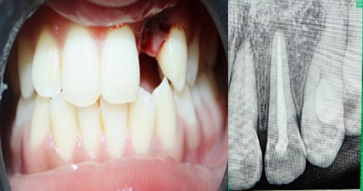
Figure 1 a)Case 1 pre operative photograph b)post operative after splinting and endodontic treatment
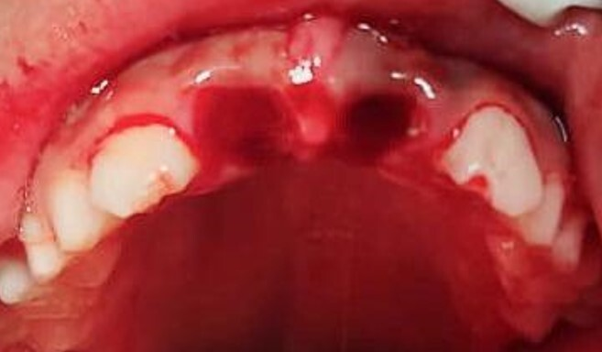
Figure 2 Case 2 pre operative photograph

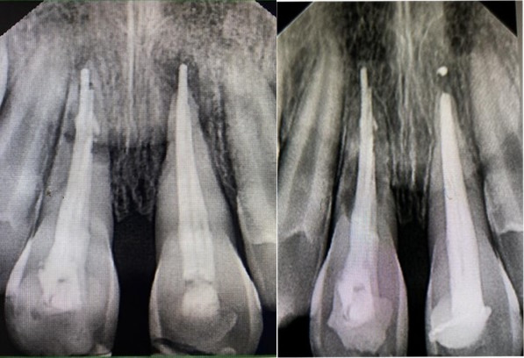
Figure 3 a) Case 2 Initial apical replacement resorption noticed wrt 21 b) Case 2, re endodontic treatment done wrt 21, 11 showing root resorption
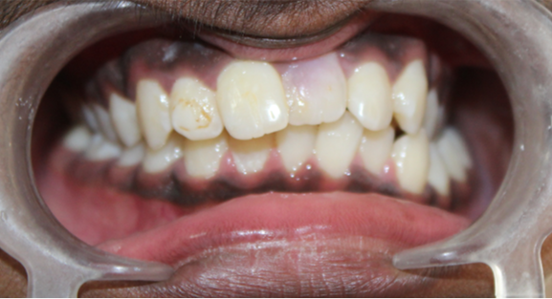
Figure 4 Case 3 Pre Operative photograph 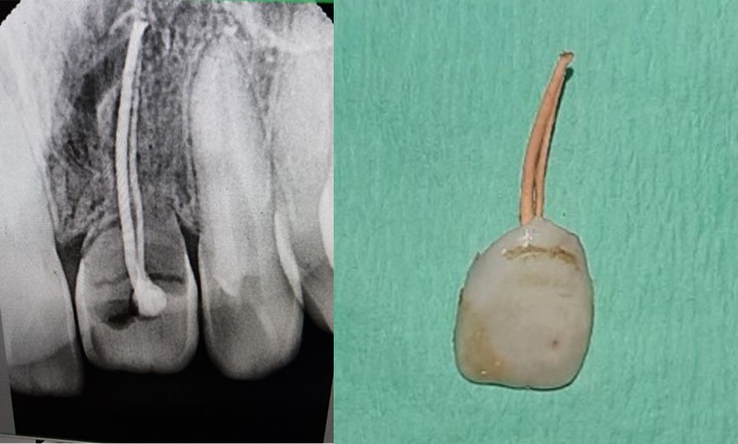
Figure5 a) Case 3 Radiograph showing PDL and cementum are replaced by bone b) case3, extraction of 21

