GREENHOUSE CULTIVATION USING ROBOT NAVIGATION SYSTEMS WITH A MODULE FOR IDENTIFYING PESTS AND DISEASES
Chenmei Teng1, Shanliang Li1*
1 Soochow University, Suzhou, Jiangsu, 215127, China
*Corresponding author e-mail: shanliang_li@sina.com

Abstract
Background: Early pest detection is critical for greenhouse crop production and chemical reduction. Visual inspection fails for large crops. Computer vision and deep learning advances could improve reliability and productivity. A navigation robot with a pest and disease identification module can help plant-related enterprises. This module would allow the robot to detect and classify plant pathogens in real time, speeding up reaction and treatment.
Methods: This research presents a technique for the navigation robot's pest and disease identification module. The worst greenhouse tomato and pepper pests, Bemisia tabaci and Trialeurodes vaporariorum are inspected. A massive dataset of diseased tomato plant images was collected to generate and validate models. These photographs have been preprocessed to enhance visual contrast using Brightness-Preserving Dynamic Fuzzy Histogram Equalization (BPDFHE). Leaf image segmentation is possible using Otsu's. Principal Component Analysis (PCA) for image compression can be used to extract the features.
Results and Discussion: We suggested the Mayfly Optimized K Means Clustering with Back Propagation Neural Network (MOKMC-BPNN) algorithm, which has shown to be effective in several image identification of pests and diseases. Results show that the proposed model performs better than the existing methodology and achieves 98% of accuracy, 95% of recall, 0.64% of IoU, 85% of healthy and 88% of unhealthy success rates for disease detection rate, 83% of Bemisia tabaci insect and 85% of Trialeurodes vaporariorum success rate for disease identification rate.
Conclusions: The performance of the proposed system is compared to more widely used techniques to demonstrate how successful it is and to achieve the effective level of identification of pest disease and control.
Keywords: Pest and disease identification, navigation robot, Bemisia tabaci, Trialeurodes vaporariorum, Mayfly Optimized K Means Clustering with Back propagation neural network (MOKMC-BPNN)

Research Highlights
This study describes a strategy for using robot navigation systems to detect and identify greenhouse pests and diseases.
- Determines whether to process the image or request a new one based on quality. Depending on the desired outcome, several functions are applied to the idea. Adjusting the image to enhance pictures and magnification will reveal the details in the images.
- Second, it divides the image into equal-brightness halves. Creates image segments based on a nearby threshold. It chooses areas with high pixel values to meet a predetermined criterion. Identifies points for image segmentation based on the Otsu method.
- The extraction of features identifies the components of the input areas related to each other.
- MOKMC-BPNN technique for identifying pests and diseases in a greenhouse environment. Use the MOKMC-BPNN model's estimates to check the greenhouse's domain for pests or diseases continuously. When a problem is found, the effects on plant health can be reduced using the proper measures, such as targeted insect control methods and disease management techniques.
- Background
Pests and plant diseases have a direct impact on crop yields. Insects and other pests typically hide from the sun by hiding beneath a plant's leaves during the day, only to emerge at night and feast on the plant's leaves. That makes it harder to spot them munching on crops during the day. In many cases, by the time farmers become aware of insect harm, the pest population has grown to an unmanageable level. At this point, spraying crops with many insecticides is necessary to eliminate pests and reduce agricultural damage. However, pesticide residues persist even after washing once crops have been treated throughout the growing season (Chen et al., 2020). The computers were limited to that of a device for doing calculations and processing existing data to generate insights for use in making decisions. Artificial intelligence techniques are those used to teach computers to think like humans. One such method, known as an Expert System, was developed to teach computers to solve problems analogous to human beings (Gunawan et al., 2018). Infectious diseases can be either biotic or abiotic. The causes of biotic conditions include microorganisms like viruses, bacteria, and fungi. Pollution, pesticides, and an abundance or deficiency of the nutrients plants need to thrive are all examples of abiotic illnesses. The effective management of crop diseases depends on correct diagnosis. Crops can be protected from pests and diseases in a number of ways, including the use of licensed seeds, the growing of disease-resistant crop varieties, the provision of enough soil nutrients, and the administration of limited pesticides (Deepika and Kaliraj, 2021).
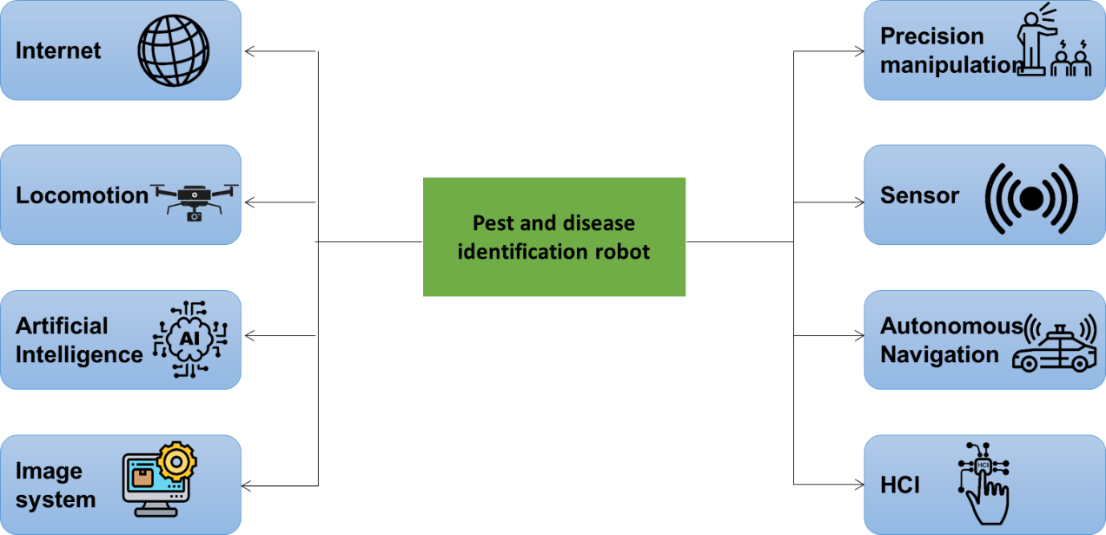
Figure 1: Framework of pest and disease identification robot
Figure 1 depicts the framework of the pest and disease identification robot. In spite of the fact that the idea of robotic applications for agricultural operations has been investigated for over three decades, more and more agricultural automated systems are being created for tasks like weed control, row crop planting, and fruit and vegetable harvest. The breakthroughs in machine vision, data processing, and controllers that have occurred recently have allowed for this. Automation has been implemented in some agricultural sectors. The lack of new herbicide modes of action and the spread of herbicide-resistant weeds have made weed management in row crops a priority for agricultural researchers. Several major farm machinery manufacturers have publicly indicated their intent to develop autonomous machines, develop functional prototypes, or file patents for agricultural robotic systems. The concept of a standalone platform with a wide variety of attachment points is gaining traction in the field of agricultural robots (Barnes et al., 2021)
The detection of pests in tomato crops has traditionally relied on the observance skills of farmers, which is both time-consuming and ineffective when applied to big harvests. Automating this time-consuming inspection process using robotic systems and computer vision can boost inspection accuracy, improve crop vitality, and reduce pesticide use by 5–10%. To this end, robots must be able to navigate their way around glasshouses, take clear photos of pests and their environments, and use this information to create efficient, high-level commands in line with an Integrated Pest Management (IPM) strategy. To detect problems early, robots need to combine various abilities in sophisticated and frequently ad hoc ways. Because the insect eggs are so small (0.3 mm), it takes a combination of vision and talent to automatically get comparable, high-quality photographs of the pests from different sides of the leaves (Martin et al., 2021). The greenhouse atmosphere is ideal for plant growth since it protects plants from the elements and most problems.
The plants are given the ideal circumstances for development, allowing them to reach their full potential. A greenhouse provides perfect plant growth conditions at any time of year by trapping heat and moisture. Growers may cultivate plants in climates that would normally be too harsh for doing so, due to the invention of the greenhouse. Plants can be grown successfully regardless of latitude and season (Dharmasena et al., 2019). Several sources have reported the current state of machine vision's implementation in farming. Most of them deal with agricultural fields, and only a handful includes plant nurseries. A plant factory's environment is intricate and distinct from the natural world. In addition to the plant itself, there is also mechanical machinery, irrigation pipes, and hanging ropes. Machine vision applications face additional difficulties because of the plant's fluctuating lighting (Tian et al., 2022). Therefore, we suggested greenhouse cultivation using robot navigation systems with a module for identifying pests and illnesses.
Contribution of the research
- We detailed that a large collection of images of diseased tomato plants affected by Bemisia tabaci and Trialeurodes vaporariorum was collected to design and evaluate models.
- The images were processed beforehand with BPDFHE to boost contrast.
- Otsu's method enables the segmentation of leaf images.
- PCA method for compressing images can be used to extract the features.
- We proposed the MOKMC-BPNN algorithm, which has succeeded in various pest and disease detection tasks.
Advantage and Disadvantages of research findings of pest and disease management:
This section discusses the findings of several researchers' technical reports and research papers. Other researchers provide solutions to the issues raised by integrated and dispersed systems. The relevant literature is displayed in Table 1.
References | Objective | Summary of finding
Pattinson et al., 2020 | Greenhouse plants are safe from frost, heat, and other weather hazards. Improved pest and disease management can be achieved through integrated crop management strategies and the ability to produce throughout the year. | They provided an overview of the GreenPatrol system's localization and navigation capabilities and pest detection abilities, and we provided the results of live demonstrations of the system in a representative context.
Thamaraiselvan et al., 2023 | The research used Light Detection and Ranging (LiDAR) data to provide a comprehensive and trustworthy strategy for autonomous robot navigation within an agricultural field. | The sprayer boom can be retracted in a greenhouse or extended for use outside, like on a farm with open fields. A successful pesticide management system is expected to be implemented using the autonomous sprayer.
Maski and Thondiyath, 2021 | The research proposed faster and more accurate plant disease detection using a lightweight version of YOLO. | The findings of these tests suggest that when it comes to mobile agricultural robots for plant disease identification, the YOLO variants that are much lighter are the most effective.
Liu et al., 2019 | The study discussed these challenges by introducing a self-driving robot truck for pest monitoring and a system for classifying Pyralidae insects. | The experiment results demonstrate that the robot vehicle can autonomously take pictures of pests, with a 94.3% success rate in a real-world agricultural planting scenario.
Lin et al., 2023 | The study developed a method for increasing crop yield per acre using a finer identification of pests using a graph pyramid attention, convolutional neural network (GPA-Net). | Finally, experimental comparisons demonstrate that the proposed GPA-Net outperforms state-of-the-art methods, making it ideal for use in smart agriculture and environmental protection contexts requiring the differentiation of pests and illnesses affecting crops.
Wang et al., 2023 | The study suggested ResNeXt-SVM, a new approach for recognizing strawberry aesthetic quality based on the ResNeXt network and SVM. | The proposed method improves recognition rates and could one day be used in automated strawberry harvesting.
Elango et al., 2021 | The researchers constructed a robot that can harvest tomatoes and keep an eye out for pests simultaneously. | This technology monitors the field and selects fruit at the right time, making harvesting easier. The bot can gather tomatoes at 90–120 min/hectare.
Rangarajan et al., 2022 | The research discussed identifying the presence of Cercospora Leaf Spot (CLS) in Abelmoschus esculentus L. (okra), popularly known as lady's finger. | The suggested quadcopter system must be constrained to operate within specified parameters for successful illness detection. At last, some guidance for where to go from here in terms of development has been offered.
Cao et al., 2022 | The research introduced an improved version of the network model for semantic segmentation, which may be used to separate rows in aerial photographs of farms. | The experimental findings show that the proposed algorithm successfully extracts field navigation lines with high accuracy and efficiency and has the technological benefits of being both highly resilient and widely applicable.
Acosta and Quilca,  2022 | A study designed a system for an autonomous robot to monitor plants used in carrot cultivation in real-time using three cameras; this robot would analyze the captured images for signs of bacterial or parasitic infection and alert workers to remove the affected plants before they spread disease to healthy ones. They also developed a P program to recognize the plants' colors. | Python code was developed to recognize the plant's color using the Open CV artificial vision library; this was done so that the disease wouldn't spread to other plants; a global positioning system (GPS) module was implemented; and finally, the robot route was planned using the simulator Coppelia Sim, where the robot's path was determined, and its lateral range was detected.
Oberti and Schmilovitch, 2021 | The research examined weed and disease detection tasks, as well as a look at precise actuation of medicines, are discussed in this chapter, along with the current state of robotic spraying. | This shows that key components of integrated robotic systems for precise crop protection are progressing rapidly, despite the difficulties of some impending issues.
Dutta and Gogoi, 2020 | The IoT envisions assigning a unique identifier to every physical item  to facilitate communication between devices and people over a network. | Consequently, farmers need proper training to track the evolution of pests and illnesses and respond appropriately.
Shi et al., 2023 | This paper provides an in-depth evaluation of the techniques and software programs used for crop row detection in the environment of agricultural tractor navigation. | We also summarize the pros and cons of today's most popular crop row recognition methods, including time-tested techniques and cutting-edge deep learning algorithms.

- Methods
In greenhouse, identifying pests and diseases is essential to protecting crop health and maximizing yields. Detecting plant diseases and insects can be done using any one of a number of methods. The use of robots to detect and identify pests and diseases could improve productivity, precision, and scalability in the sector. Figure 2 depicts the architecture of the proposed work.
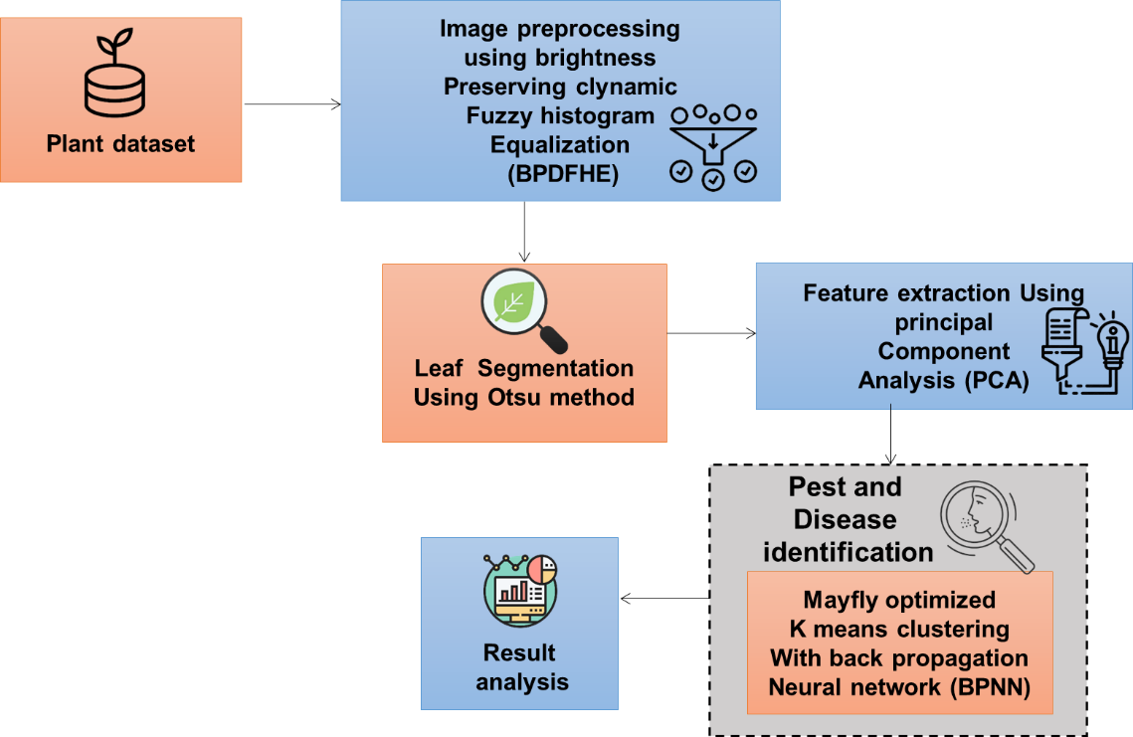
Figure 2: Architecture of the proposed work
- Dataset
In 2019, the researchers identified that Mediterranean region, identifying pests and diseases is essential to protecting crop health and maximising yields in the Mediterranean region (Gutierrez et al., 2019). Detecting plant diseases and insects can be done using any one of a number of methods. The use of robots to detect and identify pests and diseases could improve productivity, precision, and scalability in the sector. Figure 2 depicts the architecture of the suggested work. The produced models' reliability depends on the thoroughness of the dataset and its labeling. A manual camera is one method of getting clear images of the grow space's inside (Gutierrez et al., 2019).

- Manual Dataset Generator
In the culture chamber, tomatoes are cultivated in entirely enclosed boxes. Disease and other contaminants can't spread in these confined growing rooms. Diseases of various kinds have been deliberately introduced into the rooms. Manual insect photography uses Mendelu's growth chamber plants. Each of the five culture boxes contains tomato plants at different stages of development and insect infestation. The AP-3200tPGE color camera and DataCam 2016R monochrome camera, coupled with a PC, record the photos. The worker collects data based on knowledge and the experiment supervisor's directions. Lenses and lighting can be switched depending on the situation. Manual cameras use the operator's skill to set focus and shutter speed. Thirteen thousand forty-seven photographs were manually taken, 6,016 with a monochrome DataCam 2016R and 7,031 with a color AP-3200t-PGE.
- Automated Dataset Generator
The file includes plant development images. Healthy and sick leaves are shown. The dataset contains leaf infection phases. The models require illness labels to be applied to images in this dataset for training. The initial installation of the automatic dataset generating system takes place in the greenhouse. The system is relocated to a safer location in case of an epidemic. On July 6, 2018, after harvesting all of the tomatoes, the process of creating the dataset begins. On September 19, 2018, the second dataset generation phase began and ended in 2018. Several data-gathering issues were resolved. Unrepresentative images were removed from the data set. The first microcontroller collected 100,593 photos, and the second 75,741. The first microcontroller yielded 18,050 valid images, and the other 19,692.
- Dataset Labeling
The produced model's precision is dependent on the thoroughness of the labeling. Open-source and commercial technologies can speed up and semi-automate picture labeling. Label Image, a free and open-source MIT-licensed software project, is presently used. It's a QT-based Python picture annotation program. Pascal VOC and YOLO save annotations in XML. Manually recognizing photos is laborious. A semi-automatic system labeled images for Mendel University experts to protect time. Image titles determine the list's rank. Image quality, variation, and random selection chose the ranking. Image Quality Assessment (IQA) scores images from 0 to 100. Daily photo albums were created from the data. Weekly picks of high-quality and random photographs complete the list's labeling order. Images and rankings were updated weekly. Insects and eggs are present in 4,331 image tagging tool-classified photos. Table 2 lists the cropped photographs for each condition. Data-driven models are produced through the selective tagging of insects and eggs. The original 4,331 photographs were tagged, from which 54,743 were trimmed.
Table 2: Cropped image labeling for each condition
Disease | Tags
Trialeurodes vaporariorum eggs | 26.314
Bemisia tabaci eggs | 10.559
Trialeurodes vaporariorum insect | 14.406
Bemisia tabaci insect | 7,467
Total | 58,744

- Image preprocessing using BPDFHE
It's an improved version of histogram equalization, capable of boosting contrast with less effort on the computer. The image's histogram is utilized in histogram equalization, a typical preprocessing technique, to assess the image's frequency distribution. This graph, which resembles a bar chart, highlights the image's low-contrast regions. In this case, we distribute the values based on the most frequently occurring pixel intensities to achieve the desired equalization. When some pixel intensity values are off, this method becomes problematic. Because standard histogram equalization ignores such imprecise or imprecise gray values, they can cause unexpected histogram changes in the target image. The BPDFHE method utilizes a fuzzy representation of the picture values to aid the histogram equalization method in dealing with the ambiguity of gray-level pixel values. The steps involved in the BPDFHE process are as follows.
In BPDFHE, the fuzzy domain is used to account for the imprecision of the gray level values of the pixels, and a smooth histogram is generated as a result. Fuzzy histograms are represented by the sequence of real numbers$g\left(j\right)$, where $j=0,1,…., J-1,$ and $g\left(j\right)$ denotes the frequency distribution of the gray values. Let's think of the gray matter, $J\left(v,z\right)$, as the fuzzy integer $J^{\sim }\left(v,z\right)$. Here is the format that the calculated fuzzy histogram will take:
$g\left(j\right)←g\left(j\right)+\sum_{v}{\sum_{a}{μ_{J^{\sim }\left(v,z\right)j,}l ϵ\left[b,a\right]}}$ (1)
where $J^{\sim }\left(v,z\right)j$ is a fuzzy function that indicates membership in the triangle, and it is defined as
$μ_{J^{\sim }\left(v,z\right)j,}=\max\left(0,1-\frac{\left|J\left(v,z\right)-j\right|}{4}\right)$ (2)
Where $[b,$ a] represents the support for the membership function.
- Leaf image segmentation using the Otsu method
The leaf picture segmentation identifies and removes from the final image any pixels that do not correspond to the three textures of interest (sky, grass in the soil, and leaves). If these textures are ignored, the chance of making mistakes throughout the dialogue is considerably reduced. This method is widely recognized as a top choice for optimal thresholding. The method uses a histogram of grey-level data and optimizes class separation by maximizing the 'between-class variance' $σ_{A}^{2}\left(l\right)$.
Let's say that a given image's pixels are represented in $K$ levels of grayscale$[0, 1,..., K-1]$. In this notation, $m\left(j\right)$ represents the number of pixels on level$j$, while $M$ represents the total number of pixels. The histogram of grey levels is transformed into a probability distribution by standardizing it. The probabilities of each shade of grey, denoted by$o\left(j\right)$, are as follows:
$o\left(j\right)=\frac{m\left(j\right)}{M},o\left(j\right)≥0, \sum_{j=0}^{K-1}{o\left(j\right)=1}$ (3)
Specifically, we determine the total mean level $μ_{S}$ of the original picture in addition to its cumulative moments at the zeroth $ω\left(l\right)$ and first $μ\left(l\right)$orders.
$ω\left(l\right)=\sum_{j=0}^{l}{o\left(j\right)}$ (4)
$μ\left(l\right)=\sum_{j=0}^{l}{j.o\left(j\right)}$ (5)
$μ_{S}=\sum_{j=0}^{l}{j.o\left(j\right)}$ (6)
The optimum cutoff point $l^{*}$ is,
$σ_{A}^{2}\left(l^{*}\right)=\max_{0≤l≤K-1}{σ_{A}^{2}(l)}$ (7)
Here,
$σ_{A}^{2}\left(l\right)=\frac{{\left[μ_{S}ω\left(l\right)-μ\left(l\right)\right]}^{2}}{ω\left(l\right)\left[1-ω\left(l\right)\right]}$ (8)
In the global intensity histogram of an image, our program looks for the peaks of clusters based on the distributions of pixels that cause local maxima of the variances. This is done by iteratively applying the Otsu method.
- Feature extraction using principal component analysis (PCA)
One common method for reducing the number of dimensions in datasets composed of single indicators or variables is principal component analysis (PCA). A linear combination of variables can describe the variance structure of a matrix by compressing diverse data into a few main components (PCs). It focuses on employing a few PCs to discover the underlying structure of many independent observable variables while allowing them to retain as much information as possible from the original variables.
The vector $v$ will consist of $o$ variables. Let's pretend $U$ is the covariance of some arbitrary vector $v$ with zero-mean eigenvalues $∝_{1}^{'}≥∝_{2}^{'},≥∝_{o}^{'}≥$' and eigenvectors ${ ∝}_{1}^{'},∝_{2}^{'},∝_{o}^{'}$. $v$ is an (n*$o$) matrix since it contains information on $o$ variables. To obtain PCA from the X matrices, we employ the matrix variables $∝_{1}^{one '}v$ ($l=1,2,…,o$) of the elements of$v$, with the condition that k′v is independent, i.e., $Cov \left[∝_{l}^{'}x,∝_{k}^{'}v\right]$= 0, l≠k. The variance of the retrieved PCA is the highest. The PCA is based on the following mathematical principles:
$U_{1}=∝_{1}^{'}v=∝_{11}v_{1}+∝_{12}v_{2}+…+∝_{1o}v_{o}=\sum_{k=1}^{o}{∝_{1j}v_{k}}$ (9)
$U_{2}=∝_{2}^{'}x=∝_{21}v_{1}+∝_{22}v_{2}+…+∝_{2o}v_{o}=\sum_{j=1}^{p}{∝_{2j}v_{k}}$ (10)
$U_{o}=∝_{o}^{'}x=∝_{o1}v_{1}+∝_{o2}x_{2}+…+∝_{oo}x_{o}=\sum_{j=1}^{o}{∝_{0k}v_{k}}$ (11)
$Var\left[U_{l}\right]=∝_{i}^{'}{K∝}_{k},l=1,2…,o$ (12)
$Cov \left[U_{l,}U_{k}\right]=∝_{i}^{'}{K∝}_{k},l=1,2…,o;k=1,2,…,o$ (13)
Here,$k$is the eigenvalue of the covariance matrix $v$, which is equal to the k^{th} highest eigenvalues of the o-coefficient vector $∝_{1k,}∝_{2k}….∝_{ok}$, and $k$. PCA is represented by $U_{l,}$ ($l=1,2…,o)$. PCA$U_{1}$ is calculated using the first linear function, $∝_{k}^{'}x$, that adequately describes the data. Maximum variance is found for a linear function k′x at the kth iteration if it is independent of ${ ∝}_{1}^{'}v, ∝_{2}^{'}v….∝_{k-1}^{'}v$. The kth principal component is the $v$ has been derived $k$ times. While $o$ PCAs are possible, on average m PCAs will be sufficient to account for mp of the observed $v$ variance. The "weight" of the jth independent variable in the ith principal component analysis is denoted by the coefficient $∝_{lk}$ ($l=1,2…,o$;$k=1,2…,o$) of the corresponding eigenvector. PCA can be partly evaluated by the amount of dataset variance they explain.
- Pest and disease identification using MOKMC-BPNN
Mayflies are in the superorder Palaeoptera's Ephemeroptera suborder. May is when these insects are most prevalent in the United Kingdom, hence the name "Mayfly." Mayfly nymphs develop underwater into fully formed adults, which might take years. Most mature males gather several meters above the sea in swarms to entice passing ladies. They do a wedding dance with distinctive up and down motions that form a rhythm. Mayfly females congregate here to mate. After a brief mating, the female releases the eggs into the water, starting the cycle.
The MO performs the necessary modifications to improve the algorithm's efficiency on both small and large-scale feature sets. Here are its constituent parts: To track the movement of a male mayfly, we use the formula in Equation 14.
$v_{j}^{d+1}=v_{j}^{s}+x_{j}^{s+1}$ (14)
The current location of the male mayfly is denoted by $v_{j}^{d}$, and its predicted location, $v_{j}^{d+1}$, is obtained by adding the current location to the velocity ${ x}_{j}^{s+1}$. The male mayfly may reach incredible speeds and skim the water's surface at a height of only a few meters. The formula for calculating a male mayfly's rate is given in Equation 15:
$x_{li}^{s+1}=h*x_{li}^{s}+b_{1}*f^{{-β}_{o}^{2}}*\left({pbest}_{li}-v_{li}^{s}\right)+b_{2}*f^{{-β}_{h}^{2}}*\left({pbest}_{i}-v_{li}^{s}\right)$ (15)
Where $x_{li}^{s}$is the speed of mayfly $l$ in dimension $i$ at time $s$, $v_{li}^{s}$ is the location of the same mayfly at the same time, $h$ is the acceleration due to gravity, is a fixed visibility coefficient used to restrict a mayfly's visibility to others, and $b_{1}$and $b_{2}$ are positive attraction constants used to measure the contribution of the cognitive and social components, respectively. In this case, ${pbest}_{l}$ is the best location that mayfly $l$^{th} has ever seen, and ${pbest}_{i}$ is the finest male mayfly's $i$^{th} component. The following changes were made to pbestk because this is a minimization problem:
${pbest}_{l}=\left\{\begin{aligned}v_{l}^{s+1} \\ if fitness\left(v_{l}^{s+1}\right)<fitness\left({pbest}_{l}\right)\end{aligned}\right.$ (16)
Where $itness\left(v_{l}^{s+1}\right)$represents the quality of a solution, the Cartesian distance between two points $v_{l}^{s+1}$ ${pbest}_{l}$. The formula determines these:
$\left|v_{l}-V_{l}\right|=\sqrt{\sum_{i=1}^{m}{{\left(v_{li}-V_{li}\right)}^{2}}}$ (17)
Here $V_{l}$ stands for either ${pbest}_{l}$ and $v_{i}$ is the location of the i^{th} element of the l^{th} mayfly. The method relies on the inherent randomness introduced by the best mayflies continuing to perform the nuptial dance throughout time. Equation 18 provides a mathematical description of this dance.
$x_{li}^{s+1}=h*x_{li}^{s}+c*q$ (18)
Where $c$ is the wedding dance coefficient, and $q$ is a random number between -1 and 1. Female mayflies, in preparation for mating, migrate toward males. This is an updated version of the female mayfly's position:
$v_{j}^{s+1}=v_{j}^{s}+z_{j}^{s+1}$ (19)
Where $v_{j}^{s}$ is the female mayfly's position at time s plus the result of adding her velocity, $z_{j}^{s+1}$, if the current solution is very good, the most attractive female will be drawn to the most handsome guy, and so on. An improved formula for a woman's speed is given in Equation (20).
$x_{li}^{s+1}\left\{\begin{aligned}if fitness\left(z_{l}\right)>fitness\left(v_{l}\right) \\ h*x_{li}^{s}+b_{2}*f^{{-β}_{o}^{2}}*\left(x_{li}^{s}-x_{li}^{s}\right) \\ \begin{matrix}else if fitness\left(z_{l}\right)>fitness\left(v_{l}\right) \\ h*x_{li}^{s}+ek*q\end{matrix}\end{aligned}\right.$ (20)
Where $x_{li}^{s}$ is the $i$^{th} component of the $l$^{th} female mayfly's velocity at time t, $x_{li}^{s}$ is the $l$^{th} female mayfly's position in dimension $i$ at time$s$, and $x_{li}^{s}$is the kth male mayfly's position in dimension $s$.
A male must be chosen initially to perform a crossover between male and female mayflies. The best males are selected to breed with the best females so that the fitness of the offspring is maximized. As illustrated in Equation, a crossover results in two new generations.
$offspring1=q_{of}*male+\left(1-q_{of}\right)*female$ (21)
$offspring2=q_{of}*male+\left(1-q_{of}\right)*male$ (22)
The male parent mayfly, the female parent, and the required offspring survival rate$q_{of}$ are all denoted here. The progeny's starting speeds are all set to zero. Mayfly mutation, the algorithm's progeny is altered to improve its capacity for exploration. To the offspring's variable, we add a random number drawn from a normal distribution, as explained in
${offspring}_{m}^{'}={offspring}_{m}+l$ (23)
Here $l$ is a lucky number with a normal distribution. Algorithm 1 depicts the pseudocode for the Mayfly optimization algorithm.
Algorithm 1: Pseudocode for the Mayfly optimization algorithm
Input: image
Output: Best agent $V_{l}$
Start the male and female mayfly population and their rate of movement at random.
Evaluate the population and then $find the best$
For $jsq←1$ to $MaxIter$, do
For $j←1$ to $PopSize$, do
Update $pbest$
Mayfly male and female speeds need to be reevaluated and updated.
Arrange the mayflies by size and color
Create children from both sexes using a crossover operation.
Make the babies mutants
Swap out the mayflies with the most promising progeny
Update $pbestj$
End
K-Means clustering is based on a straightforward idea. The dataset ${\overline{y}}_{j}$ ($j$ = 1, 2, 3,...) has $m$ observations. Cluster centers and the $L$ value are known. The K-Means clustering algorithm uses the sum of squared errors (SSE) as its goal function.
$TTF=\sum_{j=1}^{L}{\sum_{y∈D_{j}}{{|y-{\overline{y}}_{j}|}^{2}}}$ (24)
One cluster result class is denoted by$D,$ the number of categories by $L$, and the mean of a cluster, ${\overline{y}}_{j}$. In the minimal value of the goal function, the clustering effect is at its best. The K-Means clustering algorithm can be broken down into three distinct phases: First, we scale back the objective function by assigning samples to the vector centers closest to them.
$\sum_{j=1}^{m}{\begin{matrix}min \\ i∈|j=1,2,3…l|\end{matrix}{\left||y_{j}-o_{i}|\right|}^{2}}$ (25)
Euclidean distance is used in the following formula for finding the distance between two points:
$c\left(y_{j},y_{j}\right)=\sqrt{\sum_{l=1}^{c}{{(y_{jl}-y_{il})}^{2}}}$ (26)
Centers of K-clusters are represented by$o$. The value of ${the y}_{j}$ attribute is denoted by $c$.
Modify the cluster-wide mean
${\overline{y}}_{j}=\frac{1}{|D_{j}|}\sum_{y∈D_{j}}{Y}$ (27)
Determine the value of the objective. The cluster effect performs best when the objective function's value is minimized.
Incorporating a neural network that uses feed-forward backpropagation is also an important aspect of this work. This neuronal network takes as inputs the leaf image's tokens; as each token is composed of a cosine and a sinus angle, the number of input layers is twice the number of tokens. We can see how the leaves recognition program uses a neural network in the image. Figure 3 depicts the structure of BPNN.
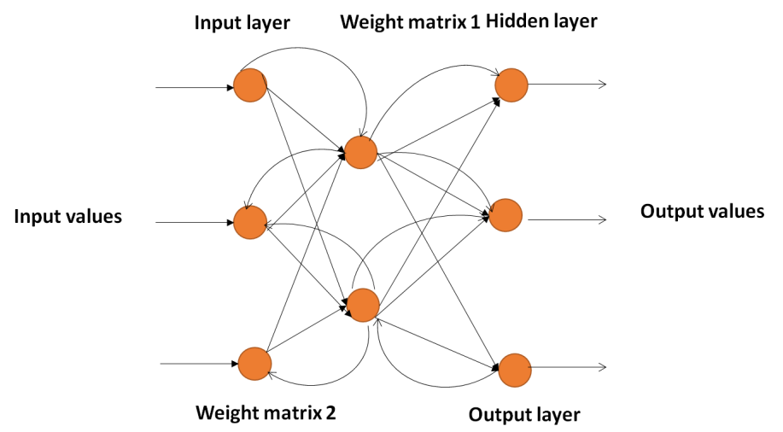
Figure 3: Structure of BPNN
Since we utilize an encoded form to express the outputs, the number of neurons is typically specified in terms of the number of different species. The standard mathematical principles of a back propagation network define all other network behavior. The three phases that make up the training of a network via back propagation are the feed-forward of the training pattern input, the computation and back propagation of the related error, and the fine-tuning of the weights and biases. During the feed-forward phase of inputs, the output of neuron in the buried layer is determined as follows:
$b_{j}=e\left(U_{jo}+a_{j}\right)$ (28)
To clarify, $o$represents network inputs, $U_{j}$ is the hidden layer's weight matrix, and $a_{j}$ is its biases. The transfer function $e$ is a bipolar sigmoid activation function.
The neural network produces a single output useful for image segmentation. In the output layer, we find $F$, the average sum of squares of the network errors, using the formula:
$F=\frac{1}{M}\sum_{j=1}^{M}{{\left(s_{j}-p_{j}\right)}^{2}}$ (29)
Where $s_{j}$is the desired value and $p_{j}$is the actual result for iteration $j$ and $M$ is the total number of training patterns. Both the hidden and output layers receive revised weights and biases as follows:
$u_{ji}\left(l+1\right)=u_{ji}\left(l\right)+η\frac{∂F}{∂u_{ji}}$ (30)
$a_{ji}\left(l+1\right)=a_{ji}\left(l\right)+η\frac{∂F}{∂a_{ji}}$ (31)
The learning rate is denoted by $η$ and the epoch number by$l$.
In addition to its poor training speed, getting stuck in local minima is another issue plaguing the traditional BPNN. In the early stages of training a BPNN, the learning process occurs rapidly throughout each epoch. The subsequent steps, however, are slower. Several techniques have been presented to enhance the original BPNN. Adaptive learning rates are frequently used to speed up the BPNN training process. The idea behind the adaptive learning rate is to enable the learning rate to fluctuate with each training session and for each weight to have its unique growth rate.
- Result Analysis
Multiple approaches have been employed in the past with varying degrees of success; in this study, we compare the suggested method to deep learning convolutional neural networks (DLCNNs), artificial neural networks (ANNs), K-nearest neighbors (KNNs), and bidirectional long short term memories (Bi-LSTMs). Using both suggested and existing methods, researchers examined key metrics like accuracy, recall, healthy and unhealthy success rates, the success average for disease detection rate, the success rate for detecting Bemisia tabaci insects, and the success rate for identifying Trialeurodes vaporariorum. To begin, the integration of computer vision Two, the Intersection over Union (IoU) method, will be used to verify the deep learning strategy. At last, unique measures will be used to verify the comparison between the two processes.
Accuracy is the degree to which a measurement's result complies with a value or standard. Accuracy and precision are required to obtain the best size. Accuracy is optional for a precise set of measures. Accuracy, in the context of mathematics,
$Accuracy= \frac{(TP + TN)}{(TP + TN + FP + FN)}$ (32)
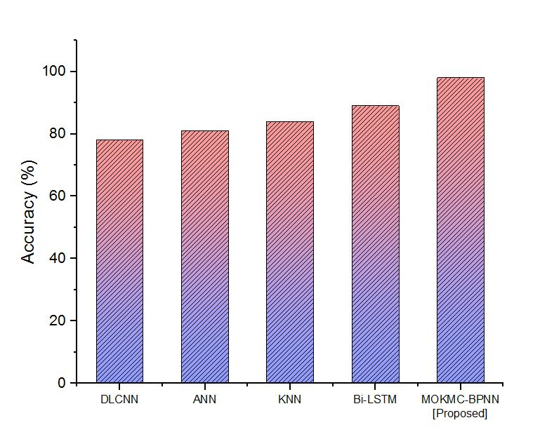
Figure 4: Comparison of the accuracy
Figure 4 shows the comparison of accurate results. Regarding significance accuracy, the proposed method, MOKMC-BPNN, outperforms conventional methods like DLCNN, ANN, KNN, and Bi-LSTM. Table 3 shows the performance analysis of the accuracy.
Table 3: Performances analysis of accuracy
Methods | Accuracy (%)
DLCNN | 78
ANN | 81
KNN | 84
Bi-LSTM | 89
MOKMC-BPNN [Proposed] | 98

One of the most important measures of accuracy is the proportion of correctly identified cases to all instances of predicatively positive data. This ratio, one of the most significant accuracy measures, is found in Equation 33. It has been established that the following operations are crucial:
Recall = $\frac{True positive}{ total number of actual positives}$ (33)
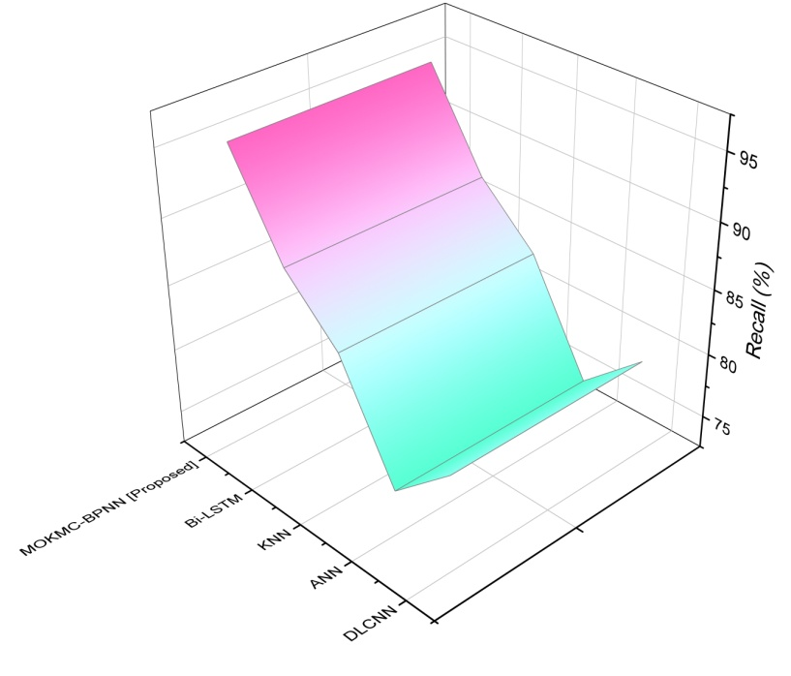
Figure 5: Comparison of the recall
The recall is seen in Figure 5. The existing method uses greenhouse pest detection to find the supporting image, outperforming DLCNN, ANN, KNN, and Bi-LSTM regarding the recall. Table 4 depicts the performance analysis of the memory.
Table 4: Performances analysis of recall
Methods | Recall (%)
DLCNN | 80
ANN | 76
KNN | 84
Bi-LSTM | 88
MOKMC-BPNN [Proposed] | 95

Figure 6: Comparison of the IoU
The measure Intersection over Union (IoU) is shown in Figure 6. The precision of the object's predicted placement on the image will be evaluated using the IoU metric. The Pascal visual object classes (VOC) are one example of a challenge that uses this measure. It may measure how well deep learning predicts objects based on the real world. Depending on the value of an IoU threshold, the results of an object detector may be accepted or ignored. In general, a prediction with an IOU greater than 0.5 is reliable.
The outcomes of each trained model's detection and identification of pests are listed in Table 5. Based on the IoU, this statistic is used to evaluate how well the deep learning system for detecting and identifying illnesses performs. The model is being assessed at the 0.5 IoU and 0.65 confidence levels.
Table 5: Pests detection and identification
Metric  ID | Egg Trialeurodes vaporariorum@0.5IOU | Egg Bemisia tabaci@0.5IOU | Insect Trialeurodes vaporariorum@0.5IOU | Insect Bemisia tabaci@0.5IOU | Insect Bemisia tabaci@0.5IOU
M1 | 0.55 | 0.17 | 0.73 | 0.35 | 0.21
M2 | 0.64 | 0.14 | 0.64 | 0.36 | 0.17
M3 | 0.59 | 0.15 | 0.66 | 0.31 | 0.33
M4 | 0.72 | 0.12 | 0.75 | 0.28 | 0.28
M5 | 0.57 | 0.16 | 0.70 | 0.33 | 0.35
M6 | 0.60 | 0.14 | 0.70 | 0.34 | 0.17

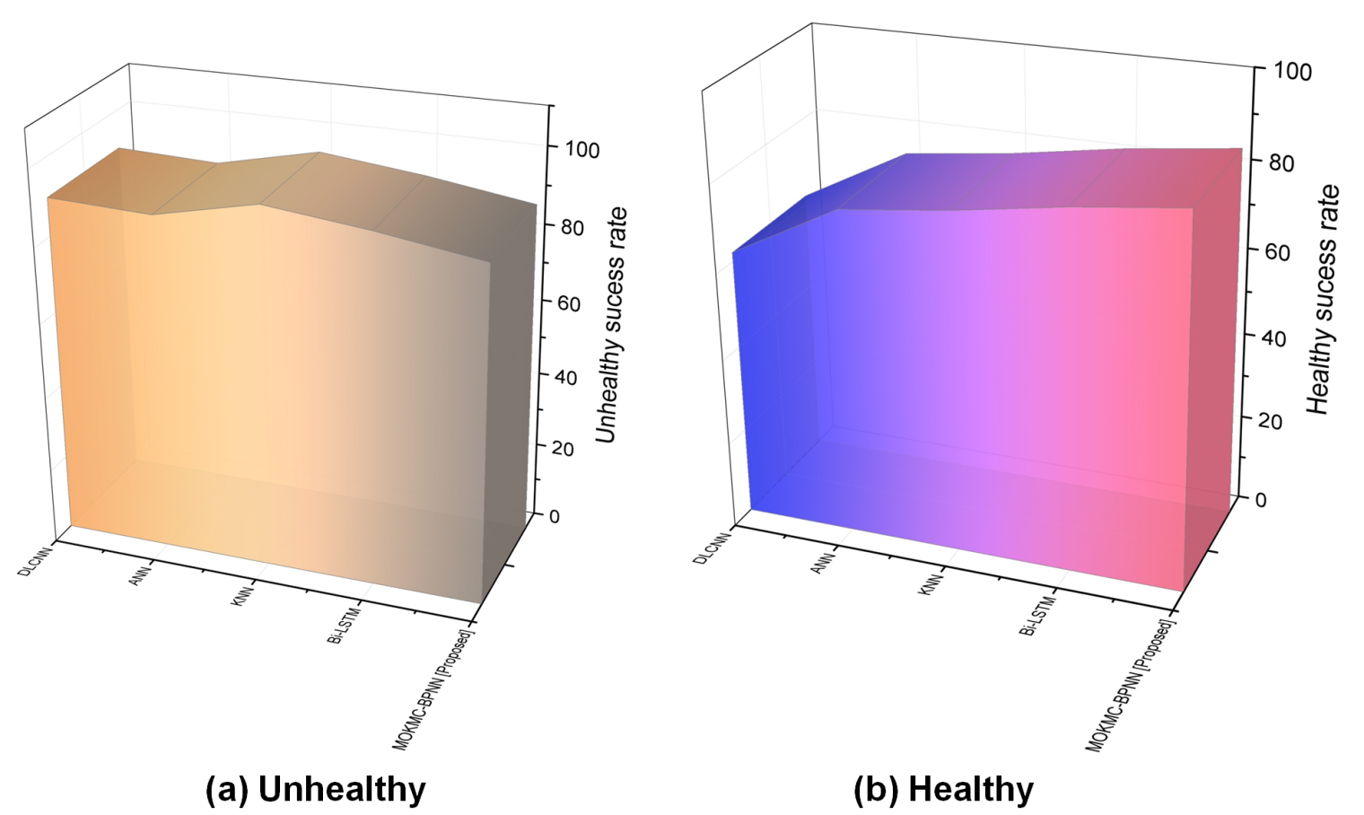
Figure 7: Success rate for Disease detection rate (a) unhealthy and (b) healthy
Results from experiments to determine which models are best at determining if an image depicts (a) unhealthy and (b) health are presented in Figure 7. The percentage and total number of samples for each model are included in the brackets. The images labeled using the image labeling tool are the ground truth against which the findings are evaluated. We frequently find disease-carrying insects or eggs in photos. As a result, the likelihood of them surviving in good health is exceedingly low. Numerous erroneous disease warnings from models are harmful to the Green Patrol effort because they promote the use of insecticides to treat a nonexistent sickness.
Table 6: Disease detection rate
Methods | Unhealthy success rate | Healthy success rate
DLCNN | 90 | 62
ANN | 89 | 75
KNN | 95 | 78
Bi-LSTM | 92 | 82
MOKMC-BPNN [Proposed] | 88 | 85

Table 6 depicts the disease detection rate. It is vital to have a model that can properly distinguish between healthy and ill plants. The suggested MOKCM-BPNN has a minimal success rate of healthy than unhealthy.
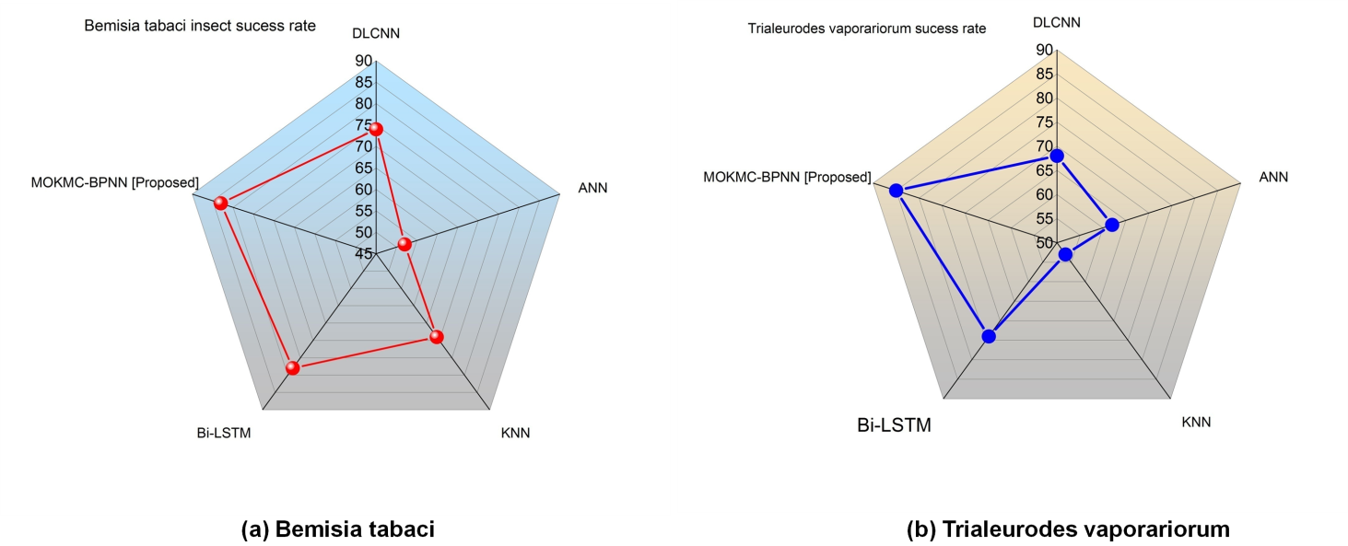
Figure 8: Pest identification (a) Bemisia tabaci and (b) Trialeurodes vaporariorum
Figure 8 depicts the (a) Bemisia tabaci and (b) Trialeurodes vaporariorum for pest identification. In cases where multiple diseases coexist in a single image (such as when eggs and a bug coexist) the one with the highest prevalence represents the true disease. The resulting data needs to be more accurate since the models incorrectly label many non-egg images. As a result, proposed and existing models cannot spot insects. The experiment demonstrates how difficult it is to detect and identify eggs. Eggs are notoriously tricky to identify and locate. There is a need for improvement in the detection of eggs, but overall is Trialeurodes vaporariorum more effective than Bemisia tabaci? Table 7 depicts the performance analysis of pest identification.
Table 7: Performance analysis of pest identification
Methods | Bemisia tabaci insect success rate | Trialeurodes vaporariorum success rate
DLCNN | 74 | 68
ANN | 52 | 62
KNN | 69 | 53
Bi-LSTM | 78 | 74
MOKMC-BPNN [Proposed] | 83 | 85

- Discussion
The parameters demonstrate that the proposed approach is superior to the current procedure, which suffers from a number of drawbacks. Some issues with the existing plan include the ones listed above. Due to the extensive computational resources required, training a DLCNN can be time-consuming and costly. DLCNN models often need a huge amount of labeled data to attain high accuracy. Such datasets might be difficult and expensive to acquire and annotate. Deep learning models, including DLCNNs, can easily be overfitted when there is a lack of data for training. To address this problem, we need to use regularization methods alongside sound validation mechanisms (Reddy et al., 2023). The initialization of ANN training weights is crucial. The efficiency of the model may change depending on the initial conditions. Choosing the right ANN architecture (the number of layers, neurons in each layer, etc.) can be challenging. Hyperparameter optimization and other complex methods are typically necessary. It can be difficult to grasp the decision-making process and interpret the learned representations in ANN models because these models are generally viewed as "black boxes" (Kasinathan et al., 2021). The memory requirements for KNN are high, especially for large datasets, because the full training dataset must be stored. When classifying a new instance, it is necessary to compute distances to all training samples. Prediction times may be lengthy for datasets containing many training occurrences. Because KNN uses distances between data points, it can produce misleading results if the features use different scales. Normalization or scaling of elements is frequently required (Singh and Kaur, 2019). However, when dealing with long sequences or deep structures, the computational cost of training a Bi-LSTM model can become prohibitive. Although LSTMs are well-suited for long-term dependencies, they may need help to capture extremely distant relationships in sequences. Overfitting is a potential issue with Bi-LSTM models because of the high number of parameters they normally include. Regularization techniques and high-quality training data are crucial for fixing (Chen et al., 2020). We found that the proposed method outperformed both the state-of-the-art and the test data in terms of efficiency.

- Conclusion
In this research, we suggested the MOKMC-BPNN for image identification of pests and diseases. We described the data of Bemisia tabaci and Trialeurodes vaporariorum massive dataset of diseased tomato plant images was collected to generate and validate models. These images have undergone preprocessing using BPDFHE to improve visual contrast. Otsu allows for the segmentation of leaf images. The features can be extracted using PCA, a technique for image compression. Accuracy, recall, IoU, healthy and unhealthy success rates for disease detection rate, Bemisia tabaci insect, and Trialeurodes vaporariorum success rate for disease identification rate were among the measures examined in this research. The proposed MOKMC-BPNN achieves 98% of accuracy, 95% of recall, 0.64% IoU, 85% healthy and 88% of unhealthy success rates for disease detection rate, 83% for Bemisia tabaci insect, and 85% for Trialeurodes vaporariorum success rate for disease identification rate. When compared to standard practices, the proposed technique fares favorably. It is necessary to add and label images at the insect level and the egg level. Finding and identifying eggs is a difficult task. Finding them via the manipulation module will be a focus of future efforts. The accuracy of the deep learning system used to detect them must be increased. Finally, the autonomous robot will be able to determine which pests to look for in the greenhouse by selecting its inspection path, the length of time it spends inspecting each plant, the number of photos it needs to analyze in real-time, and other parameters due to Integrated Pest Management.

List of Abbreviations
Brightness-Preserving Dynamic Fuzzy Histogram Equalization - BPDFHE
Mayfly Optimized K Means Clustering with Back Propagation Neural Network-MOKMC-BPNN
Principal Component Analysis-PCA
Light Detection and Ranging-LiDAR
Back Propagation Neural Network- BPNN
Deep Learning Convolutional Neural Networks –DLCNN
Artificial Neural Networks-ANN
K-nearest neighbors-KNN
Bidirectional long short term memories-Bi-LSTM
Acknowledgement:
Ministry of Education Humanities and Social Sciences Foundation Project (21YJC630126); Jiangsu University Philosophy and Social Science Project (2021SJA1364); Post-doctoral scientific research support project of Jiangsu Province (2021K295B)"
References
- Acosta, E.F.C. and Quilca, B.J.L., 2022, June. Design of a self-sustaining robot for the monitoring of carrot crop plants. In 2022 International Conference on Service Robotics (ICoSR) (pp. 152-156). IEEE.
- Barnes, E., Morgan, G., Hake, K., Devine, J., Kurtz, R., Ibendahl, G., Sharda, A., Rains, G., Snider, J., Maja, J.M. and Thomasson, J.A., 2021. Opportunities for robotic systems and automation in cotton production. AgriEngineering, 3(2), pp.339-362.
- Cao, M., Tang, F., Ji, P. and Ma, F., 2022. Improved real-time semantic segmentation network model for crop vision navigation line detection. Frontiers in Plant Science, 13, p.898131.
- Chen, C.J., Huang, Y.Y., Li, Y.S., Chang, C.Y. and Huang, Y.M., 2020. An AIoT based smart agricultural system for pests detection. IEEE Access, 8, pp.180750-180761.
- Chen, P., Xiao, Q., Zhang, J., Xie, C. and Wang, B., 2020. Occurrence prediction of cotton pests and diseases by bidirectional long short-term memory networks with climate and atmosphere circulation. Computers and Electronics in Agriculture, 176, p.105612
- Deepika, P. and Kaliraj, S., 2021, May. A survey on pest and disease monitoring of crops. In 2021 3rd International Conference on Signal Processing and Communication (ICPSC) (pp. 156-160). IEEE.
- Dharmasena, T., de Silva, R., Abhayasingha, N. and Abeygunawardhana, P., 2019, July. Autonomous cloud robotic system for smart agriculture. In 2019 Moratuwa Engineering Research Conference (MERCon) (pp. 388-393). IEEE.
- Dutta, J., Dutta, J. and Gogoi, S., 2020. Smart farming: An opportunity for efficient monitoring and detection of pests and diseases. J. Entomol. Zool. Stud, 8, pp.2352-2359.
- Elango, S., Srinigha, A., Vigashini, G.P., Vishnupriya, J. and Yashwanthi, V., 2021. Development of an Automated System for Tomato Harvesting and Pest Detection. In Microelectronic Devices, Circuits and Systems: Second International Conference, ICMDCS 2021, Vellore, India, February 11-13, 2021, Revised Selected Papers 2 (pp. 350-359). Springer Singapore.
- Gunawan, G., Sugiarto, I., Yulius, R., Yuniningsih, Y., Alanda, A. and Nasution, M.I., 2018. Pest plant disease prevention and identification system using certainty factor method. International Journal of Engineering & Technology, 7(3.2), pp.763-765.
- Gutierrez, A., Ansuategi, A., Susperregi, L., Tubío, C., Rankić, I. and Lenža, L., 2019. A benchmarking of learning strategies for pest detection and identification on tomato plants for autonomous scouting robots using internal databases. Journal of Sensors, 2019, pp.1-15.
- Kasinathan, T., Singaraju, D. and Uyyala, S.R., 2021. Insect classification and detection in field crops using modern machine learning techniques. Information Processing in Agriculture, 8(3), pp.446-457.
- Lin, S., Xiu, Y., Kong, J., Yang, C. and Zhao, C., 2023. An Effective Pyramid Neural Network Based on Graph-Related Attentions Structure for Fine-Grained Disease and Pest Identification in Intelligent Agriculture. Agriculture, 13(3), p.567.
- Liu, B., Hu, Z., Zhao, Y., Bai, Y. and Wang, Y., 2019. Recognition of pyralidae insects using intelligent monitoring autonomous robot vehicle in natural farm scene. arXiv preprint arXiv:1903.10827.
- Martin, J., Ansuategi, A., Maurtua, I., Gutierrez, A., Obregón, D., Casquero, O. and Marcos, M., 2021. A generic ROS-based control architecture for pest inspection and treatment in greenhouses using a mobile manipulator. Ieee Access, 9, pp.94981-94995.
- Maski, P. and Thondiyath, A., 2021, July. Plant disease detection using advanced deep learning algorithms: A case study of papaya ring spot disease. In 2021 6th International Conference on Image, Vision and Computing (ICIVC) (pp. 49-54). IEEE.
- Oberti, R. and Schmilovitch, Z.E., 2021. Robotic spraying for precision crop protection. Innovation in agricultural robotics for precision agriculture: A roadmap for integrating robots in precision agriculture, pp.117-150.
- Pattinson, M., Tiwari, S., Zheng, Y., Fryganiotis, D., Campo-Cossio, M., Arnau, R., Obregón, D., Martin, J., Tubio, C., Lluvia, I. and Rey, O., 2020, November. Galileo enhanced solution for pest detection and control in greenhouses with autonomous service robots. In 2020 European Navigation Conference (ENC) (pp. 1-10). IEEE.
- Rangarajan, A.K., Balu, E.J., Boligala, M.S., Jagannath, A. and Ranganathan, B.N., 2022. A low-cost UAV for detection of Cercospora leaf spot in okra using deep convolutional neural network. Multimedia Tools and Applications, 81(15), pp.21565-21589.
- Reddy, S.R., Varma, G.S. and Davuluri, R.L., 2023. Resnet-based modified red deer optimization with DLCNN classifier for plant disease identification and classification. Computers and Electrical Engineering, 105, p.108492.
- Shi, J., Bai, Y., Diao, Z., Zhou, J., Yao, X. and Zhang, B., 2023. Row Detection BASED Navigation and Guidance for Agricultural Robots and Autonomous Vehicles in Row-Crop Fields: Methods and Applications. Agronomy, 13(7), p.1780.
- Singh, J. and Kaur, H., 2019. Plant disease detection based on region-based segmentation and KNN classifier. In Proceedings of the International Conference on ISMAC in Computational Vision and Bio-Engineering 2018 (ISMAC-CVB) (pp. 1667-1675). Springer International Publishing.
- Thamaraiselvan, S., Vivin, M.I., Ronald, K., Ray, R. and Bini, D., 2023, March. LIDAR-based Navigation Rover for Fields with Smart Pest Sprayer using Machine Vision. In 2023 9th International Conference on Advanced Computing and Communication Systems (ICACCS) (Vol. 1, pp. 1889-1894). IEEE.
- Tian, Z., Ma, W., Yang, Q. and Duan, F., 2022. Application status and challenges of machine vision in plant factory—A review. Information Processing in Agriculture, 9(2), pp.195-211.
- Wang, G., Zheng, H. and Li, X., 2023. ResNeXt-SVM: a novel strawberry appearance quality identification method based on ResNeXt network and support vector machine. Journal of Food Measurement and Characterization, pp.1-12.

