**A MODIFIED DETERMINISTIC MODELING OF COVID-19 IN NIGERIA – A CASE OF CLOSED SYSTEM**

Aromolaran, A. Davidson,1 Okeke, Evelyn N.,2 Lasisi, Kazeem E.3 and David, I. John2

1Department of Statistics, Yaba College of Technology, Yaba, Lagos state

2Department of Mathematics & Statistics, Federal University Wukari, Taraba state

3Department Mathematics & Statistics, Abubakar Tafawa Balewa University Bauchi

Correspondence Email: [adeyemi.aromolaran@yabatech.edu.ng](mailto:adeyemi.aromolaran@yabatech.edu.ng)

# ABSTRACT

*Modeling is a unique area of mathematical sciences and mostly relied upon at proffering solutions to problems in all human fields (health, economy, engineering etc.) of endeavours. Inadequacy of urgent medical solution to the ravaged covid-19 pandemic in 2020 calls for alternative solutions at combatting the menace created by the scourge.* *Unlike many other works in mathematical areas of Covid-19 before the advent of vaccination, this work provides in-depth into combination of Covid-19 testing and vaccination effect in the mathematical modelling of combating efforts at curtailing the menace caused by the disease. Hence, ‘**a modified deterministic modeling of Covid-19 in Nigeria – A Case of Closed System’ is intended at making contributions to find solution to the challenges of Covid-19 pandemic. The aim of the research is to formulate a deterministic model for the Covid-19 pandemic of the 2020 in Nigeria, with objectives to formulate deterministic model, determine the disease basic reproduction number and make recommendations to control the Covid-19 according to the research findings. A disease infection flow transmission diagram was constructed identifying nine (9) population compartments with a number of assumptions, which gives the model SSVETeQIAISILR. Set of non-linear differential equations for the deterministic differential equations (DDE) were obtained and tested for positive invariance, positivity of the system solution, boundedness of solution of the system equation, equilibrium point of the system stability found to occur at point , endemic equilibrium point, and existence of endemic global stability of the deterministic models. The analyses and parameter estimation of the model was done with the aid of R-programming language and Maple software (version 20). The model Basic Reproduction Numbers was estimated at $R_{o}^{D}$ = 0.00019. The parameters ꓥ, β1, β2, βV, α, σ, k, v, ф, , ϒ, μ, and μ1, contributed to the deterministic model basic reproduction number, population recruitment rate (ꓥ), transmission rate from infected (asymptomatic – β1, symptomatic – β2, undetected but exposed - ф) population, testing rate (βV), (σ), population exposure, exposed tested get infected ($ρ$), quarantine and isolation are identified as promoting the Covid-19 epidemic infection in Nigeria. Following the findings, early closure of country’s borders to check increasing recruitment rate, introduction of social distancing, wearing of nose & mouth guide, early commencement of free testing of the disease (Covid-19), introduction of movement restriction (close-down/lock-down), compulsory Covid-19 vaccination to every vulnerable in the population, effective government quarantine and isolation (treatments) centers and immediate engagement of both medical and non-medical researchers to find solutions of different kind were recommended.*

**Keywords**: Deterministic, Modeling, Covid-19, Vaccination, Covid-19 Test, Transmission,

Basic Reproduction number, Sensitivity Analysis

## 1.0 Introduction

World Health Organization declared Covid-19 an outbreak of public health emergency of international concern on 30th January, 2020 and a pandemic on March 11, 2020 as a result of its epidemic rampant multiplicity across countries and continents of the world. The emergence of covid-19 dealt a severe and acute public health emergency due to the world, such that individual countries responded in an unpredictable manner influencing the trajectory of national epidemics. Disease pandemic has become a periodic reoccurrence in the recent times globally. Within the last two decades, there have been between two to three pandemics of different dimension and magnitude of threat to humanity, among which were HIV/AiDS, Ebola, Zika Virus, Lassa Fever and Covid-19. Covid-19 has taken a dimension that no other pandemic has ever taken in its threat to human population across the globe. The outbreak of Covid-19 has severely inflicted all human phases of live, from health to economy and social development activities. It is an outbreak that has brought a total standstill to human movements and activities in a manner that has never been experienced at least in the last two to three decades. Statistical modeling is defined as a major non-laboratory tool used to analyze, understand, and predict the course of this disease in humans (Anderson et al, 1991).

Modelling is one of the most utilized mathematical strategies to mitigate effect of disease transmission in epidemiology study, and it has been found to be of significant application in epidemic studies like we have in covid-19 infection. Since the beginning of the ongoing global COVID-19 pandemic, there have been many non-pharmaceutical efforts (mathematical modeling) to study its transmission, control and finding lasting solution to address the generated public health nuisance it has created.

Egger, *et al.* (2017) reported the conclusion reached at the Geneva workshop on developing WHO guidelines on the use of modelling studies routinely. It was stated that findings of mathematical modelling studies can provide important evidence that may be highly relevant. They further stated that evidence from modelling studies should be considered specifically in the absence of empirical data directly addressing the question of interest. The team agreed that in the recent years, the number of mathematical modelling studies have increased steeply, while many questions addressed in the studies are relevant to the development of world health organization (WHO) guidelines. Modern epidemiology aims at modeling the spread of a disease and show that if certain conditions are met, then a disease will become extinct. Unlike many other works in mathematical field of research on Covid-19 before the advent of vaccination, this work intends to provides in-depth into combination of Covid-19 testing and vaccination effect in the mathematical modelling of combating efforts at curtailing the disease transmission. The aim of this research is to formulate a deterministic model of Covid-19 distribution in Nigeria, that will enable control measure which will bring about reduction in its spread in the country and estimate the model basic reproduction number.

Application of deterministic differential equations in epidemic disease modelling and Covid-19 in particular, has becoming so popular in applied mathematics field of study and has helped significantly. This is one of many demonstrations that illustrate the importance of mathematics within our history, especially within astronomy and physics (Joshua Carroll, 2015). Mathematical model has been identified to have significantly entrenched into solving many real live problems and have many advantages over other models., among which are system performance optimization, prediction and so on. Mathematical modelling is one of the few known scientific approaches to studying the spread, predicting possible outcomes and evaluating the effectiveness of control strategies. Infectious disease modelling is generally conducted to understand disease transmission dynamics and the effectiveness of health intervention such as vaccination (Earn, 2008).

Hethcote (2000) opined that the deterministic epidemiology modeling seems to have started in the 20th century, while Trottier *et al*. (2000) claims that deterministic model is a compartmental model. In deterministic models, a large population is divided into smaller groups called *compartments* (or *classes*) where each group represents a specific stage of the epidemic. Such models, often formulated in terms of a system of differential equations (in continuous time) or difference equations (in discrete time), attempt to explain what happens on the average at the population scale (Dadlani *et al*. 2020).

A deterministic system is a model in which no randomness is involved in the development of future states of the system. A solution of a deterministic model is a function of time or space and is generally uniquely dependent on the initial data. Trottier *et al*. (2000) explained that deterministic modeling principle is stemmed on the nonlinear dynamics of infection spread in a population and that it is a simple model that can help one to identify the factors controlling the persistence and stability of transmitted infections within large human populations. Most of the statistical models used in describing spread of epidemic diseases employ traditional compartments like susceptible-exposed-infected-recovery (SEIR) structure as exposited in many research literatures of disease modelling. All these models are deterministic type and do not consider uncertainty and some variations in the parameters as it is obvious in the case of a growing epidemic. In particular, it has been shown that uncertainty is certain in the disease transmission rate of Covid-19.Peter, *et al*. (2021) in their work on Analysis and Dynamics of Fractional Order Mathematical Model of Covid-19 in Nigeria Using Atangana-Baleanu Operator, proposed a mathematical model of the coronavirus disease 2019 (Covid-19) to investigate the transmission and control mechanism of the disease in Nigeria. The work adopts a combination of mathematical methods of deterministic approach, ranging from Atangana-Baleanu fractional derivative operator and existence criteria of solution to Laplace transformation to obtain some numerical simulations. Stability theory of differential equations was used to evaluate the qualitative behaviour of the model. The model was built on the human population subdivided into six compartments of susceptible - S(t), exposed –E(t), infected without exhibiting any sign and symptoms and are undetected}, quarantined –Q(t) {infected or suspected case going through incubation period before symptoms are noticeable}, infected –I(t){infected with sign and symptoms and are highly infectious but not yet quarantine or isolated}, confirmed cases of Covid-19 from quarantine category –C(t), and recovery population –R(t) {represents recovery after treatment}.

Adaka *et al*. (2021) in their study involving 228 days’ time series data of confirmed death cases of Spain for the time when the Covid-19 positive cases were only 6 with zero death. The study was a four-compartment model tagged SLIR (susceptible; latent; infectious and recovered) - . According to Earn (2008) the numbers of individuals in each sub-population must be an integer, but if the population size N is sufficiently large, we can treat *S*, *I* and *R* as continuous variables and express our model for how they change in terms of a system of differential equations. Each infected individual runs through the course of sickness and finally gets removed from the number of the sick by recovery or death, (Kermack *et al*. 1927). According to Trottier and Philippe (2000), examined the application of the two analytical methods of deterministic model, Difference and Differential equation methods. From their evaluation we had the followings as outlined below: Deterministic models can be analyzed using either of difference or differential equations. Difference equations considers the transitions among the classes of disease compartments using discrete time steps and the number of cases at a given time from the preceding time t. Deterministic models exhibit damped oscillations which shows random variations, and prediction of the spread of infectious diseases.

More of the research works in models of infectious disease have employed deterministic model approach because of its number of advantages and flexibility. Among these advantages are, they require less data, relatively easy to set up, and availability of user-friendly computer software for data analyses. The dynamics of the SEIR model are now well understood so that deterministic models are commonly used to explore whether a particular control strategy will be effective. Models are generally classified into predictive and explanatory; it is therefore important to differentiate between them for good understanding before their application.

Trottier and Phillippe (2000) in their work explained that Predictive modeling uses complex models in the hope to mimic observation as closely as possible, while explanatory modeling is rather concerned with capturing the main features of a dynamic given some assumptions. Anderson and May (1991) in their work on Infectious diseases of human dynamics and control stated that explanatory modeling can help to interpret observed epidemiological trends, guide the collection of data towards and design programs for the control of infectious diseases. It was concluded that explanatory deterministic models exhibit damped oscillations, show random variations (in chaotic regime), and predict the spread of infectious diseases. Similarly, Iboi, *et al*. (2020) through their work on mathematical modeling and analysis of Covid-19 pandemic in Nigeria developed a model by splitting the total human population at given time *t,* denoted by , into the six mutually-exclusive compartments (susceptible S(t), exposed E(t), symptomatically-infectious (IS), asymptomatically-infectious Ia(t), hospitalized Ih(t) and recovered R(t) individuals). Mathematical models translate real-world problems into controllable mathematical formulations whose analysis will be capable of providing insight, results and direction useful for the originating application. Deterministic model is mathematically easier, while stochastic model is more complex and can be computationally intensive. Bailey (1964) and Robert et al (2009) opined that for a large population size, a deterministic model is more appropriate.

2. 0 The Covid-19 Model Designed, Its Assumptions and Parameter Description

This work will be developing deterministic model of transmission of Covid-19 with continuous vaccination testing, by considering asymptomatic and symptomatic individuals. The individuals in the population are classified into compartments depending on their status with regards to the infection under study and assumptions surrounding the time rate of transforming from one status to another. The total population NN for this study is divided into nine (9) population compartments. The compartments are non-vaccinated susceptible – , vaccinated susceptible – , exposed – *E*, Covid19 Test – , asymptomatic infected – *IA*, symptomatic infected – , quarantined – *Q*, isolation - , and recovered - *R*. The total number of the population *N* by its sub-population is given by

Which can be rewritten at a given time t as;



For the purpose of this study, every Nigerian state resident regardless of their age and gender, in the population falls into either of the two susceptible compartments of the Covid-19  or . The SN are the unvaccinated susceptible individuals of the population *N*, while the SV are the vaccinated and susceptible individuals among the . The vaccine can become impotent and as such the vaccinated susceptible gets transferred back to become unvaccinated susceptible. The susceptible by their activities become exposed to the virus, hence becomes the exposed *E*, which are subjected to screening through test . The exposed tested gets classified into infected but shows no symptom, virus undetected, which are transferred to quarantine *Q*, infected but show no symptoms and tested positive which are transferred to the asymptomatic class IA and infected, show symptoms and tested positive are classed symptomatic IS. After the latent period ends, those quarantined *Q* will either do not show any symptom and tested negative to return back to the susceptible, while those that tested positive transits to isolation IL for treatment along with those from asymptomatic and symptomatic. The individuals from compartment IA transits into IS from where they all transit to isolation. The individuals in Isolation IL, are treated before transmitted to the recovered (*R*). Also from recovered *R*, the individuals get transited back to the susceptible  since the disease has no permanent cure. Hence, it is assumed that μ parameter as contained in the compartments SN, and SV are death caused by natural occurrence, while μ1 represents deaths believed caused by the disease Covid-19 as displayed in the compartments and R. The susceptible population is increased and decreased respectively at a rate of ‘*ꓥ*’ per unit time. *ꓥ* is a parameter representing the net inflow into susceptible by new birth and  by natural and Covid19 induced deaths respectively. The susceptible (non-vaccinated) gets exposed and infected with Covid-19 through the infectious individuals at rates  and , while the vaccinated gets infected at rate . Every model is a simplification of reality and is never free of assumptions (Leung, 2019). This Covid-19 model being built around a number of assumptions upon which its mathematical equations will be formulated.

The total population is homogenous and constant in size *N*

Containment rate μ is introduced into the susceptible population

The vaccine is imperfect, has tendency to fail. It helps to boost immunity to fight the SARS-COV-2 and the vaccinated individuals has a probability to get infected at rate $β_{v}$

SARS – COV - 2 can stay in the host body for at least 14 days (S. Pappas, 2020).

The Covid-19 test enables separation of the exposed population into the undetected exposed, asymptomatic and symptomatic populations respectively

Infected/infectious host whose immune fights off the virus completely with no single virus left progress to the recovered class – R

Individuals with symptoms and those tested positive but no symptoms will be isolated at government centers and get treated with application of pharmaceutical treatments .

It is assumed that the disease is fatal and there is possibility of death due to the disease. Hence, any death by person infected is assumed to have died from the disease.

Quarantine state is not the same as Isolation state.

It is assumed that quarantine is merely for separation of undetected infected and infectious exposed individual from the population, from where they can manifest the disease and taken to the isolation or be declared free of virus for susceptible compartment

**Table 1: Model Parameter Description**

|  |  |
| --- | --- |
| Symbols | Parameter Description |
|  | Recruitment rate of the susceptible population |
| μ | Natural mortality rate |
| μ1 | Natural mortality rate plus Covid-19 death induced |
| β1 | Prob. of transmission from asymptomatic infected |
| β2 | Prob. of transmission from symptomatic infected |
| βv | Probability of vaccinated get back to susceptible |
| $$γ$$ | Rate of vaccination |
| Z | Rate of transition from Quarantine to Susceptible |
| σ | Rate at which Exposed population gets tested |
| ф | Transition of undetected Exposed to Quarantine |
|  | Proportion of tested Exposed becomes Infected |
| α | Prob. of tested Exposed people becomes Infected |
| λ | Rate of transition from Quarantine to Isolation |
| k | Rate of transition of asymptomatic infected to Isolation |
| ϒ | Rate of symptomatic being transferred to Isolation |
| ꭕ | Rate of Isolated individuals become Recovered |
| $$∇$$ | Rate of Recovered individual transits to Susceptible |
| V | Proportion of asymptomatic that did not transit into symptomatic |

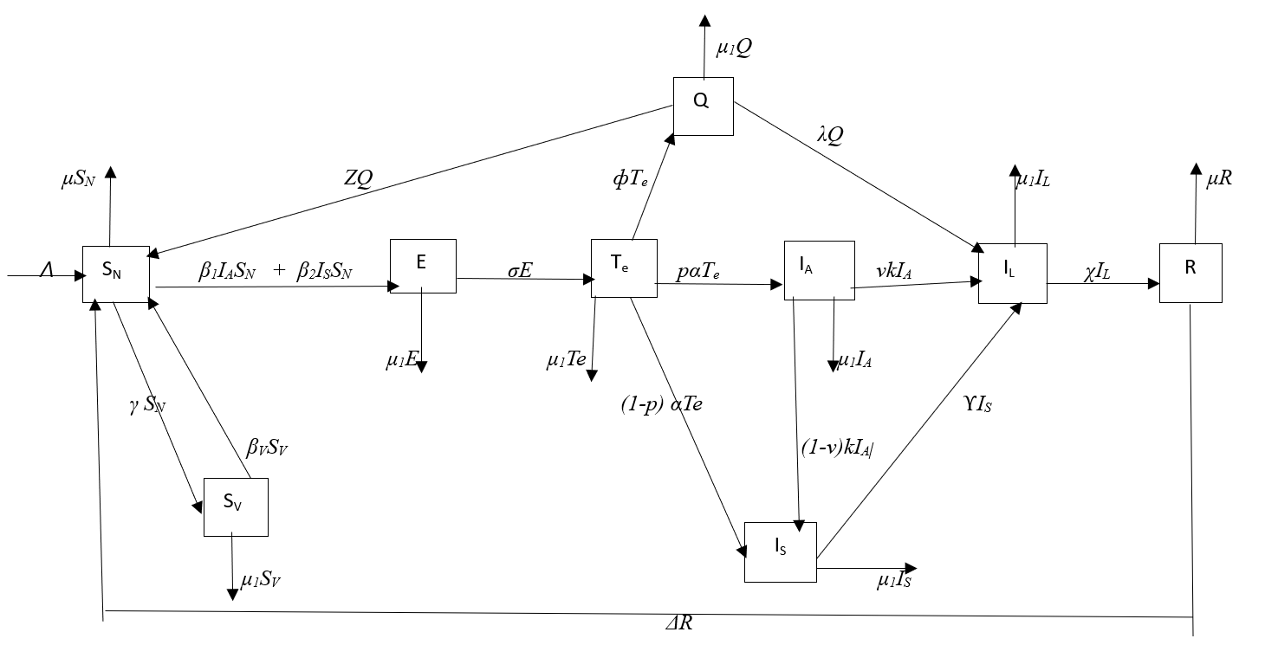

**Figure 1.0: Proposed Schematic Model of Covid-19 Transmission by Nine Compartment Sub-Population Interactions**

Based on the interaction diagram presented above in figure 3.0, the covid-19 transmission model with it’s appropriate in-flow and out-flow rates of each compartment and parameters are constructed as follows in the system of deterministic differential equations below:

 1

With initial conditions, where the model parameters are non-negative.

Where, 

The proposed COVID-19 model 2.0 above can be re-written as presented in 2.1 with



 2.1

2.1 Model Basic Properties

2.1.1 Positive Invariance

Theorem 2.1.1 All the variables defined in (1) above denotes population and all are non-negative at a given time with all the initial conditions being non-negative. Hence,  for non-negative initial conditions.

Therefore,  2.2

Proof

and remains non-negative for all . The summation of all the factors in system (2.0) will yield a differential equation for the total population as  2.3

Then, solution of the above (equation 2.3) will give,  where is the initial total population. As , then . The visible domain of equation (2.2) becomes; .

Thus, the model is positively invariant 

2.1.2 Positivity of the Solution of System 2.0

Theorem 2.1.2 Let

, 2.4. Then, of the equation 2.4 are positive for all times.

Proof:









Then applying the initial conditions and solving using separation of variables, we get

 2.5

 2.6

Also, from the equation sixth of 2.0 (*IA*(*t*))









Therefore,  2.7

Similarly for the seventh, eighth and ninth equations of 2.0, we get

 2.8

 2.9

 2.10

Therefore, the proposed model 2.0 is positive for all t 0

2.1.3 Boundedness of Solution of the System of Equation

Theorem

All solution of system of equation 2.0 are bounded for all .

Proof:

Since 

We get

 2.11

Assuming that 

Then,  2.12

Hence, we have 

Then, all solutions of the system 2.0, are ultimately bounded for all 

3 The Covid-19 Model Analysis

The formulated model is analysed to obtain the disease-free equilibrium point and the endemic equilibrium point as well as their global stabilities. Also the basic reproduction number is obtained.

3.1 Disease-Free Equilibrium

Let *E*0 be the disease-free equilibrium. At disease-free equilibrium, the infection is absent . At equilibrium, the rates of change are equal to zero.

 2.13

Then, from equation (2.1), we have

 2.14

 2.15

From (2.15),

 2.16

Substituting (7) into (5), we have

 2.17

Putting (2.17) into (2.15), we have

 2.19

Therefore, the disease-free equilibrium *E*0 is given by

 *E0*= (*SN, Sv, E, Te, Q, IA, IS, IL, R*)

2.20

3.2 Endemic Equilibrium

The endemic equilibrium point is a point where the disease is prevalent

(i.e. *E* ̸= *Te* ̸= *Q* ̸= *IA* ̸=*IS* ̸= *IL* ̸= 0).

Let *E*1* = (*SN*, SV*, E*\**, Te*, Q*\**, IA*, IS*, IL*, R*\*) denote the endemic equilibrium.

Setting the rates of change of the model (3.12) to zero leads to

 2.21

 2.22

 2.23

 2.24

 2.25

 2.26

 2.27

 2.28

 2.29

Solving the equations 2.21 – 2.29, we obtain

 2.30

By substitution and simplifying further we have

2.31

Evidently, from 2.31, the COVID-19 model (2.1) has a positive unique endemic equilibrium when *R0**> 1*.

3.3 Global Stability of the Endemic Equilibrium

The global stability of the endemic equilibrium is explored here. The Goh-Voltera type of Lyapunov function will be used to investigate the global stability of the endemic equilibrium for a case when

*ρ* = 1*, v* = Δ = σ = 0. Let the associated reproduction number be ˆ*R*0 = *R*0 *ρ*=1*, v* = Δ = σ = 0.

Theorem 3.3 The *endemic equilibrium of the COVID-19 model* (2.1) *with ρ* = 1*, v* = Δ = σ = 0 *is globally asymptotically stable whenever the associated reproduction number* ˆ*R*0 *>* 1*.*

*Proof.*

The Goh-Voltera type of Lyapunov function will be used to prove the theorem. Consider

 2.32

The time-derivative of 2.32 is

 2.33

Substituting the right-hand side of (2.1), we have

 2.34

But at steady state,, then (2.34) becomes

 2.35

Expanding 2.35, it gives

 2.36

Collecting the infected terms with asterisks to form the following equations:

 2.37

 2.38

 2.39

 2.40

 2.41

From (2.38),  2.42

 2.43

 2.44

From (2.40),  2.45

 2.46

Also, from (2.41)  2.47

From (2.41),

 2.48

Substituting (2.44), (2.46), (2.47), (2.48) into (2.36) and simplifying, we have

 2.49

At steady state, we have the following from model (2.1) for a case when *ρ* = 1*, v* = Δ = Σ = 0:

 2.50

 2.51

 2.52

 2.53

 2.54

 2.55

 2.56

By substituting (2.51) - (2.56) into (2.49) and simplifying further we have

 2.57

With the arithmetic mean greater than the geometric mean, then we have the following inequalities:



3.4 Model Parameter Estimation

The table 3.1 below, shows the details of how initial values of the individual parameters of the model were obtained from estimation and from literatures of similar works with this research, to generated the parameters values used to solve the set of non-linear differential equations 3.12 using R-Programming Language (version 4.2) and MAPLE software (version 20).

**Table 2: Initial values of Parameter Estimation from Proposed Model Analysis**

**(unit: /day/week)**

|  |  |  |  |  |
| --- | --- | --- | --- | --- |
| Symbols & Parameter Description | | Value | Unit | Reference |
| ꓥ | Recruitment rate of the susceptible population | 36400 | per103 pp | Nigeria Birth Rate 2022 |
| μ | Natural mortality rate | 10.994 | per103 pp | Nigeria Death Rate 2022 |
| μ1 | Natural mortality rate plus Covid-19 death induced | 1.124 | 1/day | Estimated |
| β1 | Prob. of transmission from asymptomatic infected | 1.727E-7 | 1/day | Anggriani *et al* (2021) |
| β2 | Prob. of transmission from symptomatic infected | 7.474E-8 | 1/day | Anggriani *et al* (2021) |
| β*v* | Probability of vaccinated get back to susceptible | 0.0005 | 1/day | Tesfaye &Satang (2021) |
| $γ$ | Rate of vaccination | 0.5000 | 1/day | Estimated |
| Z | Rate of transition from Quarantine to Susceptible | 0.0680 | 1/day | Peters *et al* (2021) |
| σ | Rate at which Exposed population gets tested | 0.7000 | 1/day | NCDC (ncdc.gov.ng ) |
| ф | Transition of undetected Exposed to Quarantine | 0.1818 | 1/day | Evensen *et al* (2020) |
| P | Proportion of tested Exposed becomes Infected | 0.2000 | 1/day | Anggriani *et al* (2021) |
| α | Prob. of tested Exposed people becomes Infected | 0.0714 | 1/day | Estimated |
| λ | Rate of transition from Quarantine to Isolation | 0.1430 | 1/day | Estimated |
| K | Rate of transition of asymptomatic infected to Isolation | 0.1900 | 1/day | Belkhiria &Nascimento, Ohajunwa *et al* (2020) |
| ϒ | Rate of symptomatic being transferred to Isolation | 0.1900 | 1/day | Belkhiria &Nascimento, Ohajunwa *et al* (2020) |
| ꭕ | Rate of Isolated individuals become Recovered | 0.7310 | 1/day | Nino-Torres *et al* (2022) |
| $∇$ | Rate of Recovered individual transits to Susceptible | 0.1500 | 1/day | Tilahun &Alemneh (2021) |
| V | Proportion that did not transit into symptomatic | 0.9000 | 1/day | Assumed |

**Table 3: The Initial Values Generated through R – Programming Language**

|  |  |  |
| --- | --- | --- |
|  | Initial values | |
| Parameters | Im_est | Nls_est |
| $$Λ$$ | 3.220E+01 | 3.644E+01 |
| $$Υ$$ | 1.098 | 1.1020 |
| $$β_{v}$$ | 1.713E-02 | 1.791-02 |
| Z | 4.205E-01 | 4.465E-01 |
| $$β_{1}$$ | 6.754E-03 | 7.884E-03 |
| $$β_{2}$$ | 4.835E-04 | 5.100E-04 |
| $$γ$$ | 1.156E-01 | 1.790E-01 |
| σ | 1.2310 | 1.1150 |
| $$μ$$ | 3.2162 | 3.4662 |
| p | 6.458E-02 | 6.68E-02 |
| α | 7.376E-02 | 7.200E-02 |
| ф | 5.252E-01 | 5.250E-02 |
| λ | 7,125E-01 | 7.100E-01 |
| $$μ_{1}$$ | 1.4050 | 1.4300 |
| k | 0.2000 | 0.2100 |
| v | 0.3010 | 0.3000 |
| χ | 3.015E-02 | 3.900E-02 |
| $$∇$$ | 0.1428 | 0.1460 |
|  |  |  |

*Remark: Result from R – programming language was used to generate the Initial values for Maple to run the Solutions for the Model Differential Equations*.

3.5 The Basic Reproduction Number

This is a key epidemiological parameter or index as the expected number of infected individuals from an infectious person in a totally or partially susceptible population respectively or the average number of new infections generated by a single infected individual in a completely susceptible population (Shaw and Kennedy, 2021).. Using the next generation method, the values of  can be obtained from the maximum or dominant eigenvalue of . The *F* and *V* are Jacobian matrices of f(newly infected matrices) and v (existing matrices) that are evaluated from the disease-free equilibrium point above.

F =  2.58

And

V =  2.59

Then

 2.60

Where;



With the values of the parameters as displayed in table 4.2, and *ρ* is the spectral radius of the dominant eigenvalue of the matrix *FV* −1. The basic reproduction number is

$R_{o}^{D}$ = 0.0000295

**4. Numerical Simulations**

**Parameters Variation on the Deterministic Basic Reproduction Number (Ro)**

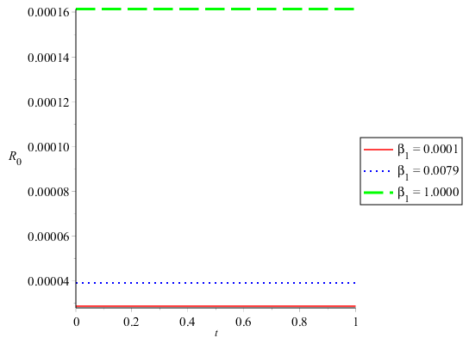 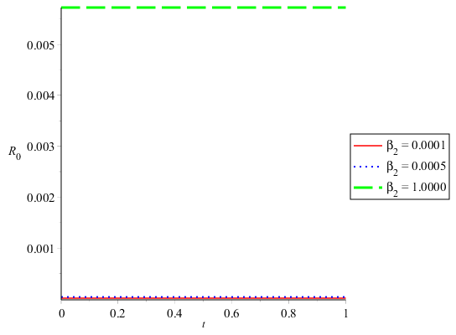 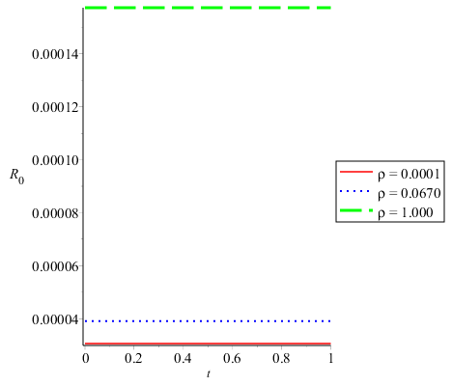

**A:Transmission Rate from Asymptomatic B: Transmission Rate from Symptomatic E:Proportion of Tested Exposed**

**infected Population ( $β_{1})$ on Ro infected Population on Ro people becoming Infected ($ρ$) on Ro**

Ro = 0.000039, $β_{1}$ = 0.0001, 0.0079, 1.00 Ro = 0.000039, $β_{2}$ = 0.0001, 0.0005, 1.00 Ro = 0.000039, $ρ$ = 0.0001, 0.067, 1.00

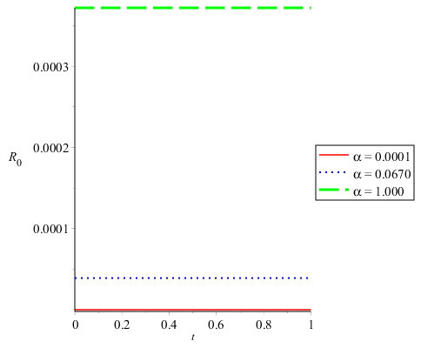 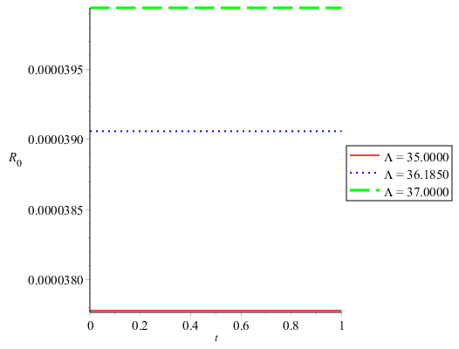

**F: Probability of Tested Exposed People N: Recruitment Rate on Ro**

**becoming Infected ($α$) on Ro**

Ro = 0.000039, α= 0.0001, 0.067, 1.00 Ro = 0.000039, $Λ$ = 35.00, 36.185, 37.00

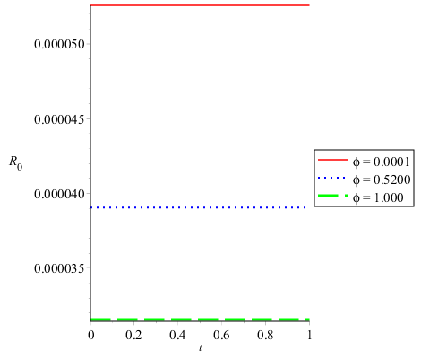 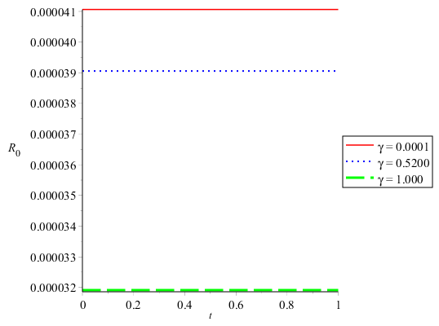 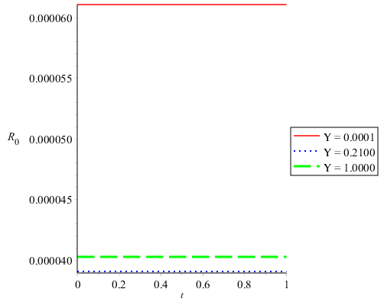

**H:** **Rate at which undetected exposed people I: Rate of Vaccination on Ro K: Rate of Infected Symptomatic being**

**get Quarantined on Ro transferred**

Ro = 0.000039, ф= 0.0001, 0.5200, 1.0000 Ro = 0.000039, $γ$ = 0.0001, 0.5200, 1.000 Ro = 0.000039, ϒ= 0.0001, 0.210, 1.00

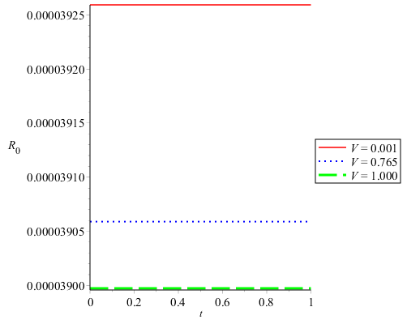

**M: Rate of Asymptomatic infected People become**

**infected Symptomatic on Ro**

Ro = 0.000039, V = 0.001, 0.765, 1.000

Figures 4.18 (A, B, E, F & N) shows that as the value of the parameters β1 (transmission rate from asymptomatic infected population); β2 (Transmission rate from symptomatic infected population); $ρ$ (proportion of tested exposed people becoming infected); α (probability of tested exposed people becoming infected), and ꓥ (the recruitment rate) increases, value of basic reproduction number (Ro) increases as well. With figures 4.18 (H, I, K, & M) as the values of the parameters increases, ф (rate at which undetected exposed people get quarantined); $γ$ (rate of vaccination); ϒ (rate of Infected symptomatic being transferred to isolation) and v (rate of Asymptomatic infected people become Symptomatic) increases, the value of basic reproduction number decreases.

**5. Discussion**

The formulated model 3.11 was tested and found to be positively invariant, positivity and ultimately boundedness of the solution. The valid results for the dynamical behaviours of the stationary distribution are achieved, with the disease-free equilibrium lies at point  has been established in 3.6.4. The global stability of the endemic equilibrium and the disease equilibrium were found existing. Also established that the model system of equations is epidemiological well-posed, and realistic, if all the variables of the system are positive for all time (*t*). The model basic reproduction number, which is a milestone in every epidemic. It can be established that the disease-free equilibrium is locally asymptomatically stable almost surely since ( 0.0000295).

From the deterministic model as shown in table 4.3, the parameters ꓥ (recruitment rate), β1 (probability of transmission from asymptomatic infected), β2 (Probability of Transmission from symptomatic infected ), βV (Probability of vaccinated get back to susceptible), α (probability of tested exposed becomes infected), σ ( Raet at which exposed population get tested), μ (natural mortality rate) and p (proportion of tested exposed becomes infected), k( Rate of Transition of asymptomatic infected to Isolation), v(Proportion of asymptomatic that did not transit to symptomatic), μ1( Natural mortality rate plus Covid-19 death induced), λ (Rate of transition from Quarantine to Isolation), ϒ (Rate of symptomatic being transferred to Isolation), ф (Transition of undetected exposed to Quarantine), Z (Rate of transition from Quarantine to Susceptible) and $γ$ ( Rate of vaccination) are found to have significant effect on the Covid-19 transmission. Lim *et al*. (2020) reported that the presence of asymptomatic and undetected cases of Covid-19 may bias the estimation of basic reproduction number (Ro), since certain proportion of infected persons would be asymptomatic at the population level. Several studies have calculated using mathematical, statistical or stochastic methods in different populations for COVID-19, Iyaniwura et al (2022) in a study of nineteen African countries, estimated the basic reproduction number of Covid-19, which varies from 1.98 (Sudan) to 9.66 (Mauritius) with Nigeria having 3.86. Hilton and Kneeling (2020) opined that the estimate being highly dependent of the complexity of the mathematical model used. Hence, Ro values are dependent on the model structures and assumption made.

6.0 Conclusion and Recommendation

From the findings, it is concluded that there are two equilibria point (disease-free equilibrium and endemic equilibrium) and existence of global stability. The disease free-equilibrium is globally asymptomatically stable when Ro < 1. The endemic equilibrium was obtained and is globally asymptomatically stable when the associated reproduction number (Ro > 1). Population recruitment rate during Covid-19 (ꓥ), Covid-19 virus transmission rate from infected (asymptomatic – β1, symptomatic – β2, undetected but exposed - ф) population members, Covid-19 testing rate (βV), (σ), population exposure, exposed tested get infected ($ρ$), quarantine and isolation are identified as promoting the Covid-19 epidemic infection in Nigeria. It is a known fact that Covid-19 has come to live with human population and the possibility of re-occurrence as already being experienced in some populations globally is a testimony to this. In line with the set-out objectives of the research, the deterministic model of Covid-19 transmission has been formulated by considering the infected population with asymptomatic and symptomatic. The result obtained from this study can be used for future study of any epidemic or pandemic disease control in a nation with high population size. Based on the findings from this research, the followings are being proposed to manage the present situation of Covid-19 or its future re-occurrence and other related epidemic or pandemic in Nigeria. Prompt address of the susceptible population recruitment by closing the nations border avoiding migration at the onset of the disease outbreak, immediate introduction of social distancing, and wearing of nose & mouth mask/guide etc. to control the transmission rates from (asymptomatic, symptomatic, undetected but exposed) population members identified, early commencement of free disease testing (Covid-19 testing rate) and accessibility to the population members. Also, Movement restrictions policies like system close-down or lock-down before the infection gets to an epidemic state and compulsory Covid-19 vaccination to every vulnerable population members at affordable or no cost.

# REFERENCES

Adakal, D., Majumder, A. and Bairagi, N. (2021) Mathematical perspective of Covid-19 pandemic: Disease Extinction Criteria in Deterministic and Stochastic Models, Chaos, Solitons and Fractals, <https://Doi.org/10.1016/j.chaos.2020.110381>

Anderson R. M. (1988). The Role of Mathematical models in the study of HIV transmission and the Epidemiology of AIDS, 1:241–56.

Anderson, R. M. & May, R. M. (1991). Infectious Diseases of Humans, Oxford University Press, Oxford.

Anggriani, N., Ndii, M., Amelia, R. & Suryaningrat, W. (2021). A Mathematical COVID-19 model considering Asymptomatic and Symptomatic classes with waning immunity, *Alexandria Engineering Journal*. <https://doi.org/10.1016/j.aej.2021.04.104>

Covid-19 Vaccination in Nigeria. [https://en.wikipedia.org/w/index.php?title=COVID- 19_vaccination_in_Nigeria&oldid=1116696626](https://en.wikipedia.org/w/index.php?title=COVID-%20%20%20%20%20%2019_vaccination_in_Nigeria&oldid=1116696626) Retrieved 10th April 2023 from

Dadlani, A., Afolabi, R. O., Jung, H., Sohraby, K., & Kim, K. (2020). Deterministic models in epidemiology: from modeling to implementation. *arXiv preprint arXiv:2004.04675*.

Earn, D. J. (2008). A light introduction to modelling recurrent epidemics. In *Mathematical epidemiology* (pp. 3-17). Berlin, Heidelberg: Springer Berlin Heidelberg.

Eastin, C., & Eastin, T. (2020). Epidemiological characteristics of 2143 pediatric patients with 2019 coronavirus disease in China: Dong Y, Mo X, Hu Y, et al. Pediatrics. 2020. *Journal of Emergency Medicine*, *58*(4), 712-713.

Egger, M., Johnson, L., Althaus, C., Schöni, A., Salanti, G., Low, N., & Norris, S. L. (2017). Developing WHO guidelines: time to formally include evidence from mathematical modelling studies. *F1000Research*, *6*., 15-84.

Hethcote, H. W. (2000). The mathematics of infectious diseases. *SIAM review*, *42*(4), 599-653.

Hethcote, H. W., & Yorke, J. A. (2014). *Gonorrhea transmission dynamics and control* (Vol. 56). Springer.

Hilton, J., & Keeling, M. J. (2020). Estimation of country-level basic reproductive ratios for novel Coronavirus (SARS-CoV-2/COVID-19) using synthetic contact matrices. *PLoS computational biology*, *16*(7), e1008031. [https://doi.org/10.1016/j.cca.2020.05.044 0009-8981/](https://doi.org/10.1016/j.cca.2020.05.044%200009-8981/).

Iboi, E. A., Sharomi, O., Ngonghala, C. N. & Gumel, A. B. (2020). Mathematical modeling and A Analysis of COVID-19 pandemic in Nigeria, *Journal of Mathematical Biosciences and Engineering*, 17(6), 7192-7220.

Iyaniwura, S. A., Rabiu, M., David, J. F., & Kong, J. D. (2022). The basic reproduction number of COVID-19 across Africa. *Plos one*, *17*(2), e0264455.

Jiafeng P. (2013). Stochastic SIS Epidemic Model and Corresponding Statistical Inference. A Ph.D Thesis, Department of Mathematics and Statistics, University of Strathelyde.

Joshua Carroll (2015). Mathematics: The Beautiful Language of the Universe. *In Universe Today*, retrieved 10th January 2023 from [www.universetoday.com](http://www.universetoday.com)

Keeling, M. (2005). The implications of network structure for epidemic dynamics. *Theoretical population biology*, *67*(1), 1-8.

Kermack, W. O., & McKendrick, A. G. (1927). A contribution to the mathematical theory of epidemics. *Proceedings of the royal society of london. Series A, Containing papers of a mathematical and physical character*, *115*(772), 700-721.

Leung, N. N. (2019). *Models of infectious disease transmission to explore the effects of immune boosting* (Doctoral dissertation, University of Melbourne, Parkville, Victoria, Australia).

Lim, J. S., Cho, S. I., Ryu, S., & Pak, S. I. (2020). Interpretation of the basic and effective reproduction number. *Journal of Preventive Medicine and Public Health*, *53*(6), 405.

Niño-Torres, D., Ríos-Gutiérrez, A., Arunachalam, V., Ohajunwa, C., & Seshaiyer, P. (2022). Stochastic modeling, analysis, and simulation of the COVID-19 pandemic with explicit behavioral changes in Bogotá: A case study. *Infectious Disease Modelling*, *7*(1), 199-211.

Pappas, S. (2020). Can People Spread Coronavirus after they Recover? <https://www.livescience.com/coronavirus-spread-after-recovery.html>

Peter, O. J., Shaikh, A. S., Ibrahim, M. O., Nisar, K. S., Baleanu, D., Khan, I., & Abioye, A. I.(2021). Analysis and dynamics of fractional order mathematical model of COVID-19 in Nigeria using atangana-baleanu operator. *Journal of Computers, Materials & Continua*, 66 (2). <https://DOI:32604/cmc.2020.012314>

Roberts, M. G., & Heesterbeek, J. A. P. (2009). *Mathematical models in epidemiology* (Vol. 215). EOLSS.

Shaw, C. L. and Kennedy, D. A. (2021). What the reproductive number Ro can and cannot tell us about COVID-19 dynamics. Theoretical population biology, 137, 2-9 <https://doi.org/10.1016/j.tpb.2020.12.003>

Trottier, H. & Philippe, P. (2000). Deterministic Modeling of Infectious Diseases: Theory and Methods. *The Internet Journal of Infectious Diseases, (*1) 2.

Trottier, H., & Phillipe, P. (2002). Deterministik Modeling of Infectious Diseases: Applications to Measles and Other Similar Infections. *The Internet Journal of Infectious Diseases (Online)*, *2*(1).

WHO (2020). Corona Virus Disease (COVID-19) Outbreak Situation. World Health Organization (WHO). <https://www.who.int/emergencies/diseases/novel-coronavirus-2019>