Title: A customized nasal dilator and breather for Patient with Deviated Nasal Septum
Abstract:
Nasal obstruction due to deviated nasal septum is commonly defined as patient discomfort manifested as a sensation of insufficient airflow through the nose. The definitive treatment for a Deviated Nasal Septum is septoplasty, the current device can be used as an adjunct to treatment. And can be used as a breather until the patient receives or underwent for definitive treatment. This device contains a Nasopharyngeal airway and a Customized Nasal Dilator, the nasopharyngeal airway is made of soft and elastic medical plastics, with good biocompatibility, without skin damage and allergy, which will be inserted inside the affected nostril and fits accurately between the septum and the lateral endonasal tissue the nasal dilator which is composed of heat cure acrylic resin helps to keep the nasopharyngeal airway in position without dislodging. The device also has elastics band on both sides which can be worn like a mask by the patient. The nasopharyngeal tube of this device has a stopper that prevents the nasopharyngeal tube to go inside the nostril accidentally and the tube is replaceable.
Introduction:
The rigid framework supporting the nasal airway is provided by the bony and cartilaginous septum and paired nasal bones. The bony septum consists of the vomer, perpendicular plate of the ethmoid, and maxillary crest. The lateral nasal walls contain the paired inferior, middle, and superior turbinates, sometimes supplemented by the supreme turbinates. The turbinates have both bony and soft tissue components and thus may represent both fixed and variable sources of nasal obstruction. The internal nasal valve is formed by the nasal septum, upper lateral cartilage (ULC), and head of the inferior turbinate and is the region of the nose with the narrowest cross-sectional area. The normal angle between the nasal septum and ULC is 10 to 15; small decreases in this angle may result in symptoms of nasal blockage.^{1, 2}
The commonest nasal diseases which cause nasal obstruction include two inflammatory disorders: allergic rhinitis (AR) and chronic rhino sinusitis (CRS) ³ though less common, nasal obstruction can also be caused by a structural alteration, such as a deviated nasal septum (DNS). Overall, nasal obstruction is one of the commonest ear, nose, and throat (ENT) presentations in primary care and one of the commonest reasons for secondary care ENT referrals.^{4, 5} It also affects nasal cavity airflow dynamics and unsuitable paranasal sinus aeration contributing to sinusitis.⁶ disturbed mucociliary dysfunction, lymphocytic penetration, and squamous metaplasia are other modifications that are seen caused by the alterations of airflow dynamics. These changes have been reported on both sides; however, they are more extreme on the concave side.⁷
In addition to obstruction of the airway, NSD (Nasal Septum Deviation) applies pressure on the surrounding structures. This can disturb the drainage pathways; impair mucosal ciliary function by contact, as well as cause obstruction, retention, and secondary infection that involves all the sinuses by disturbing normal mucus drainage. The majority of these mucosal abnormalities were reported in the maxillary sinus area.⁸
Symptoms of a deviated septum can be relieved with medications. If medicine alone doesn't offer adequate relief, a surgical procedure called septoplasty may be needed to repair a crooked septum and improve breathing.
In those patients where surgery is not primarily indicated or desired by the patient, non-surgical options should be discussed. Several devices for the external or endonasal widening of the valve area have been designed for use by sportsmen, snorers, and/ or patients with nasal breathing problems. Alar or Nasal stents made of acrylic resin have been used for the treatment of nostril stenosis and were reported to be well tolerated and can also be used to maintain the nasal airway⁹, Alar or nasal stents have also been added to molding plates appliances to correct nasal cartilage deformity in infants with cleft lip and palate.¹⁰
There are several prefabricated nasal dilators are available but the problems with prefabricated nasal dilators are their adaptability and support to endonasal tissue.
This article illustrates the fabrication of a customized Nasal Breather for Deviated Nasal Septum patient which consists of a replaceable nasopharyngeal tube that fits accurately between the septum and the lateral endonasal tissue and helps the patient to breathe passively, especially during the night without dislodging. When worn, this device expands the nasal valve by pressing the depressor septum at the joint.
Case History:
A 39-year-old male Patient with Deviated Nasal Septum was referred to the Department of Prosthodontics, Crown & Bridge And Implantlogy, Rishiraj college of Dental Sciences and Research Centre, Bhopal, Madhya Prades , India. Patient’s chief complaint was difficulty in breathing due to blocked nostril especially during night due to compression of the unaffected side of the nostril when patient is sleeping on one side. After detailed discussion it was decided to fabricate a nasal dilator with nasopharyngeal tube so that patient can wear it in night which keeps the nostril dilated and nasopharyngeal tube helps patient to breath passively with the device.
Procedure:
- The patient was made to sit upright and the inner surfaces of both the nostrils were gently coated with petroleum jelly. The left nostril was blocked with a gauze piece to prevent the flow of impression material into that nostril.
- A nasopharyngeal airway (Fig 1) 4mm in thickness (Medisafe International India Pvt. Ltd.) was inserted in the patient's nostril within the patient's tolerable limit. The tube is oriented inside the nostril in such a way that the pointed end of the bevel is kept towards the tissue and opening towards the septum. A lateral cephalogram was taken to check the extent of the tube, the overall length of the tube is marked with an OHP marker.
- A bobby pin was used as a stopper and placed at the marking to prevent accidental insertion of the airway while making the impression (Fig 2). An addition silicone impression material (Express Putty & light body 3M ESPE US) material was taken and loaded around the tube (Fig 3) and inserted on the affected side till the marking. And the same material is inserted on another side. The patient was instructed to breathe through the mouth during the impression-making procedure (Fig 4).
- After setting the impression material whole impression is removed along with the tube and disinfected by immersing in 2% glutaraldehyde solution for 1 hour and then rinse under tap water (Fig 5).
- The hollow portion of the tube was blocked out using putty impression material (Express Putty & light body 3M ESPE US), impression is directly flasked using three pour technique with type II & III Gypsum (Fig 6 & 7).
- After dewaxing the heat-cure acrylic resin was mixed and packed into the mold and sufficient time was given for bench curing. A long curing cycle was employed to prevent the presence of any residual monomer.
- After deflasking, the prosthesis was finished and polished, another nasopharyngeal tube of the same length and width was taken and replaced in the prosthesis with same orientation and a plastic stopper (Fig 8) is placed to prevent the accidental insertion of the tube inside the nostril.
- A hole on the non-affected side was created, elastic, and is also used on either side of the prosthesis which can be worn around the head to keep the prosthesis in place (Fig 9 & 10).
- Instructions were given to the patient regarding the method of insertion and removal of the prosthesis. Post-insertion appointments were scheduled to ascertain that the nasal mucosal tissue surrounding the prosthesis was not inflamed.
Discussion:
The current device consists of a nasal dilator and nasopharyngeal airway. A nasopharyngeal airway device (NPA) is a hollow plastic/soft rubber tube that a healthcare provider can utilize for assisting oxygenation and ventilation in patients who are difficult to oxygenate or ventilate via bag-mask ventilation. Here in this article, we have used the nasopharyngeal airway, which is made of soft and elastic medical plastics, with good biocompatibility, without skin damage and allergy.
The nasopharyngeal airway comes with different widths and lengths; the width of the airway was selected according to the severity of nasal septum deviation, availability of the space between the septum and lateral endonasal tissue, and patient’s tolerable limit.
This customized nasal dilator and breather helps the endonasal tissue to keep in place and dilated which helps in passive breathing especially during the night even if the patient sleeps on the affected side, this device contains an elastic band that can be worn around the head which helps the device to keep in position without dislodging.
The nasal septal or dilator prosthesis is constructed of either medical-grade Silastic silicone rubber or heat-processed acrylic resin. Both materials are biocompatible; however, medical grade Silastic silicone rubber cannot be highly polished, and it is porous and friable which might lead to sorption of fluids, irritation of tissues from adhesion of mucus crust, and tearing of the material.
On the other hand, the heat-processed acrylic resin can be highly polished, has a lesser tendency for water sorption, and the mucus crust seldom adheres to its highly polished surface.¹¹ These Devices should not be thought of as curative for Nasal Obstruction but rather should be considered as adjuncts to treatment.
In those patients with significant improvement in breathing with nasal dilators, but who cannot tolerate the devices, nasal surgery or septoplasty may be considered. The therapeutic implications for patients who can tolerate and do receive benefits, long-term use of these devices may be considered.

Summary:
This article presents a simple method for the fabrication of a heat-processed acrylic resin Nasal Dilator with a nasopharyngeal airway for a deviated Nasal Septum Patient, the patency of the Nasal dilator will allow for comfortable breathing. The method yields an intranasal dilator and a nasopharyngeal airway that fits accurately into place, allows comfortable nasal breathing, eliminates symptoms associated with nasal obstruction, and is comfortable, retentive, and well-tolerated by the patient.
References:
- Rhee JS, Weaver EM, Park SS, et al. Clinical consensus statement: diagnosis and management of nasal valve compromise. Otolaryngol Head Neck Surg 2010; 143(1):48–59.
- Barrett DM, Casanueva FJ, Cook TA. Management of the nasal valve. Facial Plast Surg Clin North Am 2016;24(3):219–34.
- Hastan D, Fokkens W, Bachert C, et al. Chronic rhinosinusitis in Europe—an underestimated disease. A GA2LEN study. Allergy. 2011;66(9):1216-1223.
- Fokkens W, Lund V, Mullol J, et al. EPOS 2012: European position paper on rhinosinusitis and nasal polyps 2012. A summary for otorhinolaryngologists. Rhinol J. 2012;50(1):1-12.
- Ryan D, van Weel C, Bousquet J, et al. Primary care: the cornerstone of diagnosis of allergic rhinitis. Allergy. 2008;63(8):981-989.
- Berger G, Hammel I, Berger R, Avraham S, Ophir D. Histopathology of the inferior turbinate with compensatory hypertrophy in patients with deviated nasal septum. The laryngoscope. 2000 Dec;110(12):2100-5. DOI: 10.1097/00005537-200012000-00024
- Mariappan RG, Dhanalakshmi M, Mathaikutty DM, Shanmugam R, Shanmugam U, Swaminathan B, Nandipati S. Clinico-Pathological Correlation and the Effects of Septal Surgery on Nasal Mucociliary Clearance. Sch J App Med Sci. 2014;2(5C):1691-5.
- Abdelgawad Elsayed Elboraei, Y., Enad S. Alenazy, A., Oqab N Altimyat, A., Inad S Alanazi, A., Mujawwil A Alanazi, N., Abdullah S Alanazi, N. Overview on Deviated Nasal Septum: Simple Review. Arch Pharma Pract 2020;11(2):182-^{4.}
- Young JM. Internal nares prosthesis. J Prosthet Dent 1970: 24: 320–323.
- Grayson BH, Santiago PE, Brecht LE, Cutting CB. Presurgical nasoalveolar molding in infants with cleft lip and palate. Cleft Palate Craniofac J 1999: 36: 486–498.
- Zaki HS, Myer EN. Prosthetic management of large nasal septal defects. J Prosthet Dent 1997;77:335-8.

Figures Legends
Fig 1: Nasopharyngeal Airway
Fig 2: Bobby pin stopper
Fig 3: Impression Loading
Fig 4: Impression Making
Fig 5: Final Impression
Fig 6: Flasking
Fig 7: Dewaxing & Molds
Fig 8: Front View of the Device
Fig 9: Right Side View of the Device
Fig 10: Left Side View of the Device
Fig 11: Post Op & Lateral Cephalogram of the Patient
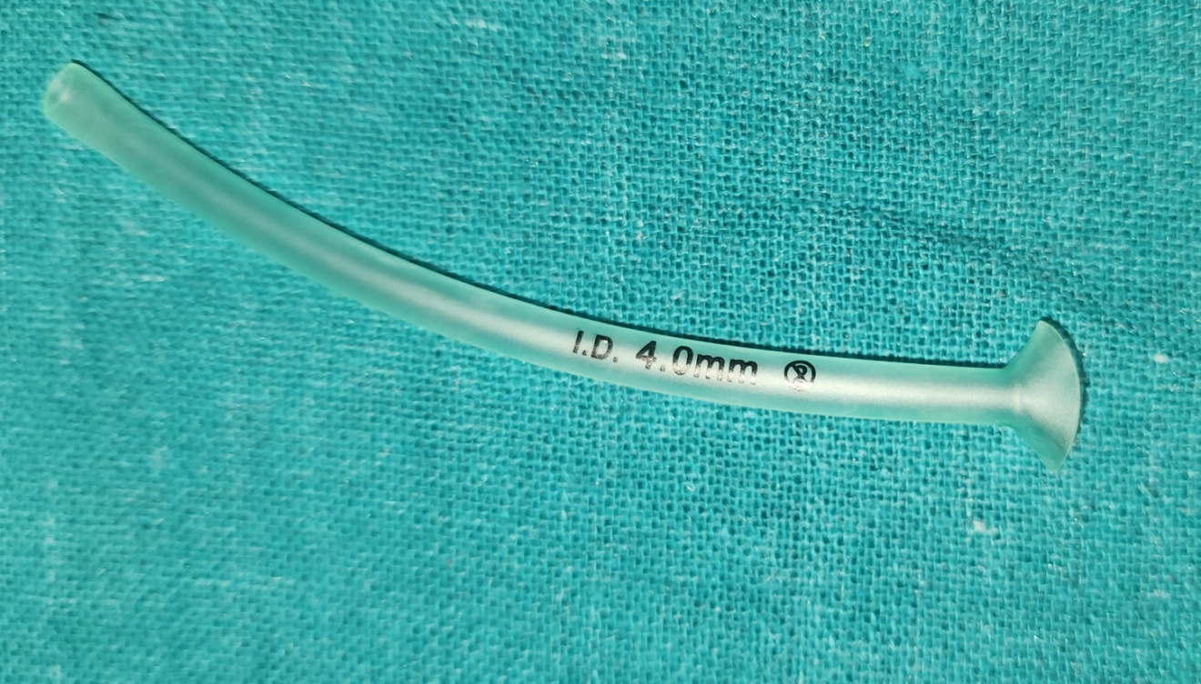
Fig 1: Nasopharyngeal Airway

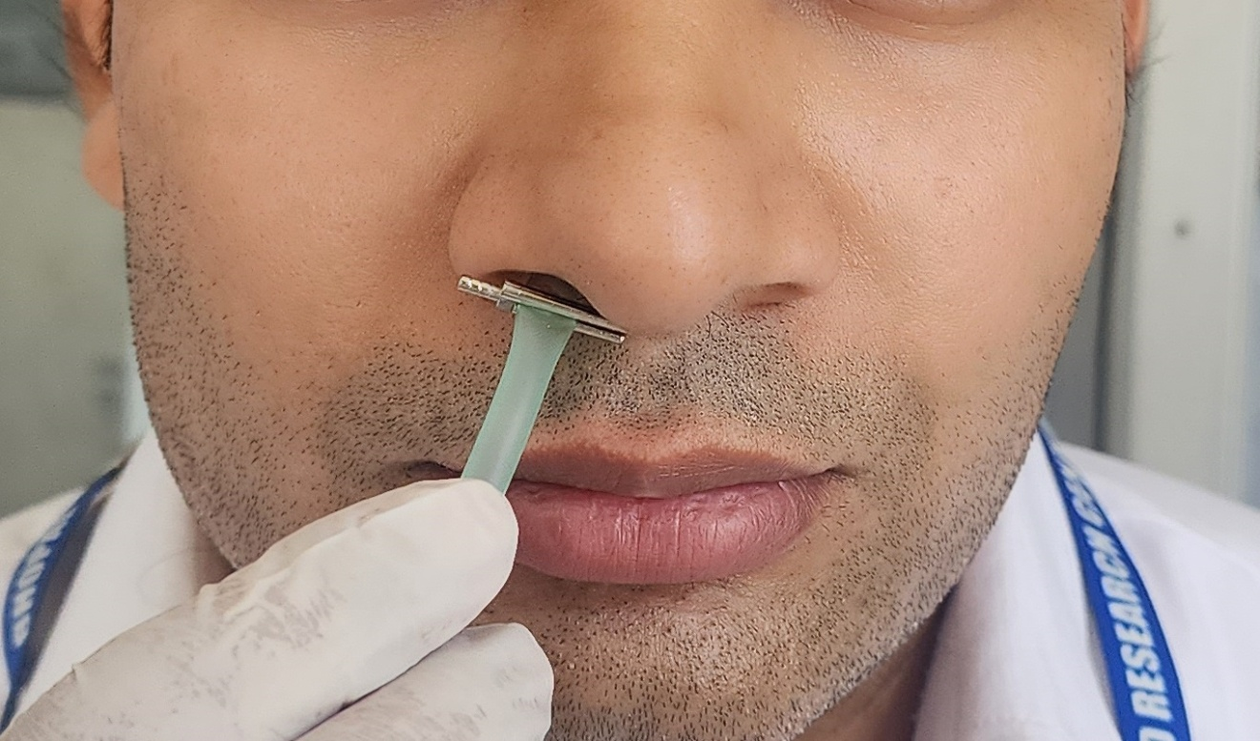
Fig 2: Bobby pin stopper

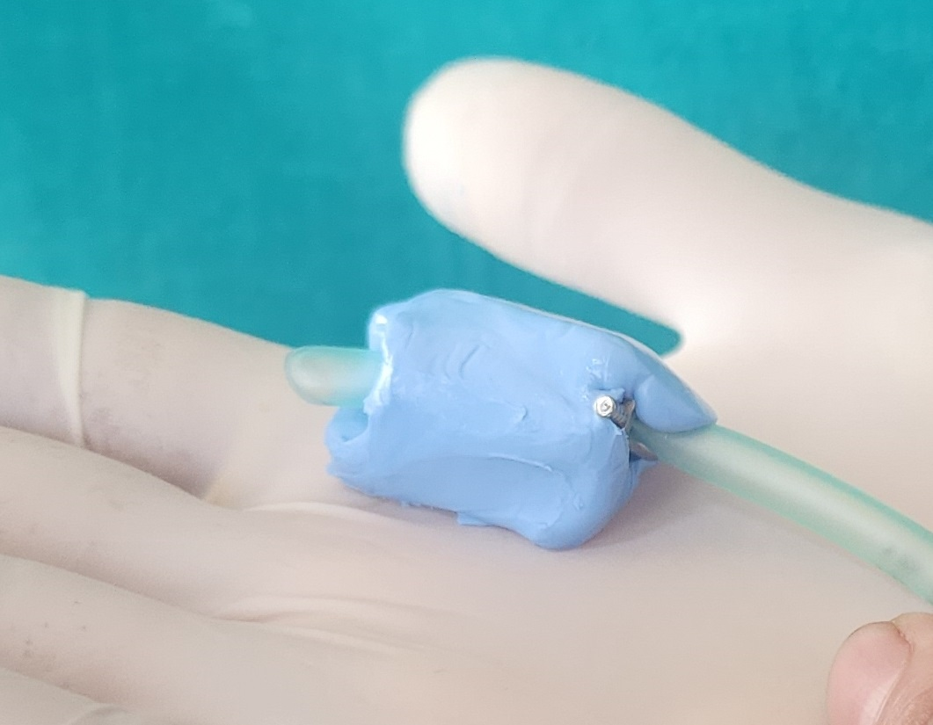
Fig 3: Impression Loading

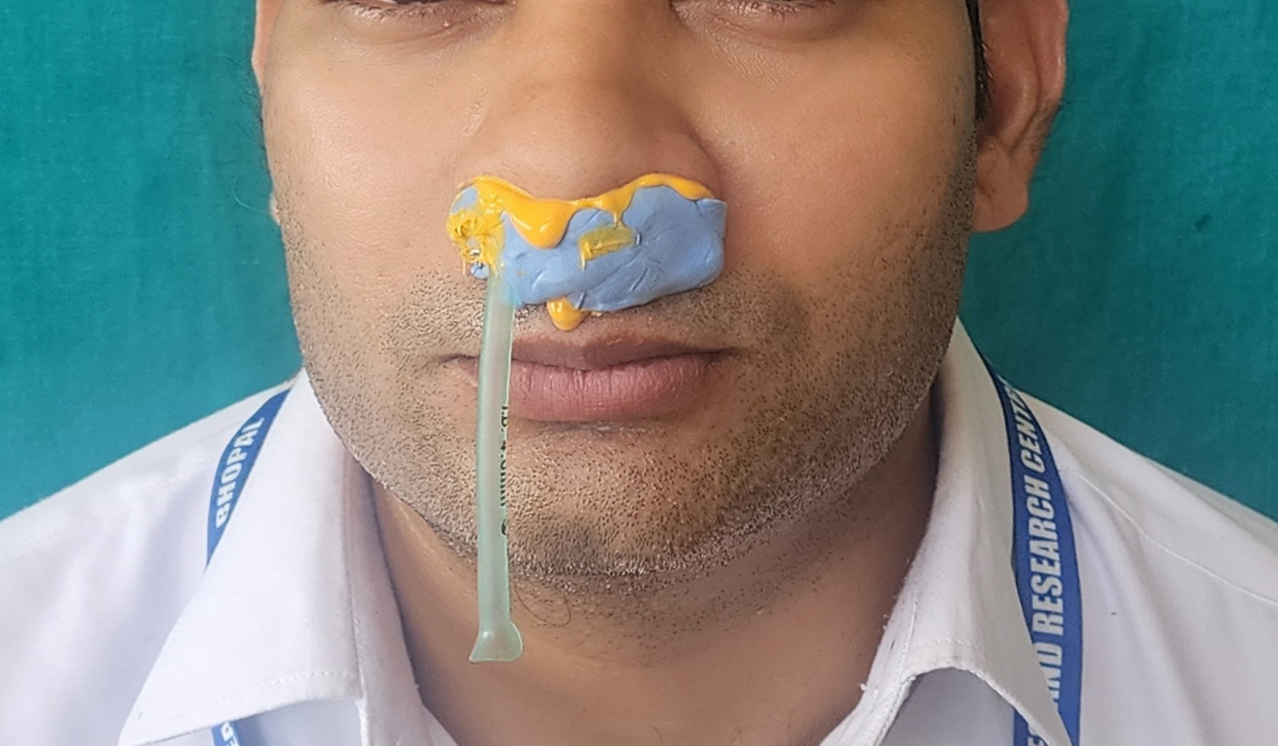
Fig 4: Impression Making

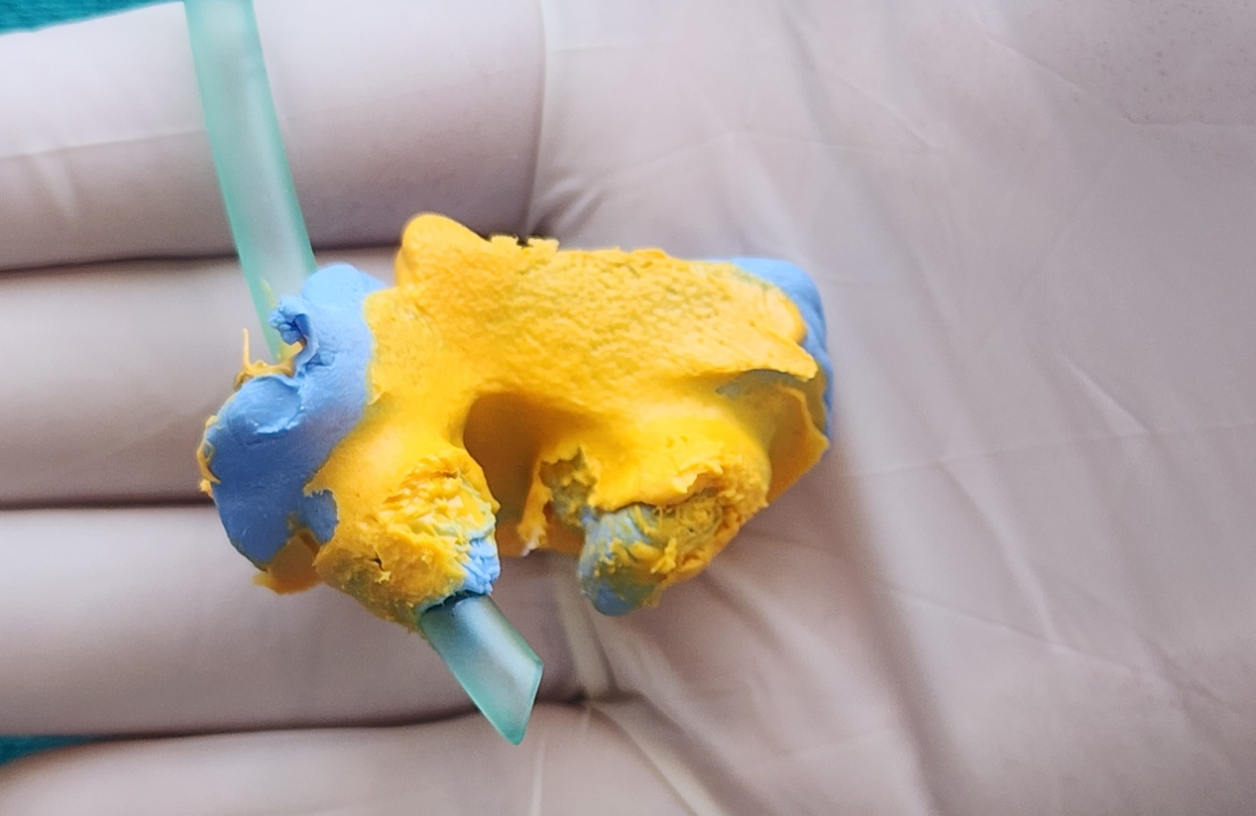
Fig 5: Final Impression

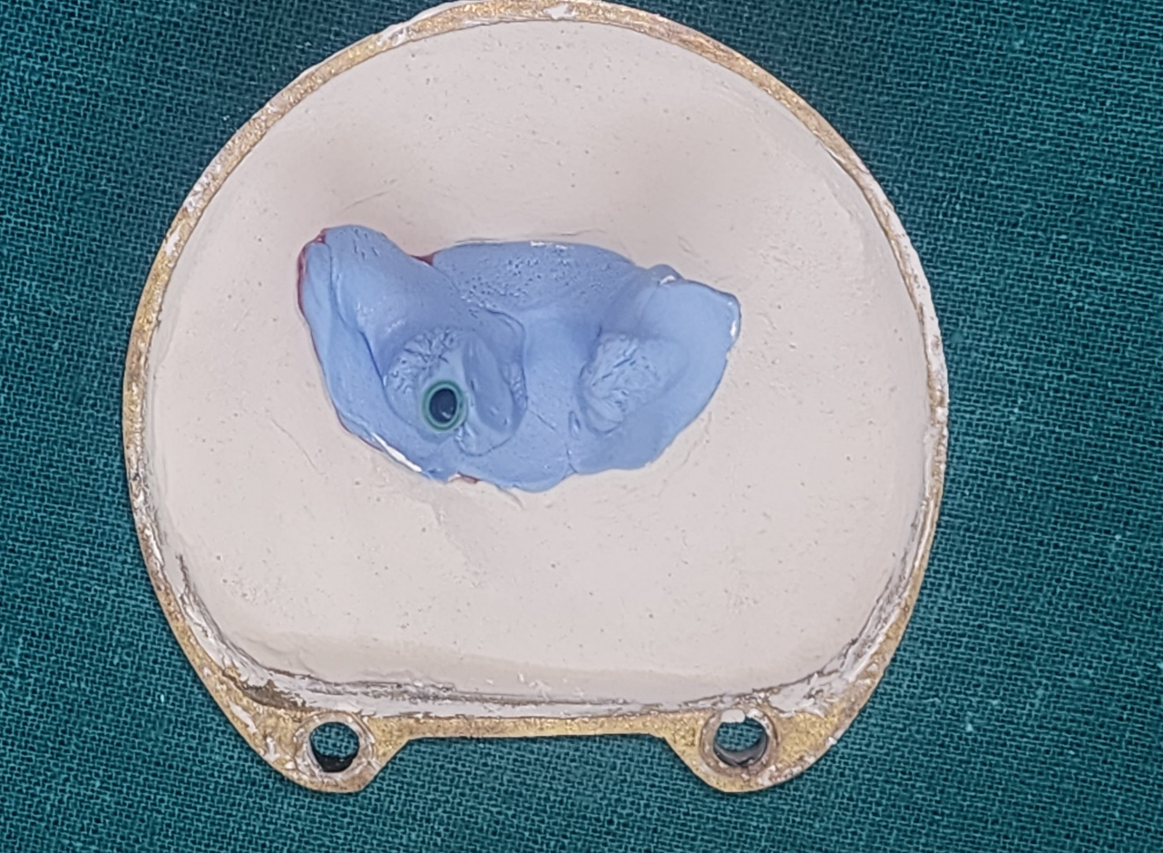
Fig 6: Flasking

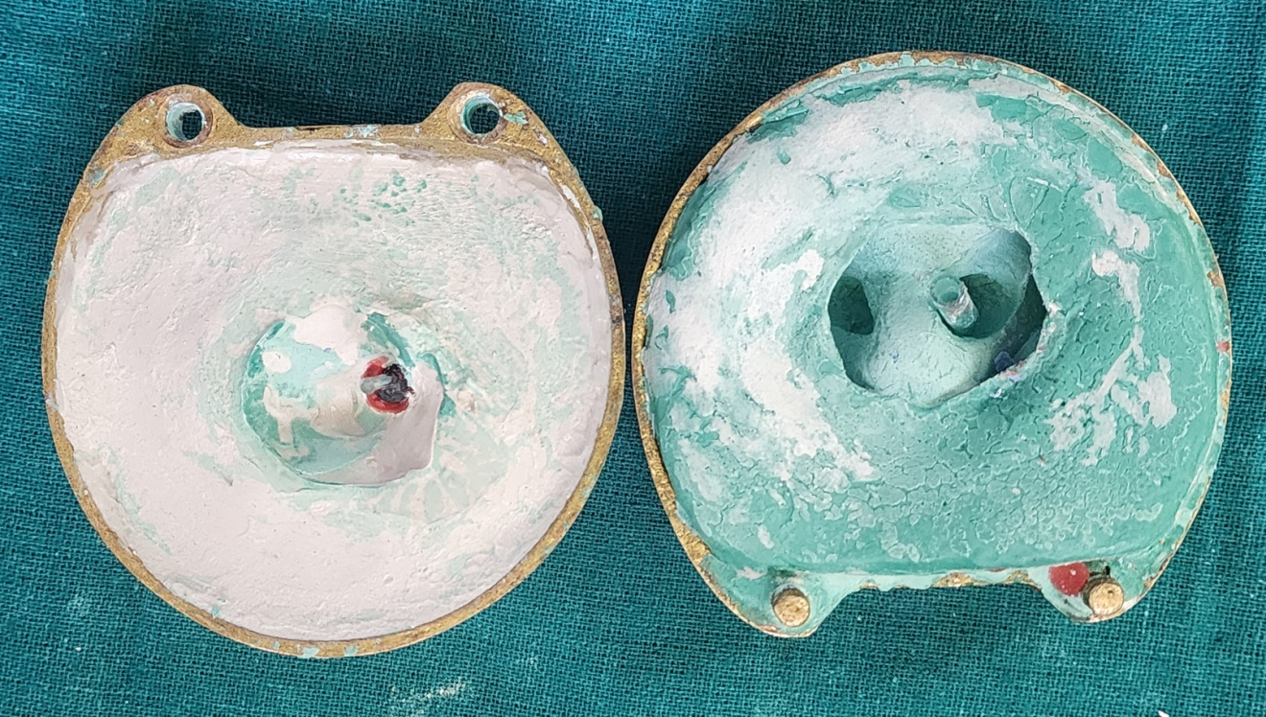
Fig 7: Dewaxing & Molds

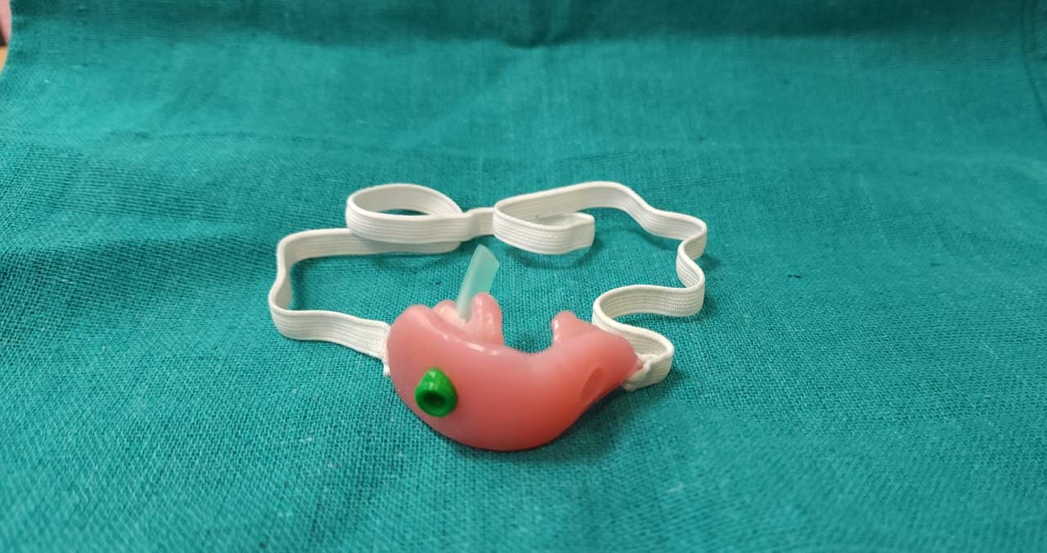
Fig 8: Front View of the Device

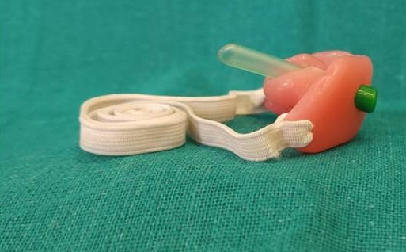
Fig 11: Post Op & Lateral Cephalogram of the Patient

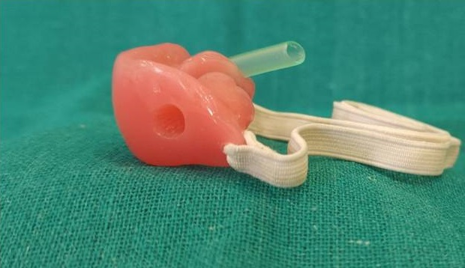Fig 10: Left Side View of the Device
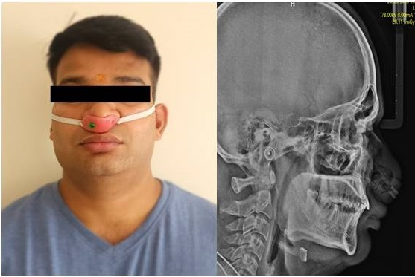
Fig 11: Post Op & Lateral Cephalogram of the Patient

