THE INFLUENCE OF MARKETING COMMUNICATION AND TRUST ON CUSTOMER LOYALTY WITH CUSTOMER SATISFACTION AS AN INTERVENING VARIABLE AT PT. MEDIA SYNERGY IN 2023
Belinda, Ahmad Subagyo, Hanantyoko Dewanto
Sekolah Tinggi Ilmu Ekonomi Gici
belindalambe5@gmail.com
bagyo1972@gmail.com
hanan.dewanto@gmail.com

Abstract: This research aims to see the influence of marketing communications, and trust on customer loyalty through customer satisfaction. This study was conducted at PT. Medial Synergy. This research uses a quantitative approach by applying a purposive sampling technique in selecting male and female samples and using the Konigsee Implant five times in one month. A total of 50 questionnaires were distributed to respondents. The analysis method used in this research is by using path analysis and assisted by the SPSS analysis application. Research findings show that marketing communication has a positive but not significant effect on customer loyalty, Apart from that trust has a significant positive effect on customer loyalty, customer satisfaction has a positive and significant effect on customer loyalty, then marketing communication has a significant positive effect on customer satisfaction, there is a positive effect and significant trust in customer satisfaction, the indirect effect shows that customer satisfaction cannot mediate between marketing communications and customer loyalty, while customer satisfaction is proven to be able to mediate between trust and customer loyalty.

Keywords: Marketing Communication, Trust, Customer Loyalty, Customer Satisfaction.

INTRODUCTION
Health is an important variable that must be addressed by every country. Indonesia even maintains health as a collective freedom, and this is stated in Article 8 of the 1945 Constitution which reads: "Every citizen has the right to receive health services". Hospitals are an important part of the health framework as they are state-implementing organizations in the delivery of public administration together with private aid foundations. Health services actually require a lot of medical equipment that is produced using the best materials, so that it is sufficient to overcome problems that occur in hospitals. Providing medical equipment in Indonesia is one of the companies that stands out because it promises huge profits. In the current millennium era, the number of distributors selling existing medical devices continues to increase. The increasing number of business tools is what encourages companies to run their business in such a way that they are able to retain their customers. Entrepreneurs, especially medical equipment manufacturers, are competing to maintain customer loyalty to their products. The company also designs effective and efficient business strategies to maintain customer loyalty. Business strategy is an integrated corporate effort aimed at building advantages over competition and achieving business goals
LITERATUR Review
According to Tjiptono in Nurul Rizky and Sri Dewi Setiawati (2020) marketing communication is a marketing activity that seeks to disseminate information, influence/persuade, and remind the target market of the company and its products so that they are willing to accept, buy, and be loyal to the products offered by the company in question. According to Nickels in Prasetyo (2018) defines that marketing communication is a process of exchanging information that is carried out persuasively so that the marketing process can run effectively and efficiently. According to Kotler & Keller (2016:225), customer trust is a company's willingness to rely on business partners and depends on a number of interpersonal and inter-organizational factors, such as perceived competence, integrity, honesty, and benevolence of the company. According to Peter Halim et, al. (2015) in their journal stated that customer trust is consumers' positive expectations of producers for their ability to produce products that satisfy customers. Customer satisfaction is a state or feeling of pleasure that is achieved if the product meets consumer needs and expectations (Daryanto & Setyobudi, 2014, p. 90). Kotler and Keller (2016:33) say customer satisfaction reflects a person's assessment of perceived product performance in relation to expectations. If performance falls short of expectations, customers are disappointed. If performance meets expectations, customers are satisfied. If it exceeds expectations, the customer is happy.
According to Kotler and Kevin in journal (Lie et al., 2019) loyalty is an image of integrity that is firmly held to buy or subscribe to certain products even in the future even though there are interventions in the situation and capabilities of the marketing department that have the opportunity to cause behavior changes. Meanwhile, according to Oliver in the journal (Putri et al., 2018), customer loyalty is defined as a strong customer commitment to a product or service consistently in the future.

METHODOLOGY
This research was carried out from September 2022 to June 2023. Then the place of this research was at PT. Medial Synergy. The objects in this research are customers from PT. Medial Synergy. The sampling technique in this research was to use a purposive sampling technique with a research sample of 50 samples. This research analysis uses path analysis with the help of the SPSS analysis application. The hypotheses in this research are as follows:
1. H1: It is suspected that there is a positive and significant influence between marketing communications on customer satisfaction
2. H2: It is suspected that there is a positive and significant influence between trust and customer satisfaction
3. H3: It is suspected that there is a positive and significant influence between marketing communications on customer loyalty
4. H4: It is suspected that there is a positive and significant influence between trust and customer loyalty
5. H5: It is suspected that there is a positive and significant influence between customer satisfaction and customer loyalty
6. H6: It is suspected that there is a positive and significant influence between marketing communications on customer loyalty through customer satisfaction as an intervening variable
7. H7: It is suspected that there is a positive and significant influence between trust and customer

FINDINGS AND DISCUSSION
- Test of Validity
Table 1
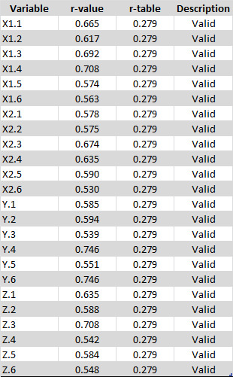
Source: Results of PLS Data Processing (2023)
Based on Table 1.1, the calculated r value for each statement is more than 0.279, which means that all statements in this research questionnaire are valid.

- Test of Reliability

Table 2

Based on Table 2.1, the Cronbach's Alpha value of each variable is more than 0.6. So each of these variables can be reliable.

- Path Analysis Diagram Model
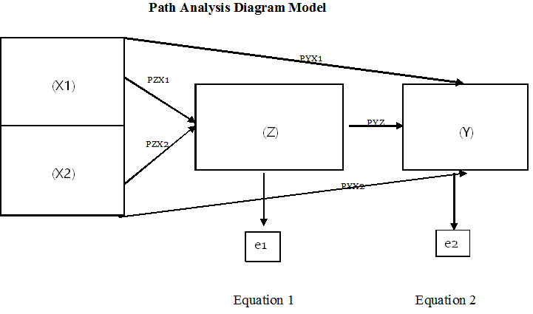
Based on the path diagram above, there are two structural equations, namely as follows:
1. Z = PZX1 + PZX2 + ε1
2. Y = PYX1 + PYX2 + PYZ + ε2
- Coefficient of Determination
Table 3 The coefficient of determination of Equation 1 and Equation 2
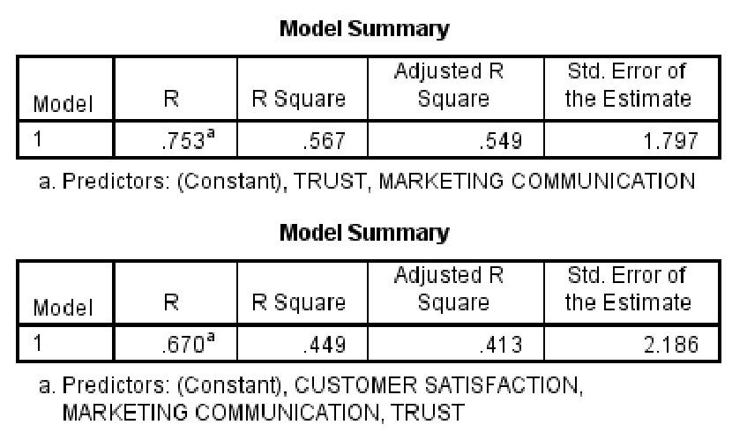
Source: Results of SPSS Data Processing (2023)
From Table 3 above it can be seen that the Adjusted R-Square value from Equation 1 is 0.549 or 54.9%, which means that the influence of the trust and confidence communication variables on the customer satisfaction variable is 54.9% while the remaining 45.1% is influenced by other variables outside this research. Then in equation 2, it is 0.413 or 41.3%, which means that the influence of marketing communication, trust, and customer satisfaction variables on customer loyalty is 41.3%, while the remaining 58.7% is influenced by other variables outside this research model.
- Compute Paths
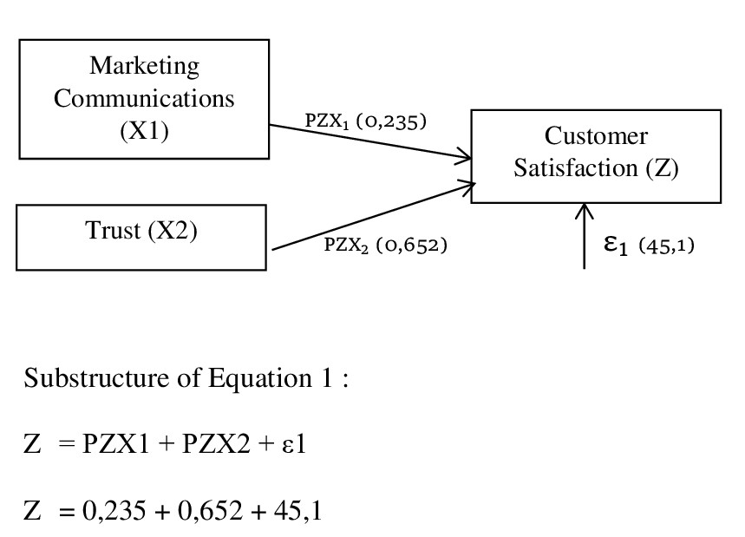
Here is the explanation:
1. The magnitude of the marketing communication channel coefficient (X1) is 0.235. This shows
that marketing communication (X1) has a direct effect of 0.235 on customer satisfaction (Z).
2. The magnitude of the confidence path coefficient (X2) is 0.652. This shows that trust (X2) has a direct effect of 0.652 on customer satisfaction (Z).

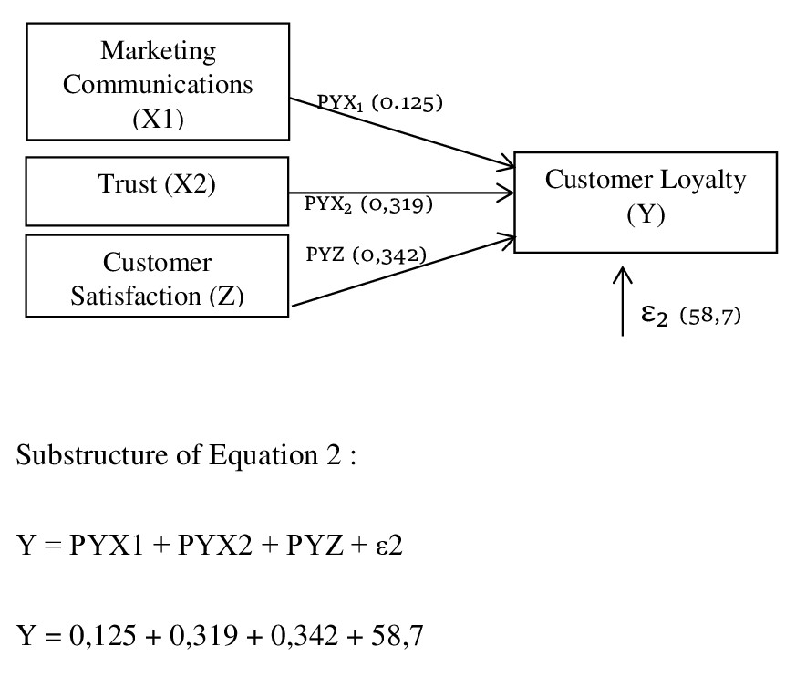
The following is the explanation:
1. The marketing communication channel coefficient (X1) is 0.125. It shows
that marketing communication (X1) has a direct effect of 0.125 on customer loyalty (Y).
2. The path coefficient (X2) is 0.319. This shows that trust (X2) has a direct effect of 0.319
on customer loyalty (Y).
3. The magnitude of the path coefficient of customer satisfaction (Z) is 0.342. This shows that customer satisfaction (Z) has a direct effect of 0.342 customer loyalty (Y).

- Test of the Mediation Effect Hypothesis
Figure 1 Equation 1 and Equation 2
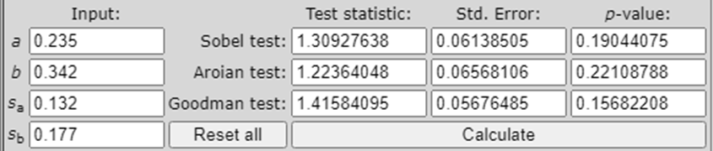
Source: Results of SPSS Data Processing (2023)
Based on the picture above, the results of the mediation effect test will be described as follows:
In Figure 1 above, it is known that the calculated results for the Sobel test in equation 1 are 1.30 <1.67 (t table). It can be concluded that the intervening variables used in the substructure of equation 1 contribute positively but do not have a significant effect. This means that customer satisfaction is not an intervening variable between marketing communications and customer loyalty at PT. Medial Synergy.
The results of the Sobel test for equation 2 are 1.84 > 1.67 (t table). The results of the Sobel test, prove that customer satisfaction can mediate between the influence of trust on customer loyalty. High trust makes customers feel more satisfied and confident to engage in long-term relationships. This certainly has a positive impact and can stimulate sales.

- CONCLUSION
Based on the data from the research results and discussions explained in the previous chapter, the following conclusions are outlined in this research, namely:
1. Based on the results of the hypothesis test (H1) which was explained in the previous chapter, it is concluded that marketing communication has a positive and significant effect on customer satisfaction at PT. Medial Synergy. This shows that good marketing communications can help customers get the expected benefits by encouraging them to repurchase or use Konigsee Implant continuously.
2. Based on the results of the hypothesis test (H2) which was explained in the previous chapter, it can be concluded that trust has a positive and significant effect on customer satisfaction at PT. Medial Synergy. Trust is based on openness and mutual relations between the customer and the company. The company makes every effort to provide integrity, kindness, and competence to build customer trust so that a sense of satisfaction arises and loyalty is formed.
3. Based on the findings of the hypothesis test (H3) presented in the previous chapter, it can be concluded that marketing communications have a positive effect but do not have a significant relationship with PT customer loyalty. Medial Synergy. PT's marketing communications strategy. Synergy media such as advertising, sales promotions, routine sales visits to hospital clinics, and participation in large events have not run optimally. This means that the information received by customers has not provided a perception that can build loyalty. This is also supported by data obtained by researchers regarding the number of loyal customers at PT. Mediali Synergy is still relatively small.
4. Based on the findings of the hypothesis test (H4) which was explained in the previous chapter, it can be concluded that trust has a significant positive influence on PT customer loyalty. Medial Synergy. The trust that customers have given them a sense of security and comfort to make repeated transactions and even recommend them to other people, which is the actualization of loyalty.
5. Based on the results of the hypothesis test (H5) which was explained in the previous chapter, there is a positive and significant influence of customer satisfaction on customer loyalty at PT. Medial Synergy. It is not surprising that customer satisfaction has a significant effect on Konigsee Implant customer loyalty, because many customers are satisfied with the products and services from PT. Medial Synergy. The higher the satisfaction of a customer, the greater the level of loyalty to a product.
6. Based on the results of the hypothesis test (H6) which was explained in the previous chapter, it can be seen that the results of the Sobel test of customer satisfaction are not proven to mediate between marketing communications and PT customer loyalty. Medial Synergy. Thus, customer satisfaction is not an intervening variable between marketing communications and customer loyalty at PT. Medial Synergy.
7. Based on the results of the hypothesis test (H7) which was explained in the previous chapter, the Sobel test proves that customer satisfaction is proven to mediate the influence of trust on customer loyalty. High trust makes customers feel more satisfied and confident to engage in long-term relationships. This certainly has a positive impact and is able to stimulate sales. Thus, the greater the customer's trust in a product, the greater the customer's loyalty to a brand.

REFERENCES

Antara, S., Sepang, J., & Saerang, I. S. (2014). Analisis Rasio Likuiditas…( Liquidity Ratio Analysis) 902. Jurnal EMBA, 2(3), 902–911.
Arifin, Z., & Rizaldy, M. (2023). Reslaj : Religion Education Social Laa Roiba Journal Sarjanawiyata Tamansiswa Reslaj : Religion Education Social Laa Roiba Journal. Reslaj : Religion Education Social Laa Roiba Journal, 5(1), 168–184. https://doi.org/10.47476/reslaj.v5i3.1813
Artichah, G. B., & Nawang Wulan, G. A. (2022). Tingkat Pengetahuan Akuntan Muda Dalam Menjaga Eksistensi Akuntansi Syariah Guna Menyongsong Indonesia Emas 2045 (Level of Knowledge of Young Accountants in Maintaining the Existence of Sharia Accounting to Welcoming Indonesia Gold 2045.). El Muhasaba Jurnal Akuntansi, 13(1), 26–37. https://doi.org/10.18860/em.v13i1.13489
Daga, R. (2017). Strategi Meningkatkan Kepuasan Nasabah Tabungan (Strategy to Increase Savings Customer Satisfaction) Pada PT. Bank Perkreditan Rakyat Hasa Mitra Cabang (Branch) Makassar. AKMEN Jurnal Ilmiah, 14(3), 445–458.
Ferdinand, A. (2018). Grand Theory & Middle Range Theory. 2018.
Hasibuan, R. M., Dr. Fitriani Harahap, S.Pd., M., & Armansyah Lubis, S.E., M. . (2021). Pengaruh Kualitas Pelayanan Terhadap Kepuasan Pelanggan Di (The Influence of Service Quality on Customer Satisfaction) in Cafe Vanilla Panyabungan. Jurnal Misi Institut Pendidikan Tapanuli Selatan (IPTS), 4(3), 175–182.
Helen, H., & Rusdi, F. (2019). Pengaruh Penggunaan Media Sosial Akun Instagram @Jktinfo Terhadap Pemenuhan Kebutuhan Informasi Followers (The Influence of Using the Social Media Instagram Account @Jktinfo on Fulfilling Followers' Information Needs) Prologia, 2(2), 355. https://doi.org/10.24912/pr.v2i2.3712
I Gusti, N. S. W., Ni Wayan, C. A. P., Ni Nyoman, M., & I Gede, D. Y. (2022). Pengaruh Electronic Word Of Mouth (E-Wom), Persepsi Risiko, Kepercayaan Pelanggan, Dan Keputusan Pembelian E-Commerce Tokopedia (The Influence of Electronic Word of Mouth (E-Wom), Risk Perception, Customer Trust, and Tokopedia E-Commerce Purchase Decisions. Management),. E-Jurnal Manajemen, 11(1), 107–115.
Irnawanto, R., & Ady, S. U. (2022). Analisis Pengaruh Kualitas Produk, Dan Kualitas Pelayan Terhadap Loyalitas Pelanggan Dengan Kepuasan Pelanggan Sebagai Intervening Pada Minimarket Alfamart (Analysis of the Influence of Product Quality and Service Quality on Customer Loyalty with Customer Satisfaction as an Intervening at Alfamart Minimarket) in Surabaya. Soetomo Business Review, 3(2), 300–315.
Iwan, H. K., Saefullah, A., Afrianti Rahayu, D., Khristanto, W., Tannady, H., Candra Susanto, P., Magdalena, & Totok Suyoto, Y. (2022). Peran Motivasi Ekstrinsik Dan Pelatihan Digital Marketing Dalam Meningkatkan Kinerja Pelaku UMKM (The Role of Extrinsic Motivation and Digital Marketing Training in Improving the Performance of MSMEs) in Belitung Timur. Jurnal Kewarganegaraan, 6(2), 5025–5027. https://journal.upy.ac.id/index.php/pkn/article/view/4061
Jackie, Rina Friska B. Siahaan, Dewi Anggraini, Willi Chandra, & Fauzi A.M. Hutabarat. (2022). Pengaruh Social Media Marketing Terhadap Purchase Intention Di Teko Healthy Resto Medan (The Effect of Social Media Marketing on Purchase Intention at Teko Healthy Resto Medan). SOSMANIORA: Jurnal Ilmu Sosial Dan Humaniora, 1(2), 167–175. https://doi.org/10.55123/sosmaniora.v1i2.446
Julia Nengsih, S., & Yulsyofriend, Y. (2022). Efektivitas Penggunaan Media Bahan Sisa Kantong Plastik dalam Mengembangkan Kreativitas Anak Usia Dini di Taman Kanak-Kanak (The Effectiveness of Using Plastic Bag Leftover Media in Developing Early Childhood Creativity in Kindergarten) Pembina 01 Linggo Sari Baganti. Jurnal Family Education, 2(3), 252–259. https://doi.org/10.24036/jfe.v2i3.64
Kartika, D., & Ismaya, H. (2017). SISWA PADA MATA PELAJARAN ILMU PENGETAHUAN SOSIAL ( IPS ) KELAS Program Studi Pendidikan Ekonomi Fakultas Pendidikan Ilmu Pengetahuan Sosial IKIP PGRI Bojonegoro Email : tikayakartika@gmail.com melalui Kementrian Pendidikan dan Kebudayaan , telah melakukan. Skripsi, 017. (STUDENTS IN THE SUBJECT OF SOCIAL SCIENCES (IPS) CLASS Economic Education Study Program Faculty of Social Sciences Education IKIP PGRI Bojonegoro Email: tikayakartika@gmail.com through the Ministry of Education and Culture, have carried out. Thesis, 017.)
Kohar, K., & Arifin, A. (2020). Pengaruh Kecerdasan Emosional Dan Kemampuan Komunikasi Dosen Terhadap Kepercayaan Mahasiswa. Jurnal Ilmiah Ekonomi Manajemen, (The Influence of Emotional Intelligence and Lecturer's Communication Ability on Student Confidence. Scientific Journal of Management Economics), 11(02), 157–166. https://ejournal.umpri.ac.id/index.php/JIEM/article/view/1742%0Ahttps://ejournal.umpri.ac.id/index.php/JIEM/article/download/1742/993
Masili, V., Lumanauw, B., Tielung, M. V. J., Kualitas, P (Quality P) ., Terhadap (On), L., Pelanggan (Customer), L., Masili, V., Lumanauw, B., Tielung, M. V. J., Masili, V., Lumanauw, B., & Tielung, M. V. J. (2022). Vol.+10+n0+4.5+.Veronika+Masili.+OK. 10(4), 44–51.
Mehta, C.R., and Patel, N. R. (2007). SPSS Exact Tests. SPSS16.0 Manual, January, 1–220.
Paramitha, D. K., & Idayati, F. (2020). Pengaruh Profitabilitas, Likuiditas, Ukuran Perusahaan Terhadap Manajemen Laba. Jurnal Ilmu Dan Riset Akuntansi (JIRA) (The Influence of Profitability, Liquidity, Company Size on Profit Management. Journal of Accounting Science and Research (JIRA), 9(2), 1–18. http://jurnalmahasiswa.stiesia.ac.id/index.php/jira/article/view/2801
Penyaluran, P., & Produktif, Z. (2023). 5, 62–79. https://doi.org/10.37146/ajie
Publisher, D., & Access, O. (2023). Original Article *) Hubungan Pengetahuan, Riwayat Pemberian ASI Eksklusif, Dan Kelengkapan Imunisasi Dasar Terhadap Status Gizi Bayi (The Relationship between Knowledge, History of Exclusive Breastfeeding, and Completeness of Basic Immunizations on Infant Nutritional Status). 02(09), 830–837.
Rizky, N., & Dewi Setiawati, S. (2020). Penggunaan Media Sosial Instagram Haloa Cafe sebagai Komunikasi Pemasaran Online. Jurnal Ilmu Komunikasi, (Use of Social Media Instagram Haloa Cafe as Online Marketing Communication. Journal of Communication Sciences), 10(2), 177–190. https://doi.org/10.15642/jik.2020.10.2.177-190
Rumoning, M. H. (2018). Pengaruh Lingkungan Kerja, Disiplin Kerja Dan Stres Kerja Terhadap Komitmen Organisasi Dalam Meningkatkan Kinerja Perawat Di RSUD Kabupaten Asmat. Emba (The Influence of Work Environment, Work Discipline and Work Stress on Organizational Commitment in Improving Nurse Performance in Asmat District Hospital. Emba,), 6(2), 958–967.
Sambodo Rio Sasongko. (2021). Faktor-Faktor Kepuasan Pelanggan Dan Loyalitas Pelanggan (Literature Review Manajemen Pemasaran). Jurnal Ilmu Manajemen Terapan, (Factors of Customer Satisfaction and Customer Loyalty (Literature Review of Marketing Management). Journal of Applied Management Science) 3(1), 104–114. https://doi.org/10.31933/jimt.v3i1.707
Saputra, S., & Apriliani, A. S. (2019). Pengaruh Kualitas Pelayanan Post Service Follow Up (PSFU) Terhadap Kepuasan Pelanggan Di PT. Astra International Tbk-Toyota Sales Operation (TSO) Auto2000 Cabang Pasteur Kota Bandung Jurnal Bisnis Dan Pemasaran, 12(September), 1–14.. (The Influence of Post Service Follow Up (PSFU) Service Quality on Customer Satisfaction at PT. Astra International Tbk-Toyota Sales Operation (TSO) Auto2000 Pasteur Branch Bandung City) Journal of Business and Marketing, 12 September), 1–14.Jurnal Bisnis Dan Pemasaran, 12(September), 1–14.
Sari, M. S., & Zefri, M. (2019). Pengaruh Akuntabilitas, Pengetahuan, dan Pengalaman Pegawai Negeri Sipil Beserta Kelompok Masyarakat (Pokmas) Terhadap Kualitas Pengelolaan Dana Kelurahan Di Lingkungan Kecamatan Langkapura. Jurnal Ekonomi (The Influence of Accountability, Knowledge and Experience of Civil Servants and Community Groups (Pokmas) on the Quality of Village Fund Management in the Langkapura District Environment. Economic Journal,,) 21(3), 308–315. https://ejournal.borobudur.ac.id/index.php/1/article/view/608/583
Sarjana, P. P., Kedokteran, F., & Mada, U. G. (2008). Analisis kualitas pelayanan (Service quality analysis) . 1(September), 19–26.
Sofi Adinda Amri Nasution, & Yayuk Yuliana. (2022). Pengaruh Citra Merek, Kualitas Layanan, Dan Harga Terhadap Kepuasan Pengguna Jasa Pengiriman J&T Express Di Drop Point Krakatau Medan. Jurnal Ilmu Manajemen Dan Kewirausahaan (Jimk) (The Influence of Brand Image, Service Quality, and Price on User Satisfaction of J&T Express Delivery Services at the Krakatau Medan Drop Point. Journal of Management and Entrepreneurship) , 2(2), 185–194. https://doi.org/10.32696/jimk.v2i1.1458
Soraya, I. (2017). Personal Branding Laudya Cynthia Bella Melalui Instagram (Studi Deskriptif Kualitatif Pada Akun Instagram @Bandungmakuta). Jurnal Komunikas (Laudya Cynthia Bella's Personal Branding Through Instagram (Qualitative Descriptive Study of the Instagram Account @Bandungmakuta). Communication Journal) i,8(2),30–38. http://ejournal.bsi.ac.id/ejurnal/index.php/jkom/article/view/2654
Sumaryati, S. A. (2022). Etika Bisnis Sebagai Acuan Meningkatkan Kepuasan Konsumen: Studi Pada Bisnis Online. JUMBA (Jurnal Ekonomi, Bisnis, Dan …,). (Business Ethics as a Reference for Increasing Consumer Satisfaction: Studies in Online Business. JUMBA (Journal of Economics, Business, and) 2(1), 91–100. http://jurnal.updkediri.ac.id/index.php/jumba/article/view/2
Suwarsito, S., & Aliya, S. (2020). Kualitas Layanan Dan Kepuasan Serta Pengaruhnya Terhadap Loyalitas Pelanggan. Jurnal Ilmiah Bina Manajemen, (Service Quality and Satisfaction and Its Influence on Customer Loyalty. Management Development Scientific Journal) , 3(1), 27–35. https://doi.org/10.33557/jibm.v3i1.826
UPI, T. D. A. P. (2014). Manajemen Pendidikan. (Education Management) 2(April)

