Role of Titanium and titanium alloys in the success of dental implants

Introduction
In the modern day dental practice the use of dental implants is as acceptable as any other established procedure for the replacement of missing teeth not only for aesthetic and social issues, but also for avoiding impairment in chewing, speech, and increasing the risk of developing diseases ^{[1,2]}Implants involve the use of a metal support that is in direct contact with the bone for adequate support and retention which permits the prosthesis to withstand constant mechanical stresses. Since the introduction of titanium alloys for this purpose around 1981, there has been a marked increase in the use of dental implants to replace lost teeth in patients ^{[3,4]}
Titanium and its micro structure
Titanium is the ninth most abundant metal and it was discovered by William Gregory in 1791. It presents itself in its pure form as a silver metal with unique physical-chemical characteristics, such as low density (4.5 g/cm3), that is able to form solid solutions with elements with similarly sized atoms. In the solid state, it has hexagonal close packed geometry up to 882.5 ◦C, known as the α structure. Above this temperature, solid titanium changes to a body centred cubic form known as the β structure, until it melts at 1688 ◦C ^{[5]}. In alloys, titanium occurs in a variety of forms, which can be pure α or pure β, or combinations of the two ^{[6]}. In making implants, titanium alloys that are either completely or mainly α are preferred, because they have superior corrosion resistance. The processing conditions can be selected to favour the α micro-structure, and this also affects the mechanical properties (strength, ductility, fatigue resistance and fracture toughness).
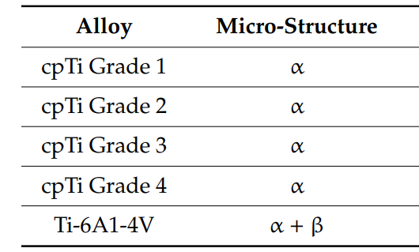
Titanium alloys with α and β microstructure

Titanium dioxide layer
Titanium and its alloys exhibit excellent corrosion resistance due to a thick, insoluble titanium dioxide (TiO2) layer that forms on the surface in nanoseconds. This oxide layer is 4–6 nm thick and also contains hydroxyl groups in addition to the oxide. The exact composition of the surface is important in promoting the adhesion of osteoblasts and the oxide layer tends to have favourable biological properties. ^{[7]}. TiO2 can be found in three different crystalline forms in ambient conditions: anatase, brookite, and rutile. The phase transitions are possible by performing heat treatment at the end of the synthesis. While brookite (that is arranged in orthorhombic geometry) is the most difficult to obtain, rutile and anatase (both presenting octahedral geometry) are easily formed . The difference found between the rutile and anatase phases is due to distortions between the octahedral formed by TiO6. To obtain these structures, several methods can be used, from hydrothermal to electrochemical. Therefore, changes in the physicochemical parameters within the synthesis will lead to the preferential formation of one of the intended phases . Thus, the phase directly affects the success of its use for applications in dentistry. Anatase is often associated with applications requiring osseointegration and, therefore, is the most used in dental implants.
Titanium implants usually have their surfaces modified after their initial fabrication in order to ensure that oxidation is uniform and that any contamination is removed ^{[8]}. The resulting surfaces have improved biological characteristics, and promote the processes of cell adhesion and proliferation, both of which contribute to bone bonding ^{[9,10]}.
Titanium and its alloys
The main alloy used is so-called commercially pure titanium, cpTi ^{[11]}. Four grades of unalloyed, commercially pure (CP) Ti are available for dental applications, designated as Grades 1 to 4. These grades are defined by their oxygen and iron content, as these elements have a substantial effect on the mechanical and physical properties of the metal, even in very small concentrations. As the concentration of oxygen or iron increases, the mechanical strength increases in parallel, while ductility decreases.These grades differ in corrosion resistance, ductility and strength, and it is grade 4 cp-Ti, with the highest oxygen content (around 0.4%) and best overall mechanical strength that is most widely used for dental implants ^{[12,13]}.

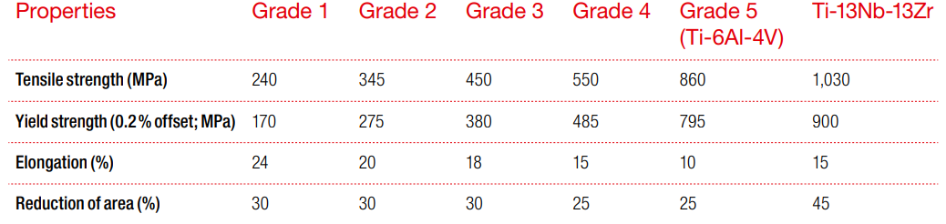

Ti-6Al-4V alloy is also called Grade 5. Grade 5 titanium is widely used in orthopaedics ^{[14,15]}. This is because of its superior strength and lower Young’s modulus. However, this alloy releases both aluminium and vanadium ^{[15]}, both of which are capable of causing biological problems. Aluminium interferes with bone mineralization ^{[16]}, leading to structural deficiencies, and vanadium is both cytotoxic and capable of causing type IV (allergic) reactions^{[17]}.

As mentioned above, the physical properties of CP Ti are mainly affected by the oxygen and iron content of the material. An increase in frequency represents a decrease in the amount of these "impurities". Grade 1 is therefore the softest and most ductile type of CP Ti, whereas grade 4 is significantly stronger and less malleable than the lower grades. Some drawbacks of classes 1-4 are relatively low mechanical strength, high modulus and low wear resistance.
CP Ti is not preferred when high stress resistance is required. Mechanical properties such as implant strength, creep strength and formability can be improved by alloying Ti with various elements (aluminum, Al, vanadium, V, tantalum, Ta, zirconium, Zr, etc.).

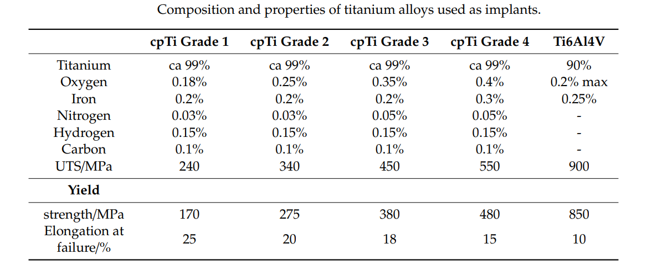

Osseointegration
The implant fixture should be designed to achieve a wide range of bone- implant interfaces for faster osseointegration. The interfacial zone between the titanium alloy implant and living bone is critical in the development of osseointegration. This region, which is thin (20–50 nm), is the region into which growth factors are released from the bone cells, and this initiates the steps that result in bone formation ^{[18]}. The initial step is deposition of proteins from the blood plasma onto the surface oxide layer. This is followed by the formation of a fibrin matrix, a structure that acts as a scaffold for osteoblasts (the bone-forming cells) ^{[19]}. Supported in this way, the osteoblasts lay down bone, which expands to fill the interfacial region, so that it grows right up against the implant surface, causing the implant to become osseointegrated. The important effect of proper osseointegration is that the implant is held rigidly, unlike the case where fibrous capsule forms, and in dentistry this provides a firm anchor for the prosthetic device.
The oxide layer on the surface plays a major role in the success of osseointegration. Thicker and rougher oxide coatings encourage osseointegration to occur reliably and quickly, at least over the shorter term ^{[20,21]}. The oxide coating also has the effect of passivating the metal, so that corrosion is inhibited and the release of titanium ions is minimized ^{[22]}.
Cells of various types interact with the surfaces of titanium alloys. These alloys have surfaces with the appropriate surface energy and charge, and the first thing they do is to attract a layer of proteins ^{[23]}. A sequence of proteins is deposited, eventually leading to the deposition of extracellular matrix proteins ^{[23]}, and these stimulate the osteoblasts, which then become attached ^{[24]}. As it is already established that cells prefer rough, porous surfaces with an irregular morphology ^{[25,26]}, of the type that can be readily produced on implantable devices. Thus, the development of shells that reduce mending time and allow for an optimal connection between biomaterials and the bone is an important exploration focus. In order to achieve that goal, various surface treatments have been developed, generally classified into two major categories: physicochemical and biochemical. A common feature of these treatments is that they leave the bulk properties unchanged and modify only certain target properties of the surface, such as its roughness or chemical composition. Roughening the surface by some additional processing step has been found to be effective in improving the ability of titanium alloys to undergo osseointegration.
For example, one study compared the survival rates of implants with rough and smooth surfaces, and showed that the survival rates at 20 to 27 months was 98% for the rough surface but only 81% for the smooth one ^{[27]}. The roughening process has been shown to alter the surface energy, and this improves the deposition of protein, which in turn enhances the attachment of cells and improves osseointegration of the implant ^{[28]}.

Biochemical methods
The aim of these methods are to immobilise various proteins, enzymes and molecules to better control the specific bone–implant interface.These molecules interact with or promote the adsorption of desired proteins to enhance osseointegration. Proteins and/or steroid growth factors have been shown to promote the proliferation of different connective tissue and inflammatory cells.Besides promoting the attachment of host cells, the inhibition of bacterial colonisation is desirable and is the focus of intensive research.
In order to prevent the initial attachment of bacteria and biofilm formation, anti-biofouling and bactericidal surfaces have been developed. Antibiofouling surfaces prevent the initial attachment with specific surface topography or chemistry. In addition, bactericidal surfaces cause the death of the bacterial cell typically on contact. Coatings that release nanosilver, photocatalytic TiO or nitric oxide have been shown to be bactericidal.

Physicochemical methods
These methods are usually used to increase the implant’s surface roughness. Rougher surfaces yield better bone response and higher bone quality than machined/turned surfaces, as demonstrated by histomorphometric studies. Wennerberg and Albrektsson classified surfaces according to their roughness (Sa) as follows: smooth (Sa < 0.5 µm), minimally rough (Sa = 0.5–1µm), moderately rough (Sa > 1–2 µm) and rough (Sa > 2µm); and concluded that moderately rough surfaces (such as SLA, detailed later) show the most favourable bone responses. The most widely used physicochemical surface treatments are sandblasting, ion implantation, laser ablation, covering with inorganic calcium phosphates and purely chemical methods, like oxidation and acid etching.
Sandblasting with large-grit corundum and acid etching with mineral acids such as aqueous HCl and H2SO4 of appropriate concentrations are^{[29]}. These substances can be used as the only treatment, or can be combined with sandblasting to produce surfaces of differing degrees of roughness ^{[30]} These Rough shells that are produced lead to better bone response and advanced bone quality than crafted/ turned shells, as shown by histomorphometric studies. Sa> 1 – 2 μm), and coarse( Sa> 2 μm).
Acid-etching to roughen surfaces is not the only chemical method that has been used. Alkaline treatment has also been used to alter surfaces, though this tends not alter surface roughness but to affect surface charge. As an example, it has been found that treatment of titanium alloy with strongly concentrated NaOH solution results in a sodium titanate surface that interacts more actively with bone and more readily promotes growth ^{[31]}. Alkaline treatment results in a negatively charged surface that rapidly adsorbs calcium ions from body fluids ^{[32,33]}. followed by deposition of phosphate ions and the eventual formation of hydroxyapatite ^{[32,33]}. The sequential nature of this deposition process has been confirmed by X-ray photoelectron spectroscopy ^{[34]}. However, despite this success, such alkaline treatments have mainly been considered for orthopaedic devices ^{[35,36]}rather than for dental implants.
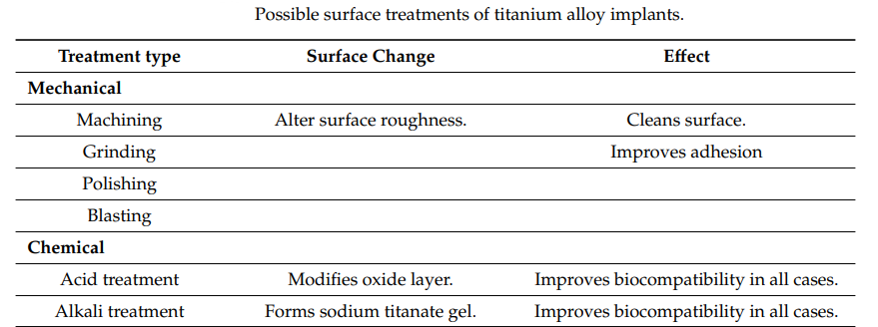

Conclusion
The excellent biocompatibility and physico-chemical properties of Ti dental implants position Ti as the gold standard in implantology. The safety and success of Grade 4 Ti is well documented, while Grade 5 offers superior biocompatibility and viability as well as superior physical properties. Regarding various surface modifications, SLA appears to successfully combine the advantages of physical and chemical methods, making it a cheap alternative. High osseointegration and low cost
Long-term survival of SLA dental implants has been confirmed by multiple in vitro and clinical studies. Based on the current literature, it can be concluded that grade 5 Ti with an SLA-modified surface ensures the best results in dental implants. Hypersensitivity or allergic reactions to titanium or other alloying constituents are very rare, but do occur, so the implantologist should be aware of this possibility and pay particular attention to the patient's medical history.

References
1.Yano, Y.; Fan, J.; Dawsey, S.M.; Qiao, Y.; Abnet, C.C. A Long-Term Follow-up Analysis of Associations between Tooth Loss and Multiple Cancers in the Linxian General Population Cohort. J. Natl. Cancer Cent. 2021, 1, 39–43. [CrossRef] [PubMed]
2. Chen, Y.; Yang, Y.-C.; Zhu, B.-L.; Wu, C.-C.; Lin, R.-F.; Zhang, X. Association between Periodontal Disease, Tooth Loss and Liver Diseases Risk. J. Clin. Periodontol. 2020, 47, 1053–1063.
3. Hong, D.G.K.; Oh, J.-H. Recent advances in dental implants. Maxillofac. Plast. Reconstr. Surg. 2017, 39, 33. [CrossRef] [PubMed]
4. Shemtov-Yona, K.; Rittel, D. An overview of the mechanical integrity of dental implants. Biomed. Res. Int. 2015, 2015. [CrossRef] [PubMed]
5. Niinomi, M.; Nakai, M. Titanium-Based biomaterials for preventing stress shielding between implant devices and bone. Int. J. Biomater. 2011, 2011. [CrossRef] [PubMed]
6. Osman, R.B.; Swain, M.V. A critical review of dental implant materials with an emphasis on titanium versus zirconium. Materials 2015, 8, 932–958. [CrossRef]
7. Sittig, C.; Textor, M.; Spencer, N.D.; Weiland, M.; Vallotton, P.-H. Surface characterization of implant materials cpTi, Ti-6Al-7Nb and Ti-6Al-4V with different pre-treatments. J. Mater. Sci. Mater. Med. 1999, 10, 35–46.
8. Al-Hashedi, A.A.; Laurenti, M.; Benhamon, V.; Tamimi, F. Decontamination of titanium implants using physical methods. Clin. Oral Implants Res. 2017, 28, 1013–1021. [CrossRef]
9. Juodzbalys, G.; Sapragonlene, M.; Wennerberg, A.; Baltrukonis, T. Titanium oral implant surface micromorphology optimization. J. Oral Implantol. 2007, 33, 177–185.
10. Hanawa, T. Titanium-tissue interface reaction and its control within surface treatment. Front. Bioeng. Biotechnol. 2019, 7, 170. [CrossRef]
11. McCracken, M. Dental implant materials: Commercially pure titanium and titanium alloys. J. Prosthodont. 1999, 8, 40–43
12. Liu, X.; Chen, S.; Tsoi, J.K.H.; Matinlinna, J.K. Binary titanium alloys as dental implant Materials—A review. Regen. Biomater. 2017, 4, 315–323.
13. Zhang, L.; Chen, L.-Y. A review on biomedical titanium alloys: Recent progress and prospect. Adv. Eng. Mater. 2019, 21.
14. Niiomi, M. Mechanical biocompatibilities of titanium alloys for biomedical applications. J. Mech. Behav. Biomed. Mater. 2008, 1, 30–42.
15. Elias, C.N.; Fernandes, D.J.; De Souza, F.M.; Monteiro, E.D.S.; De Biasi, R.S. Mechanical and clinical properties of titanium and Titanium-Based alloys (Ti G2, Ti G4 cold worked nanostructured and Ti G5) for biomedical applications. J. Mater. Res. Technol. 2019, 8, 1060–1069
16. Klein, G.L. Aluminium toxicity to bone: A Multi-System effect? Osteoporos. Sarcopenia 2019, 5, 2–5.
17. Thyssen, J.; Jakobsen, S.S.; Engkilde, K.; Johansen, J.D.; Søballe, K.; Menné, T. The association between metal allergy, total hip arthroplasty, and revision. Acta Orthop. 2009, 80, 646–652.
18. Apostu, D.; Lucaciu, O.; Lucaciu, G.D.O.; Crisan, B.; Crisan, L.; Baciut, M.; Onisor, F.; Baciut, G.; Câmpian, R.S.; Bran, S. Systemic drugs that influence titanium implant osseointegration. Drug Metab. Rev. 2017, 49, 92–104. [CrossRef]
19. Mavrogenis, A.F.; Dimitriou, R.; Parvizi, J.; Babis, G.C. Biology of implant osseointegration. J. Musculoskelet. Neuronal Interact. 2009, 9, 61–71.
20. Jemat, A.; Ghazali, M.J.; Razali, M.; Otsuka, Y. Surface modifications and their effects on titanium dental implants. BioMed Res. Int. 2015, 10.
21. John, A.A.; Jaganathan, S.K.; Supriyanto, E.; Manikandan, A. Surface modification of titanium and its alloys for the enhancement of osseointegration in orthopaedics. Curr. Sci. 2016, 111, 1003–1015.
22. Blumenthal, N.C.; Cosma, V. Inhibition of apatite formation by titanium and vanadium ions. J. Biomed. Mater. Res. 1989, 23, 13–22.
23. Nuss, K.M.R.; von Rechenberg, B. Biocompatibility issues with modern implants in Bone—A review for clinical orthopaedics. Open Orthop. J. 2008, 2, 66–78.
24. Sartoretto, S.C.; Alves, A.T.N.N.; Resende, R.F.B.; Calasans-Maia, J.A.; Granjeiro, J.M.; Calasans-Maia, M.D. Early osseointegration driven by the surface chemistry and wettability of dental implants. J. Appl. Oral Sci. 2015, 23, 279–287.
25. Balshe, A.A.; Assad, D.A.; Eckert, S.E.; Koka, S.; Weaver, A.L. A retrospective study of the survival of Smooth-And Rough-Surface dental implants. Int. J. Oral Maxillofac. Implants 2009, 24, 1113–1118.
26. Wennerberg, A.; Albrektsson, T. On implant surfaces: A review of current knowledge and opinions. Int. J. Oral Maxillofac. Implants 2010, 25, 63–74.
27. Pinholt, E.M. Bränemark and ITI dental implants in the human Bone-Grafted maxilla: A comparative study. Clin. Oral Implants Res. 2003, 14, 584–592.
28. Boukari, A.; Francius, G.; Hemmerlé, J. AFM force spectroscopy of the fibrinogen adsorption process onto dental implants. J. Biomed. Mater. Res. Part A 2006, 78, 466–472.
29. Bagno, A.; Bello, C.D. Surface treatments and roughness properties of Ti-Based biomaterials. J. Mater. Sci. Mater. Med. 2004, 15, 935–949.
30. Takadama, H.; Kim, H.M.; Kokubo, T.; Nakamura, T. An X-Ray photoelectron spectroscopy study of the process of apatite formation on bioactive titanium metal. J. Biomed. Mater. Res. 2001, 55, 185–193.
31. Yamaguchi, S.; Takadama, H.; Matsushita, T.; Nakamura, T.; Kokubo, T. Cross-Sectional analysis of the surface ceramic layer developed on Ti metal by NaOH-Heat treatment and soaking in SBF. J. Ceram. Soc. Jpn. 2009, 117, 1126–1130
32. Pattanayak, D.K.; Yamaguchi, S.; Matsushita, T.; Nakamura, T.; Kokubo, T. Apatite-Forming ability of titanium in terms of pH of the exposed solution. J. R. Soc. Interface 2012, 9, 2145–2155. [CrossRef]
33. Kim, H.-M.; Himeno, T.; Kawashita, M.; Lee, J.-H.; Kokubo, T.; Nakamura, T. Surface potential change in bioactive titanium metal during the process of apatite formation in simulated body fluid. J. Biomed. Mater. Res. 2003, 67, 1305–1309.
34. Takadama, H.; Kim, H.M.; Kokubo, T.; Nakamura, T. TEM-EDX study of mechanism of bonelike apatite formation on bioactive titanium metal in simulated body fluid. J. Biomed. Mater. Res. 2001, 57, 441–448
35. Kawanabe, K.; Ise, K.; Goto, K.; Akiyama, H.; Nakamura, T.; Kaneuji, A.; Sugimori, T.; Matsumoto, T. A new cementless total hip arthroplasty with bioactive titanium Porous-Coating by alkaline and heat treatment: Average 4.8-Year results. J. Biomed. Mater. Res. Part B Appl. Biomater. 2009, 90, 476–481.
36. So, K.; Kaneuji, A.; Matsumoto, T.; Matsuda, S.; Akiyama, H. Is the Bone-Bonding ability of a cementless total hip prosthesis enhanced by alkaline and heat treatment? Clin. Orthop. Relat. Res. 2013, 471, 3847–3855.

