Survey of Wheat Septoria tritici blotch and Identification of the Causative Agent, Zymoseptoria tritici in the Major Wheat Growing Areas of Ethiopia

Tilahun Mekonnen^{1*}. Teklehaimanot Haileselassie¹. Stephen B. Goodwin³ and Kassahun Tesfaye^{1&2}

¹ Institute of Biotechnology, Addis Ababa University, Ethiopia. King George VI street, P.O. Box 1176, Addis Ababa, Ethiopia.
^{1,2} Ethiopian Biotechnology Institute. Affiliated with Institute of Biotechnology, Addis Ababa University, Ethiopia. E-mail: kassahuntesfaye@yahoo.com/ kassahun.tesfaye@aau.edu.et
³ USDA-Agricultural Research Service, Department of Botany and Plant Pathology, Purdue University, 915 West State Street, West Lafayette, Indiana, 47907-2054, USA. Email: Steve.Goodwin@ARS.USDA.gov

*Corresponding Author: Tilahun Mekonnen, Institute of Biotechnology, Addis Ababa University, Ethiopia. E-mail: mekonnentilahun27@yahoo.com, tilahun.mekonnen@aau.edu.et

Abstract
Septoria Tritici Blotch (STB) caused by the fungus Zymoseptoria tritici is becoming major threat to wheat production throughout the world including Ethiopia. In Ethiopia, there is a dearth of information on the distribution and severity of the disease. Moreover, correct detection of the pathogen is greatly missing. The present study aimed at determining the status of STB disease in central and southeastern parts of the country, and also to identify the pathogen using microscopic and PCR based assays. A survey was conducted in 2016 and 2017 main cropping seasons following the main roads and accessible routes. A total of 182 Septoria infected wheat leaf samples were collected. Recovered isolates were subjected to microscopic and Septoria-specific diagnostic markers (ITS1 and JB446) based detections. The results that STB was 100% prevalent in all the assessed areas with variable degree of mean of incidence (76 - 92.3%) and severity (36.3 - 77.7%). The microscopic assay successfully detected Z. tritici in all the samples with considerable morphological variations. Similarly, the PCR based assay successfully amplified a 345 bp size from all the isolates and the positive control confirming the wide distribution of the disease in the country. Hence, the study successfully identified that STB is the major wheat production limiting factor in Ethiopia, and thus adopting or developing best management strategies are important to control the disease. Moreover, Zymoseptoria tritici isolates of Ethiopia have been accurately identified, and hence can be used in host-pathogen interaction studies in wheat resistance breeding program.

Keywords: Diagnostic marker; Incidence; Microscopic assay; Resistance breeding; severity.

Introduction

Wheat is the most widely grown cereal crop globally (Osundwa et al. 2013). It provides 20% of the total calories of the world’s population, making the crop an important component of food security at the global level. Wheat is one of the major staple and strategic food security crops in Ethiopia (Letta et al. 2014; Bezabeh et al. 2015). In 2016, it was cultivated in the country by 4,995,863 house holders on about 1.7 million ha with annual production of 4.5 million metric tons (CSA 2016). It is grown between 6 and 14º N latitude and between 35 and 42º E longitude ranging in altitude from 1500 to 3200 m. The most suitable regions, however, fall between 1900 and 2700 m. Both bread and durum wheat are widely cultivated with the former accounting for 65% of total wheat production and the remaining 35% by the later (Bezabeh et al. 2015).

In Ethiopia, wheat is cultivated for food (bread, biscuits, pasta, macaroni, “dabokolo”, “ganfo”, and “kinche”), animal feed and income generation. In spite of its multiple importance, the average wheat productivity of the country is 2.37 t/ha, far below the global average of 3.3 t/ha (FAO 2013). A number of factors including biotic (diseases, insect pests and weeds) and abiotic (moisture, soil fertility, etc.) and slow adoption of new agricultural technologies are known to contribute to the low productivity in wheat (Zegeye et al. 2001). Currently, the fungal disease Septoria tritici blotch (STB) caused by Zymoseptoria tritici formerly called Septaria tritici (teleomorph: Mycosphaerella graminicala) (Miedaner et al. 2013; Steinberg 2015; Sánchez-Vallet et al. 2015) is among the major bottlenecks to wheat production across the world including Ethiopia (Hailu and Woldeab 2015).

Globally, wheat yield losses of 30 – 53% have been attributed to Septoria diseases with the diseases affecting yield by causing reduced tillering, poor seed set, poor grain fill or shriveled kernels, death of leaves, spikes or the entire plant (van Ginkel et al. 1999; Simón et al. 2002; Goodwin 2007; Ponomarenko et al. 2011; Miedaner et al. 2013). Z. tritici is principally a foliar pathogen (Schultz and French 2008). The primary infection may begin with airborne or rain-splashed asexual pycnidospores and sexual ascospores from infested crop debris (Shaner 1981; Hunter et al. 1999; Gilchrist and Dubin 2002).

Recently, Z. tritici blotch has emerged as the major threat to wheat production in Arsi and Bale (southeastern Ethiopia) and Shewa (Central Ethiopia), where 75% of the total wheat production area of the country is located. In respect of its significant effect on wheat production and productivity of the country, information on the disease prevalence, incidence and severity at the national level is greatly missing. Moreover, there is a dearth of information on the causative pathogen Z. tritici in the country. However, accurate identification of the pathogen is a basis for precise prediction of disease and an essential for precise timing in fungicide applications to get the best control effects (Fraaije et al. 1999). Leonard and Fry (1986) stated that disease diagnosis is an important prerequisite to optimize fungicide input, to practice integrated pest management (IPM) and to work towards sustainable agriculture.

So far, limited efforts have been made to isolate and correctly identify Z. tritici isolates of Ethiopia. Use of integrated methodologies can generate holistic and promising information to clearly understand the pathogen and make informed decision on effective and sustainable management of the disease. Nowadays, advances in molecular technology show great potential for the rapid detection and identification of fungi for various purposes (Iwen et al. 2002). The internal transcribed spacer (ITS) sequences within the ribosomal RNA genes (ribosomal DNA) are widely used as a molecular probe to identify fungal pathogens (Beck and Ligon 1995). ITS sequences are considered to be the prime fungal default region for species identification and it can be retrieved using diagnostic primers that target the sequence (Das and Deb 2015). Hence, use of morpho-molecular techniques beyond the conventional field symptomological assay would make the pathogen detection and identification efforts very informative and also would have considerable importance to wheat growers and pathologists of Ethiopia. Therefore, the present study targeted at symptomlologiacl field survey of Septoria tritici blotch of wheat, and microscopic and PCR based identification of the causative pathogen Z. tritici in the major wheat-growing areas of Ethiopia to generate valuable information for the national wheat breeding program to design sustainable management strategies to effectively control septoria leaf blotch (SLB), and hence, contributes to increased and stable wheat production and productivity in Ethiopia.

Materials and Methods

Disease survey:
The disease survey was conducted during the 2016 - 2017 cropping seasons in eight major wheat-growing zones of Ethiopia namely East Shewa, West Shewa, North Shewa, Oromiya special zone surrounding Finfine, Southwest Shewa, Arsi, West Arsi and Bale zones, where 75% of the total wheat production area of the country is located (Fig. 1). The survey was made using the main roads and accessible routes in each survey district, and in each available wheat field, stops were made at 5-10 km intervals based on vehicle odometers. Based on the size of each wheat field, at least three to five stops were made in an “X” pattern. Whenever the wheat field was large, for instance in Agricultural research centers, more stops were made to get representative data. The surveys were conducted when the crop growth stage (GS) was on average between the medium milk (60 GS) and early dough (75 GS) stages according to Zadoks et al. (1974). Disease data were recorded on disease prevalence, incidence and severity. The disease prevalence was calculated using the number of fields affected by the disease divided by the total number of fields assessed and expressed as a percentage, i.e:

Disease incidence was calculated by using the number of infected plants divided by total plants in a quadrant and expressed as percentage assessed.

Disease severity was estimated by considering percent of necrotic leaf area on the four uppermost infected leaves of 10 - 20 plants using a double-digit 00-99 scoring scale (Saari and Prescott 1975; Eyal and Brown 1976), where the first digit (0-9) represents the blotch development up the plant height (for instance 5 if the disease reached at the middle (50%) of the plant height, 8 for flag leaf and 9 for spike), and the second digit stands for disease severity as a percentage but in terms of 0-9 (1=10%, 2=20% and 9=90%). Septoria disease severity percentage (% SDS) was computed from the 00-99 score using the following formula (Sharma and Duveiller 2007):
% Septoria Disease severity (SDS) = (D1/9) × (D2/9) × 100.
The mean incidence and severity of each field were computed from the many stops in the same field, and compiled and presented by districts.

Microscopic Diagnosis of Z. tritici
To precisely determine the causative agent of STB, microscopic discovery of the spores was carried out using high power microscope (Nikon ECLIPSE Ni) supplemented with camera and large screened TV. For microscopic detection of the spores, 43 samples were randomly selected from field-collected, infected leaf wheat samples from major wheat-growing areas of Ethiopia. Accordingly, leaf samples with pycnidia were cut into about 10 cm lengths and placed on sterile filter paper in Petri plates wetted with distilled water (Fig. 2a). The Petri dishes with specimens were incubated for 3-4 hr at 24°C (Fig. 2b) and periodically checked under stereoscopic dissecting microscope for the formation of cloudy ooze on the top of pycnidia (Fig. 2 c). Using a flame sterilized fine needle, the mono-pycnidial oozing drops were transferred onto clean glass slides. After placing a cover slip, the specimens were observed under a highly powerful microscope (Nikon ECLIPSE Ni) with total magnification power of 600x and the spore length, width and number of septa were recorded. For clear visualization of the spores, the specimens were stained with a drop of Lactofuchsin solution (Fig. 3 b). Per sample, on average, ten spores were considered to estimate the spore length, width and number of septa.

PCR based identification of Z. tritici
During the study, single spore derived colonies were grown by transferring mono-pycnidial oozing drops from leaf samples onto potato dextrose agar (PDA; potato 200 g/l, dextrose 20 g/l, agar 15 g/l) plates supplemented with 250 mg of chloramphenicol after autoclaving (Fig. 2a,b) . Inoculated Petri plates (Fig. 2c) were kept at 24ºC for 7 - 10 days until fungal growth were observed (Fig. 2.d). Developed colonies were re-streaked plated on new PDA to get pure isolates (Fig. 2 e-g). For DNA extraction, spores were multiplied in liquid media composed of 1% (w/v) yeast extract powder and 1% (w/v) sucrose, and kept on orbital shaker at 130 rpm for two to three weeks. For DNA extraction, spores were collected in sterile 50ml falcon tubes by centrifuging at 10,000 rpm for 5 munities. Genomic DNA extraction was carried out using plant DNA extraction Protocol described in Diversity Array Technology (DArT, Canberra, Australia) with some modifications. Confirming the DNA quality and concentration on gel electrophoresis and with nano-drop Spectrophotometer (ND-8000, 8-sample Spectrophotometer) (Thermo Fisher Scientific), it is used for PCR reaction.

PCR program

To confirm that the isolates are Z. tritci, a species-specific diagnostic markers developed by Beck and Ligon (1995) were used. The primer pairs sequence involved ITS1 (5’-TCCGTAGGTGAACCTGCGG-3’) and JB446 (5’- CGAGGCTGGAGTGGTGT-3’). They target the ITS region and their positive amplification results a fragment size of 345 bp in Z. tritici. The PCR reaction was performed using 96 well PCR plate in a volume of 12.5 μl containing 6.25 μl One Taq 2x Master mix with Standard Buffer (New England BioLabs), 0.4 μM each of forward (ITS1) and reverse (JB446) primers, 3.25μl nuclease free water and 1 μl of genomic DNA using BIORAD Thermal cycler. Amplification conditions involved an initial denaturation at 94°C for 3 min followed by 35 cycles with 1 min denaturation at 94°C, 1 min annealing at 60°C, primer extension at 72°C for 2 min followed by final extension step of 10 min at 72°C. Genomic DNA from the reference isolate (IPO323) obtained from Professor S. B. Goodwin’s lab., Purdue University, USA was included as positive control, and nucleic acid free water was added in the negative control. PCR product was fractionated in 3% agarose gel electrophoresis using 1× TAE buffer at 100V for 3hr. The product was stained in GelRedTM (Biotium, CA, USA) (2μl), visualized under UV light and subsequently photographed using BioDoc-It TM Imaging System (UVPLife Science Tools and Technology). A 50 +100 bp DNA ladder was used to estimate the amplification size.

Results

Disease Assessment:
The survey result that STB is becoming critical problem to wheat production in the major wheat-growing areas of Ethiopia. The disease distribution analysis showed that STB was 100% prevalent in all the assessed areas (Table 1). However, the mean incidence of the disease varied across zones and districts. Across districts mean incidence ranged from 69 -100%, with lowest (69%) incidence values was recorded for Dandi (Table 1). While, four districts (Lemu, Tiyo, Walmara and Chelia) were found to have the highest (100%) septoria disease incidence (Table 1). Across Zones, the mean incidence ranged from 76 - 91.5%, with overall mean of 87.9%. East Shewa was found to have the lowest (76%) mean incidence value (Table 1). The highest (92.3%) mean incidence was observed in Arsi zone followed by Oromia Special Zone Surrounding Finfinne (91.5%), Bale (89.8%) and North Sewa (88.0%) (Table1). Similarly, the disease severity analysis reveled that STB is becoming the major bottleneck to wheat production in Ethiopia. The overall mean disease severity percentage (%SDS) was 65.3%, with the lowest (36.3) and highest (77.7%) severity was recorded for East Shewa and Oromia Special Zone Surrounding Finfinne, respectively (Table 1). Among districts, Gedebe Assa (West Arsi zone) and Adaa (East Shewa) showed lower % SDS with their respective values of 33.0% and 36.3%. The highest percentage of Septoria disease severity was recorded in Wolmera (82.7%) followed by Lemu Bilbilo (77.7%), Chelia (76.7%), Welisso (75.3%), (75.3%) and Wenchi (74.1%) (Table1).

Microscopic identification of Z. tritici isolates
Disease diagnosis is an important prerequisite to optimize fungicide input, to practice integrated pest management (IPM) and to work towards sustainable agriculture (Leonard and Fry 1986). Precise identification of the disease causative pathogen is a basis for precise prediction of disease and an essential for precise timing in fungicide applications to get the best control effects (Fraaije et al. 1999). Irrespective of its significant effect on wheat yield loss, limited effort has been made to identify and characterize Z. tritici isolates of Ethiopian collections. Hence, the present report might be the first effort made to isolate and identify the notable wheat pathogen, Z. tritici in Ethiopia. The microscopic assay result that all (100%) of the tested symptomatic wheat leaf samples were detected to be positive for Z. tritici. Fig. 3 shows microscopic analysis of the spores isolated from leaf samples collected from the major wheat belts of Ethiopia. The micrometrical measurements of the spore lengths and widths as well as numbers of septa (Fig. 3) were determined by considering 10 spores per sample and the results is summarized in Table 2. The analysis reveled that the spores showed considerable morphological variation on spore width, length and number of septa (Table 2). The spore width, length and number of septa ranged from 1.23- 1.98 µm, 35.35 – 57.26 µm and 0-3, respectively (Table 2).

PCR based detection of Z. tritici
The two ITS (ITS1 and ITS2) sequences located between 18S (SSU) and 28S (LSU) genes surrounding 5.8S-coding sequence are frequently used to discriminate fungi at the genus and species level. Sequencing the ITS region of Z. tritici isolate ATCC #26517, Beck and Ligon (1995) developed Z. tritici specie specific markers (ITS1 and JB446 primer). In the present study, the use of the same primer pairs (ITS1 and JB446 primer) resulted in the amplification of about 345 bp fragment from all of the 43isolates listed in Table 2 (Fig. 4). Similar amplification size was observed in the positive control (PC) reference isolate (IPO323), while no amplification was observed in the negative control (NC) using the same diagnostic primers (Fig. 4).

Discussion

Septoria Tritici Blotch (STB) caused by the fungal pathogen Z. tritici (teleomorph: M. graminicola, syn. Septoria tritici) is one of the most important diseases of wheat worldwide causing significant (20 -70 %) yield losses on wheat in the major wheat production regions of the world (Kuzdraliński et al. 2017). It is becoming the major threat to wheat production in Ethiopia. Early maturing and dwarfing varieties are aggressively devastated by the disease. However, there is a dearth of information on the disease distribution and severity as well as on the precise identification of the causative agent Z. tritici that helps to design effective and targeted management strategies. Hence, the present study targeted to determine the distribution and severity of septoria leaf blotch disease of wheat in the Central (Shewa) and southeastern (Arsi and Bale) part of Ethiopia, where 75% of the total wheat production area of the country is located. High power microscopic assay and molecular assays were used to accurately identify the pathogen.

The disease distribution analysis on eight zones that septoria leaf blotch was 100% prevalent in all of the assessed areas with variable degrees of incidence (76 - 91.5%) and severity (36.3 - 77.7%). The wide distribution of the disease might be due to the long distance dissemination of the sexual ascospores by wind and also due to the wide cultivation of the susceptible varieties in the study areas that resulted from less consideration to Septoria disease during the variety development process. In addition to the inoculums and the suitable host, presence of the third component in the disease triangle; favorable environmental conditions for the disease development including cool temperatures, prolonged wetness, frequent rain and cloudy weather might have contributed for higher distribution, incidence and severity of STB in the study areas. The overall mean incidence was 87.9%, and highest mean incidence (92.3%) was observed in Arsi zone. This result coincided with previous reports. Takele et al. (2015) reported SLB incidence of 75 - 100% in South-west and West Shewa zones of Ethiopia. For the same study areas, Hailu and Woldeab (2015) described a SLB incidence of 81-85% (mean 83%). The study also reveled that the disease incidence in the research stations was relatively higher than in the farmers’ fields, and this could be due to the practice of frequent application of fungicides by the farmers to reduce the yield loss.

The double digit scale derived disease severity analysis also showed significant variability across locations. The highest percentage of Septoria disease severity was observed in Wolmera (82.7%) followed by Lemu Bilbilo (77.7%), Chelia (76.7%), Welisso (75.3%), (75.3%) and Wenchi (74.1%). This result agrees the report of Hailu and Woldeab (2015) who observed up to 84 % septoria disease severity. This confirms that these locations are hot spot for the pathogen study and also can serve as potential sites for multi location germplasm evaluations. Of course, Holetta agricultural research center located in Wolmera (%SDS=82.7%) and Bekoji agricultural research sub-station located in Lemu Bilbilo district (Arsi zone) are serving as the national and international septoria screening centers. Hence, it is important to deduce that STB is increasingly affecting wheat production and productivity in the major wheat belt of the Ethiopia.

Another interesting component of this study which might be the first in its kind to the country is the isolation and identification of Z. tritici isolates of Ethiopia. The combination of traditional and modern techniques has been employed to identify the Z. tritici isolates. In line with this, the microscopic assay detected Z. tritici spores in all the tested symptomatic wheat leaf samples collected from the major wheat growing areas of Ethiopia confirming the wide spread of the disease. The spores showed considerable morphological variation on spore width (1.23- 1.98 µm), length (35.35 – 57.26 µm) and number of septa (0-3).

As microscopic diagnosis method is less specific and less sensitive, and hence can leads to wrong conclusion, the isolates were further confirmed using molecular technique. Nowadays, PCR based assays has been successfully applied for the detection of various pathogens including viruses, bacteria and fungi (Henson and French 1993). The technique is highly powerful to differentiate fungal species even having higher morphological similarity. In the present study, the Z. tritici specie-specific diagnostic markers (ITS1 and JB446) have successfully amplified a 345 bp fragment size from all the isolates, and also from the positive control. The successful amplification from all the sample isolates and from the reference (IPO323), but not from the negative control indicates that all the study materials were found to be Z. tritici. Similarly, using the same diagnostic markers Beck and Ligon (1995) reported a PCR product of 345 bp from Z. tritici. Using the same primers, the authors have successfully distinguished Z. titici from other fungal species including Stagonospora nodurum, Septoria glycines, Septoria passerinii, Pseudocercosporella herpotrichoides, Pseudocercosporella aestiva, Ceratobasidium cereale, and Drechslera sorokiniana. Basically, PCR based detection technology is a very sensitive, fast, accurate and economical plant pathogen diagnosis technique that likely to be used for the benefit of modern agriculture. Hence, it is important to deduce that the present study has successfully detected and identified the wheat devastating pathogen, Z. tritici isolates collected from the major wheat growing areas of Ethiopia. Although it needs further confirmations through sequence analysis, the current result can be considered as great success in the history of wheat resistance breeding in Ethiopia.

In conclusion, the study successfully identified that septoria leaf blotch is becoming critical problem to wheat production in Ethiopia. The study also sorted out hot spot areas to be used for the pathogen study and for germplasm screening and stability analysis in resistance breeding. Moreover, the study successfully detected and identified the STB causative pathogen Z. tritici that can be used in downstream studies like pathogen physiological race analysis, virulence and genetic variability analysis, expression analysis, germplasm evaluation etc. Such base line information is very relevant for national wheat breading program to design and implement integrated disease management strategies to control or minimize yield loss due to STB which ultimately contributes to an increased and stable wheat production in Ethiopia.

Recommendation
- Designing a fast-track resistance breeding strategies against the wheat devastating disease STB can boost wheat production and productivity in Ethiopia.
- More studies shall be carried out to determine the pathogen physiological races, virulence spectrum, genetic diversity and population structure.

Acknowledgements

The authors are very grateful for the wheat farming community of the study area for their kind permission to assess their field and also take STB symptomatic wheat leaf samples from their field. We are also very grateful for the National Agricultural Biotechnology research Center (NABRIC), Hotteta, Ethiopia for providing laboratory space and facilities to conduct this research. We are also thankful for the Institute of Biotechnology, Addis Ababa University for the technical support during the course of the study. Department of Botany and Plant pathology, Purdue University, USA is greatly thanked for providing PCR reagents and short term training on the pathogen for the first author.

Funding: The work was supported by Ministry of Innovation and Technology (MinT) of the Federal Democratic Republic of Ethiopia.

Availability of data and materials: All the necessary data are included in the manuscript.

Authors’ contributions:
All authors contributed to the study conception and design. Material preparation, field survey, laboratory activities and statistical analysis were performed by Tilahun Mekonnen. All co-authors actively involved in designing the experiment, interpreting the data, drafting and revising the manuscript, and finally approving the manuscript. The overall activity was supervised by Dr. Kassahun Tesfaye.

Authors declarations

We confirm that the manuscript has been read and approved by all named authors and that there are no other persons who satisfied the criteria for authorship but are not listed. We further confirm that the order of authors listed in the manuscript has been approved by all of us.

Conflict of Interest: No actual or potential conflict of interest is reported by the authors.

Ethical approval: The conducted research does not involve human participants or animals.

Ethical Responsibility: Does not applicable.

References
Beck JJ, Ligon M (1995) Polymerase chain reaction assays for the detection of Stagonospora nodorum and Septoria tritici in wheat. Phytopathology 85: 319-324.
Bezabeh E, Haregewoin T, Hailegiorgis D, Daniel F, Belay B (2015) Change and growth rate analysis in area, yield and production of wheat in Ethiopia. Journal of Agriculture and Environmental Management 4: 189-191.
CSA (2016) Agricultural Sample Survey (2016), Vol. 1: Area and Production of Major Crops, Central Statistical Agency, Federal Democratic Republic of Ethiopia, Addis Ababa, 2016.
Das, S, Deb, B (2015) DNA barcoding of fungi using Ribosomal ITS Marker for genetic diversity analysis: A Review. International Journal of Pure and Applied Bioscience 3 (3): 160-167.
Eyal Z, Brown MB (1976) A quantitative method for estimating density of Septoria tritici pycnidia on wheat leaves. Phytopathology 66, 11-14.
Fraaije BA, Lovell DJ, Rohel EA, Hollomon DW (1999). Rapid detection and diagnosis of Septoria tritici epidemics in wheat using a polymerase chain reaction/PicoGreen assay. Journal of Applied Microbiology 86: 701–708.
FAO (2013) FAOSTAT agriculture data. Agricultural production 2013. FAO Statistics Divisionhttp://fao- stat3.fao.org . Accessed June 20, 2018.
Gilchrist L, Dubin HJ (2002) Septoria diseases of wheat. FAO Corporate Document Repository. Produced by: Agriculture and Consumer Protection. http://www.fao.org/docrep/006/
y4011e/y4011e0i.htm. Accessed June 20, 2018.
Goodwin SB (2007) Back to basics and beyond: increasing the level of resistance to Septoria tritici blotch in wheat. Australasian Plant Pathology 36: 532–538.
Hailu E, Woldeab G (2015) Survey of rust and Septoria leaf blotch diseases of wheat in central Ethiopia and virulence diversity of stem rust Puccinia graminis f. sp. tritici. Advanced in Crop Science and Technology 3:166 DOI 10.4172/2329- 8863.1000166.
Henson JM, French R (1993) The polymerase chain reaction and plant disease diagnosis. Annual Review of Phytopathology 31:81-109.
Hunter T, Coker RR, Royle DJ (1999) The teleomorph stage, Mycosphaerella graminicola, in epidemics of Septoria tritici blotch on winter wheat in the UK . Plant Pathology 48: 51–57.
Iwen PC, Hinrichs SH, Rupp ME (2002) Utilization of the internal transcribed spacer regions as molecular targets to detect and identify human fungal pathogens. Medical mycology 40:87-109.
Kuzdraliński A, Kot A, Szczerba H, Nowak M, Muszyńska M (2017) A review of conventional PCR assays for the detection of selected phytopathogens of wheat. Journal of Molecular Microbiology and Biotechnology 27:175-189 DOI 10.1159/000477544.
Leonard, KJ, Fry, W E (1986) Plant disease epidemiology. p. 372 Vol. 1 Population Dynamics and Management Macmillan, New York, USA.
Letta T, Olivera P, Maccaferri M, Jin Y, Ammar K, Badebo A, Salvi S, Noli E, Crossa J, Tuberosa J (2014) Association mapping reveals novel stem rust resistance loci in durum wheat at the seedling stage. Plant Genome 7: DOI 10.3835/plantgenome2013. 08.0026.
Miedaner T, Zhao Y, Gowda M, Longin CFH, Korzun V, Ebmeyer E, Kazman E, Reif JC (2013) Genetic architecture of resistance to Septoria tritici blotch in European wheat. BMC Genomics 14:858.
Osundwa MA, Okalebo JR, Ngetich WK, Ochuodho JO, Othieno CO, Langat B, Omenyo VS (2013) Influence of agricultural lime on soil properties and wheat (Triticum aestivum L.) yield on acidic soils of Uasin Gishu County, Kenya. Journal of Experimental Agriculture International, 3(4), 806-823. https://doi.org/10.9734/AJEA/2013/3446.
Ponomarenko A, Goodwin SB, Kema GHJ (2011) Septoria tritici blotch (STB) of wheat. Plant Health Instructor. DOI 10.1094/PHI-I-2011-0407-01.
Saari EE, Prescott JM (1975) Scale for appraising the foliar intensity of wheat diseases. Plant Disease 59: 377-380.
Schultz D, French RD (2008) Septoria Leaf Blotch, Stagonospora Glume Blotch. AgriLife Extension Service;The Texas A&M System. https://agrilifecdn.tamu.edu/amarillo/files/
2010/11/SeptoriaStagonospora.pdf. Accessed July30,2019.
Shaner G (1981) Effect of environment on fungal leaf blights of small grains Annual Review of Phytopathology 19: 273-296.
Sharma RC, Duveiller E (2007) Advancement toward new spot blotch resistant wheats in south Asia. Crop Science 47: 961-968.
Simón MR, Perelló AE, Cordo CA, Struik PC (2002) Influence of Septoria tritici on yield, yield components, and test weight of wheat under two nitrogen fertilization conditions. Crop Science 42(6): 1974–1981.
Steinberg G (2015) Cell biology of Zymoseptoria tritici: Pathogen cell organization and wheat infection. Fungal Genet and Biology 79: 17-23 DOI 10.1016/j.fgb.2015.04.002.
Takele A, Lencho A, W/Ab G, Hailu E, Kassa B (2015) Status of wheat Septoria leaf blotch (Septaria tritici Roberge in Desmaz) in south west and western Shewa zones of Oromiya regional state, Ethiopia. Research in Plant Sciences 3: 43-48. DOI: 10.12691/plant-3-3-1.
Sánchez-Vallet A, McDonald MC, Solomon PS, McDonald BA (2015) Is Zymoseptoria tritici a hemibiotroph. Fungal Genet and Biology 79: 29–32.
van Ginkel M, McNab A, Krupinsky J ( eds.) (1999) Septoria and Stagonospora Diseases of Cereals: A Compilation of Global Research. Mexico, DF: CIMMYT.
Zadoks JC Chang TT, Konzak CF (1974) A decimal code for the growth stages of cereals. Weed Research 14:415-421.
Zegeye T, Taye G, Tanner D, Verkuijl H, Agidie W, et al (2001) Adoption of improved bread wheat varieties and inorganic fertilizer by small-scale farmers in yelmana Densa and Farta districts of North western Ethiopia. EARO and CIMMYT. Mexico city, Mexico.

Figure Legends
Fig. 1 Map of Ethiopia with the major wheat growing- area
Fig. 2 Zymoseporia tritici isolation procedure from wheat leaf samples.
Fig. 3 Microscopic analysis of M. graminicola spores.
Fig. 4 Gel red stained agarose gel of polymerase chain reaction amplification product using Z. tritici specific primers (ITS1 and JB446).

Tables
Table 1. Distribution of Septoria tritici blotch (STB) in the major wheat-growing areas of Ethiopia
Zone | Districts | Altitude range  (m) | Prevalence (%) | Incidence (%) | Range of  00-99 score | Mean % SDS
East Shewa | Adaa | 1725-1880 | 100 | 76 | 54-67 | 36.3
Arsi | Hetosa | 2067- 2214 | 100 | 82 | 56-78 | 53.2
 | Tiyo | 2358-2651 | 100 | 100 | 77-87 | 67.1
 | Tigona Digelu | 2163-2460 | 100 | 87 | 67-79 | 62.3
 | Lemu Bilbilo | 2603 - 2993 | 100 | 100 | 76-89 | 77.7
 | Mean | 1725-2993 | 100 | 92.3 | 56-89 | 59.32
West Arsi | Gedebe Asassa | 2369- 2624 | 100 | 79 | 56-77 | 33.0
 | Dodola | 2320 - 2455 | 100 | 85 | 54-65 | 70.8
 | Kofale | 2298-2671 | 100 | 88 | 67-88 | 64.8
 | Mean | 2298-2671 | 100 | 84.0 | 54-88 | 56.21
Southwest Shewa | Illu | 2087-2099 | 100 | 74 | 55-76 | 44.8
 | Bacho | 2122-2257 | 100 | 84 | 67-89 | 41.0
 | Wenchi | 2702- 2737 | 100 | 100 | 56-77 | 74.1
 | Welisso | 2272- 2460 | 100 | 88 | 55-89 | 75.3
 | Mean | 2087-2737 | 100 | 86.5 | 55-89 | 58.79
West Shewa | Ambo | 2245-2533 | 100 | 77 | 67-76 | 49.0
 | Toke Kutaye | 2256-2369 | 100 | 100 | 66-77 | 72.4
 | Chelia | 2259 -2471 | 100 | 100 | 72-89 | 76.7
 |  | 2208-2214 | 100 | 69 | 45-89 | 75.3
 | Mean | 2208-2533 | 100 | 86.5 | 45-89 | 68.35
Oromia Special zone Surrounding Finfinne | Wolmara | 2373- 2399 | 100 | 100 | 76-89 | 82.7
 | Sululta | 2586-2615 | 100 | 83 | 65-77 | 72.8
 | Mean | 2373-2615 | 100 | 91.5 | 65-89 | 77.73
North Sewa (Selale) | Degem | 2874 -3060 | 100 | 86 | 64-77 | 74.0
 | Hidabu Abote | 2698-2737 | 100 | 90 | 69-78 | 62.6
 | Mean | 2698-3060 | 100 | 88.0 | 64-78 | 68.25
Bale | Sinana | 2394- 2551 | 100 | 87 | 65-88 | 73.8
 | Agarfa | 2456-2516 | 100 | 84 | 34-76 | 58.0
 | Goba | 2550-2609 | 100 | 100 | 66-87 | 71.9
 | Dinsho | 2527-2879 | 100 | 88 | 65-87 | 68.8
 | Mean | 2394-2609 | 100 | 89.8 | 34-88 | 68.12
Grand mean 1725- 3060 100% 87.89 45-89 65.25

Table 2. Microscopic diagnosis and morphological variability of Zymoseptoria tritici isolates of Ethiopia.
Zone | Wereda | Sample  Code | Latitude | Longitude | Altitude (m) | Prevalence | Spore width  (µm) | Spore length (µm) | Number of Septa
East Shewa | Adaa | S1 | 08º 20' 164 | 039º 00' 581 | 1881 | 100 | 1.86 | 35.35 | 0-3
 |  | S3 | 08º 46' 329 | 039º00' 029 | 1882 | 100 | 1.54 | 36.3 | 0-3
Arsi | Hetosa | S9 | 08º 05' 968 | 039º 13' 584 | 2171 | 100 | 1.47 | 47.36 | 0-3
 |  | S15 | 08º 00' 890 | 039º 09' 524 | 2213 | 100 | 1.98 | 49.57 | 0-3
 |  | S17 | 08º 00' 858 | 039º 09' 481 | 2216 | 100 | 1.52 | 41.96 | 0-3
 |  | S19 | 08º 00' 844 | 039º 09' 441 | 2211 | 100 | 1.75 | 42.75 | 0-3
 | Lemu Bilbilo | S36 | 07º 32' 552 | 039º 15' 325 | 2810 | 100 | 1.45 | 44.08 | 0-3
 |  | S41 | 07º 32' 587 | 039º 15' 343 | 2815 | 100 | 1.48 | 50.82 | 0-3
 |  | S53 | 07º 32' 648 | 039º 15' 397 | 2814 | 100 | 1.48 | 52.03 | 0-3
 |  | S55 | 07º 32' 626 | 039º 15' 395 | 2812 | 100 | 1.92 | 46.556 | 0-3
 | Adaba | S88 | 07º 01' 582 | 039º 27' 098 | 2454 | 100 | 1.24 | 49.34 | 0-3
 |  | S89 | 07º 01' 525 | 039º 27' 126 | 2459 | 100 | 1.24 | 49.335 | 0-3
 |  | S90 | 07º 01' 498 | 039º 27' 128 | 2460 | 100 | 1.43 | 47.57 | 0-3
West Arsi | Kofale | S95 | 07º 00' 990 | 039º 00' 620 | 2539 | 100 | 1.46 | 42.47 | 0-3
 |  | S96 | 07º 05' 136 | 038º 47' 093 | 2654 | 100 | 1.44 | 43.24 | 0-3
South West  Shewa | Welisso | S97 | 08º 37' 954 | 038º 02' 516 | 2397 | 100 | 1.62 | 38.43 | 0-3
 |  | S98 | 08º 37' 960 | 038º 02' 505 | 2398 | 100 | 1.56 | 47.93 | 0-3
 |  | S99 | 08º 37' 037 | 038º 01' 931 | 2320 | 100 | 1.23 | 48.45 | 0-3
 | Wenchi | S101 | 08º 38' 014 | 037º 54' 162 | 2196 | 100 | 1.4 | 50.39 | 0-3
 |  | S102 | 08º 39' 585 | 037º 53' 458 | 2295 | 100 | 1.26 | 47.07 | 0-3
 |  | S104 | 08º 40' 813 | 037º 53' 353 | 2517 | 100 | 1.68 | 53.84 | 0-3
 |  | S105 | 08º 43' 579 | 037º 53' 085 | 2739 | 100 | 1.67 | 44.56 | 0-3

Table 2 Continued

West Shewa | Ambo | S106 | 08º 54' 029 | 037º 52' 949 | 2532 | 100 | 1.83 | 47.67 | 0-3
 |  | S107 | 08º 54' 024 | 037º 52' 954 | 2536 | 100 | 1.46 | 53.17 | 0-3
 | Toke- Kutaye | S108 | 08º 58' 960 | 037º 43' 483 | 2256 | 100 | 1.59 | 47.73 | 0-3
 |  | S109 | 08º 58' 969 | 037º 43' 480 | 2258 | 100 | 1.58 | 45.62 | 0-3
 | Chelia | S111 | 09 º 01' 548 | 037o 26' 856 | 2470 | 100 | 1.26 | 44.23 | 0-3
 |  | S114 | 09º 01' 572 | 037º 26' 885 | 2470 | 100 | 1.66 | 57.26 | 0-3
 |  | S115 | 09 º 01' 559 | 09º 01' 572 | 2472 | 100 | 1.44 | 48.22 | 0-3
 |  | S116 | 09 º 01' 594 | 037º 26' 886 | 2467 | 100 | 1.55 | 41.13 | 0-3
Oromia Special Zone Surrounding Finfinne | Wolmara | SH2A | 09º 03' 268 | 038º 30' 298 | 2373 | 100 | 1.52 | 38.14 | 0-3
 |  | StH3 | 09º 03' 278 | 038º 30' 299 | 2377 | 100 | 1.55 | 47 | 0-3
 |  | SH10A | 09º 03' 590 | 038º 30' 682 | 2383 | 100 | 1.85 | 52.49 | 0-3
 | Sululta | SH11 | 09º 13' 693 | 038º 45' 358 | 2586 | 100 | 154 | 46.22 | 0-4
North Sewa |  | SH12 | 09º 24' 039 | 038º 50' 722 | 2615 | 100 | 1.68 | 42.81 | 0-3
 | Degem | SH13 | 09º 47' 222 | 038º 31' 629 | 2898 | 100 | 1.82 | 41.99  49.05 | 0-3
 |  | SH15 | 09º 47' 257 | 038º 31' 664 | 2905 | 100 | 1.157 |  | 0-3
Bale | Sinana | Bl88C | 07º 10' 141 | 40 14 973 | 2400 | 100 | 1.82 | 49.54 | 0-3
 |  | Bl89 | 07º 10 288 | 40 13 884 | 2393 | 100 | 1.27 | 37.25 | 0-3
 |  | BL90 | 07º 10 296 | 40 13 883 | 2392 | 100 | 1.17 | 45.44 | 0-3
 | Goba | Bl92 | 07º 02 019 | 039 59 243 | 2904 | 100 | 1.65 | 47.84 | 0-3
 |  | Bl96 | 07º 02 197 | 039 59 216 | 2600 | 100 | 1.37 | 46.05 | 0-3
 |  | Bl99 | 07º 02 113 | 039 59 151 | 2604 | 100 | 1.49 | 44.82 | 0-3

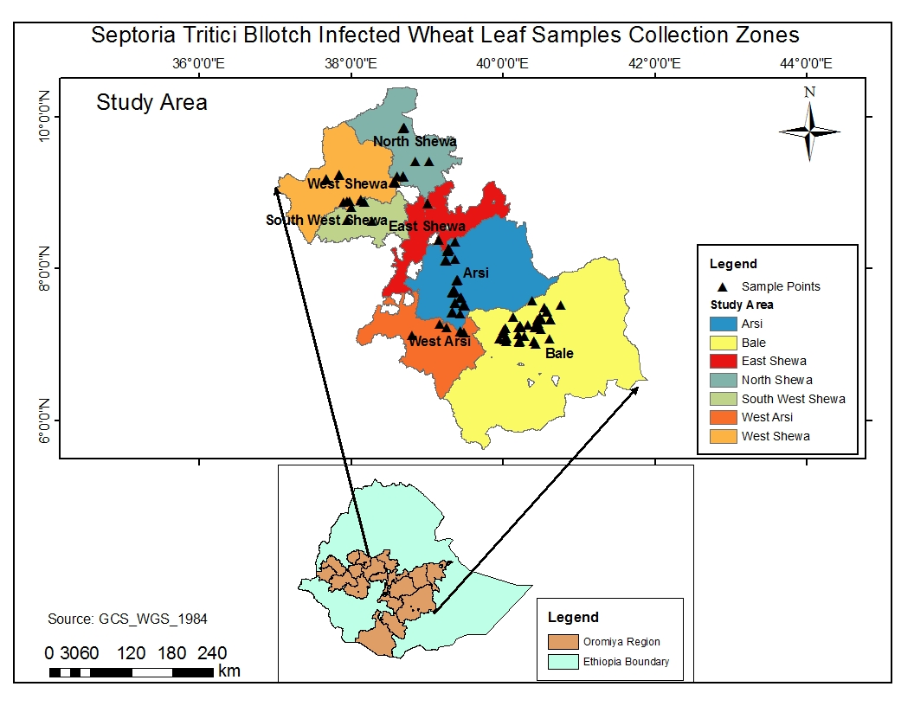
Fig. 1. Map of Ethiopia with the major wheat growing- area: Oromiya regional state (bottom) and STB infected wheat leaf samples collection sites, representing the eight Z. tritici isolates study zones in Oromiya regional State (upper).The map was original and constructed using geographic coordinates and elevation data gathered from each collection sites using global positioning system (GPS). Note: Oromia Special zone has been established recently and thus, we couldn’t able to indicate it on the map.

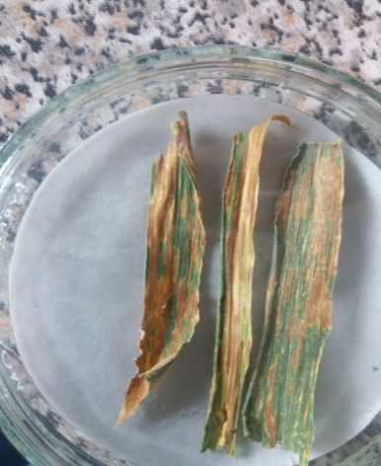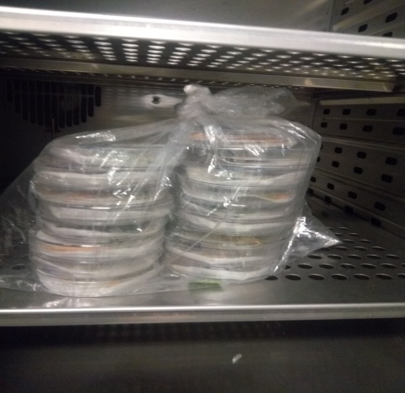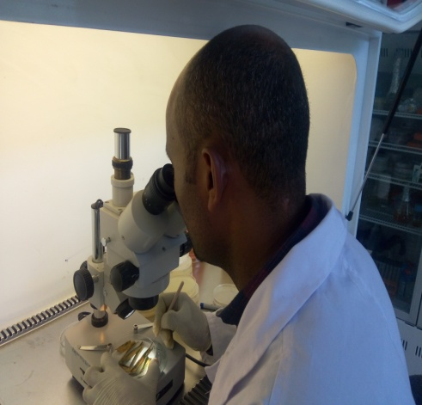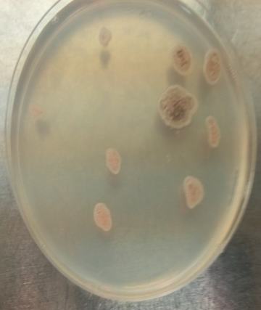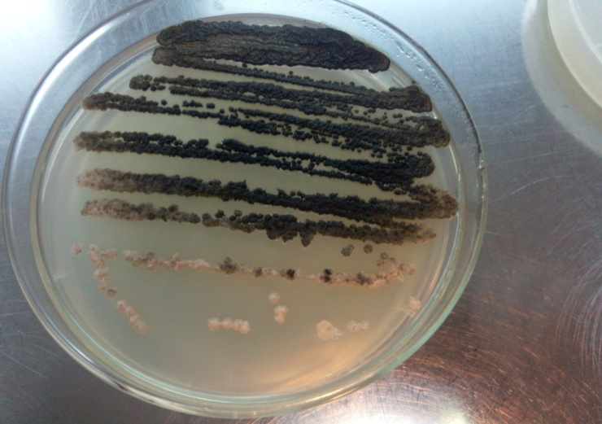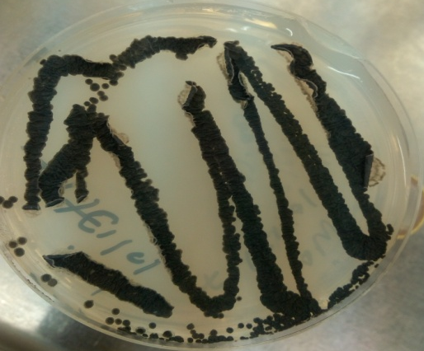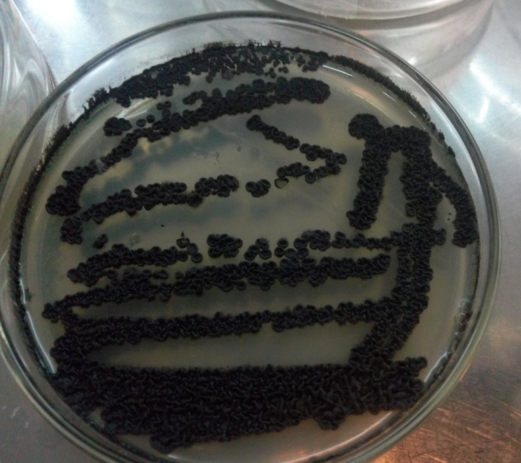
f
d
e
b
c
a
g
Fig. 2 Z. sritici isolation procedure from wheat leaf samples. a) Leaf samples put on wet filter paper in Petri dish, b) Samples incubated at 24ºC for oozing, c) Transferring oozes to PDA under dissecting microscope, d) Z. tritici colonies grown from transferred mono-pycnidial ooze on PDA after 5-7days, e) Sezptoria culture grown from streak plated single mono-pycnidial spores obtained in d, f). Re-streak plated Z. tritici cultures on PDA to obtain single spore derived colony for further studies, and g) one month old Z. tritici culture on PDA.

Fig. 3 Microscopic analysis of M. graminicola spores. a) Unstained spores (400x) at 20 µm scale, and b) Lactofuchsin-stained spores (400x) at 50µm scale, c) Measuring spore length, d) measuring spore width and e) counting spore septa (600x)
B

M S1 S3 S9 S15 S17 S19 S36 S41 S53 S55 S88 S89 S90 S91 S92 S95 S96 S98 S99 S100 S101 S102 S104 S106 S108 S109 S110 S111 PC NC M
C
D
345bp
300bp
200bp
100bp
50bp
345bp
M NC S115 S116 SH2A StH3 SH10A SH11 SH12 SH13 SH15 Bl88C Bl89 BL90 Bl92 Bl96 Bl99
Fig. 4 Gel red stained agarose gel of polymerase chain reaction amplification product using Z. tritici specific primers (JB446 and ITS1). M is a 50 +100 bp size marker while PC and NC are positive and negative control, respectively

