AESTHETIC MANAGEMENT OF FRACTURED ANTERIORS: A Case Report

Abdulgani Azzaldeen*,Alsaghee Maria **,Abu-Hussein Muhamad***

*Istituto Stomatologico Toscano, University Guglielmo Marconi of ROME,Italy, Al-Quds University, School of Dentistry, Jerusalem, Palestine
**General Dentist
*** Practice limited to Children's Dentistry,Athens,Greece

ABSTRACΤ;

Introduction: Coronal fracture of anterior teeth is an important topic for esthetic dentistry. Such fractures may jeopardize esthetics, function, tissue biology and occlusal physiology, thus endangering tooth vitality and integrity. Coronal fractures resulting from dental trauma most frequently occur to the maxillary anterior teeth of adolescents and less frequently to mandibular teeth. Adult teeth may also suffer traumatic fracture, although less frequently than for adolescents.Case Report: In our case, an economical and time-saving novel technique has been described for direct composite restoration in a young patient with uncomplicated fractured maxillary anterior tooth. Conclusion: As restoring a fractured tooth is a complex pro-cedure, this technique can prove as a simple, effective and appropriate technique that will fulfill all the requirements of dental personnel. This technique can also prove to be easy for inexperienced beginner clinicians without requiring special skills in providing the patients with direct composite restorations.
Keywords: Direct restoration, permanent anterior teeth, trauma, uncomplicated crown fracture.

Corresponding author:
Abu-Hussein Muhamad,
DDS, MSc D, MSc, M Dent Sci (Paed Dent )
123 Argus Street,
10441 Athens, Greece,
E-mail:abuhusseinmuhamad@gmail.com
INTRODUCTION
Oral injuries are the fourth most common area of personal injuries among the age group of 7–30 years old. Traumatic dental injuries have become an important health problem not only because of the relatively high prevalence but also due to the fact of the large impact caused to an individual’s daily life. Traumatic dental injuries constitute as one of the leading reason for odontological emergencies. The incidences of these injuries have increased during the past 10–20 years and a recent study have indicated that the number of the traumatic injuries incidences will exceed dental caries and periodontal diseases. Many authors have suggested that the permanent tooth fracture is a tragic experience for both child and parents. This condition was caused by the psychological discomfort, pain, loss of function, and poor aesthetics.[1,2,3]
The injured person and community with such injuries can cause expensive costs. Dentists can make a better assessment and carry out the effective treatment with the knowledge of potential prognosis of various treatment modalities. Crown fractures deserve a special attention due to their prevalence, variety of causative factors, and the diversity of clinical solutions proposed for the treatment, besides of the complicated and tricky restorations.{2,3]

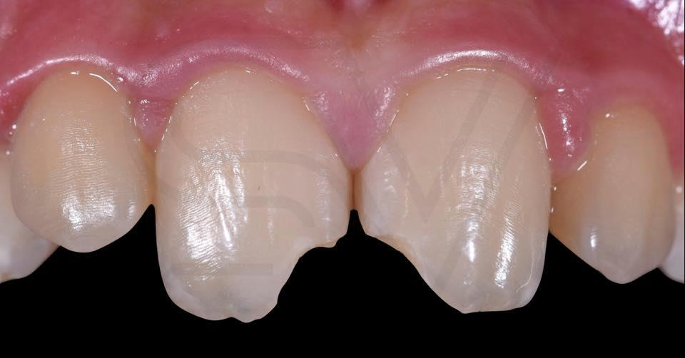
Figure-1: Pre operative view11 and 21,
There are many publications discussed the dental trauma of primary and permanent dentition. Andreason has conducted one of the most complex survey of this subject involving epidemiological, statistical, and diagnostic and treatment data from several countries, to evaluate the occurrence of traumatic dental injuries and their various etiological factors in relation to the age and gender of the patient, type and number of teeth involved, and the pattern of tooth fracture.[1,4]
The worldwide prevalence of traumatic dental injuries ranges between 6%-37% [2,3,4). Seasonal variations in the prevalence of trauma have also been reported [5,6,7] .Dental trauma (DT)of the incisors and their supporting tissues, which is one of the most challenging dental emergency situations, requires immediate assessment and management due to psychological and physical reasons [4,7]. This is especially important for young permanent teeth because of continuing development in order to minimize undesired complications. [5,6,7]The treatment of dental trauma is sometimes neglected although it might lead to pain, difficulty in articulation and mastication as well as having considerable negative effects on patient’s self-esteem [8,9]. However, aesthetics of the anterior teeth are very important aspects of human appearance and could be affected by many factors including the presence of fillings, tooth color, position, alignment, shape and number [2,3,4]. Crown fractures have been documented to account for up to 92% of all traumatic injuries to the permanent dentition.[1,7] Dental trauma often has a severe impact on the social and psychological well-being of a patient.[2] Coronal fractures of permanent incisors represent 18-22% of all trauma to dental hard tissues, 28-44% being simple (enamel and dentin) and 11-15% complex (enamel, dentin and pulp). Of these 96% involve maxillary central incisors. [4]Traumatized anterior teeth require quick functional and aesthetic repair.[3,7] The presence of fracture of anterior tooth severely compromises the aesthetic value of the patient. A complete understanding of the desire of the patient is absolutely critical for success. The repair of tooth fracture with the help of crown and bridge requires high financial expenses, is more time consuming, needs multiple appointment therapy and is a less conservative approach. In the treatment plan the initial option considered should be the most conservative one that will achieve all the desired objectives of both the patient as well as the dentist. [9,10,11 ]Direct composite restoration technique is minimally invasive, economical and successful in repairing tooth fracture with excellent longevity in carefullyselected cases and with superior matching ability. [3,4,6,7,10]

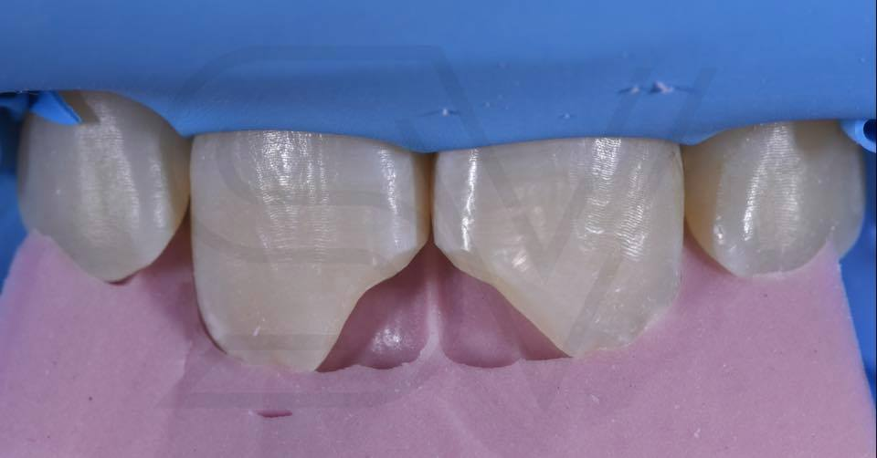

Figure-2: Intra oral view with putty template

The objective of this case report is to describe the clinical sequence for restoration of a maxillary central incisors 11 and 21 that presented a crowns fracture using an immediate insert technique for resin composite (a "free hand" technique) with a modification to obtain dentin layer.
Case Presentation
A 12-year-old boy was reported to our Paediatric Dental clinic for the treatment of fractured upper front teeth with esthetic concern. Patient gave history of trauma 6 months back due to fall from a bicycle. Clinical examination revealed Ellis class II (uncomplicated) fracture in relation to 11 and 21 Figure-1 .The tooth was asymptomatic without any associated soft or hard tissue injuries to the supporting tissues. Intraoral periapical radiograph confirms the absence of pulpal or periapical pathosis. Therefore, a direct composite restoration technique was planned for restoration of the fractured segment. Figure-2The unsupported enamel was removed via 45 degree bevel. During the intraoral examination, the fracture zone in both maxillary central incisors was classified as Class IV. In the cervical area of the facial surface, there was intact enamel beginning from the gingival margin and extending coronally 0.5mmin tooth 11 and 1.5 mm in tooth 21 Figure-3 . The patient’s oral hygiene level was scored as 0 according to an oral hygiene index,5 and the patient had a type 1 occlusion with no parafunctional movements. Both of the fractured anterior teeth were asymptomatic and responded within normal limits to cold and electric pulp tests. No periapical disease or root fracture was diagnosed during radiographic examination.
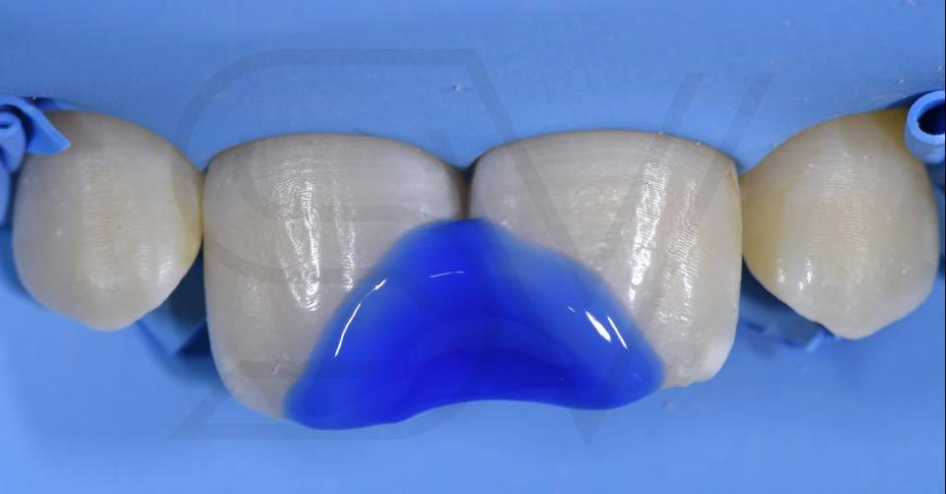

Figure 3 – Acid etching beyond the bevel.11 and 21

The treatment procedure was performed as follows: a bevel was placed on the whole facial surface, beginning from the gingival margin, to allow for a gradual increase in the thickness of the resin composite. Incisal edges and corners were rounded and the bevel was extended to a 1 mm periphery on the palatal surface. A diamond bur was utilized on the enamel surface while the dentin was cleaned with tungsten carbide burs . The remaining enamel and dentin surfaces were irregular and scalloped.
The enamel was etched with 37% phosphoric for 15 seconds and rinsed thoroughly with water. Excess water was removed with an air syringe. Figure-4
The teeth were restored using a twostep self-etch adhesive system . The primer was applied to the cavity and gently dried with an air syringe for five seconds. Figure-5
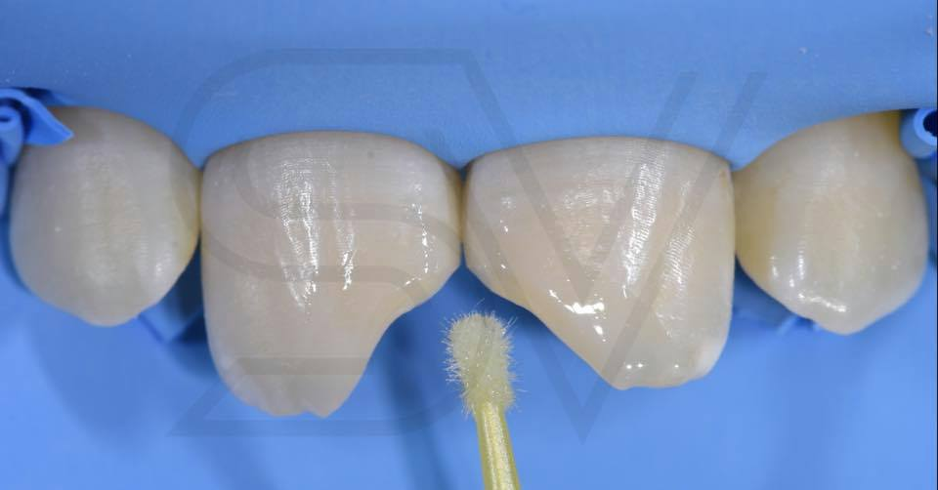

Figure 4: Bonding agents11 and 21
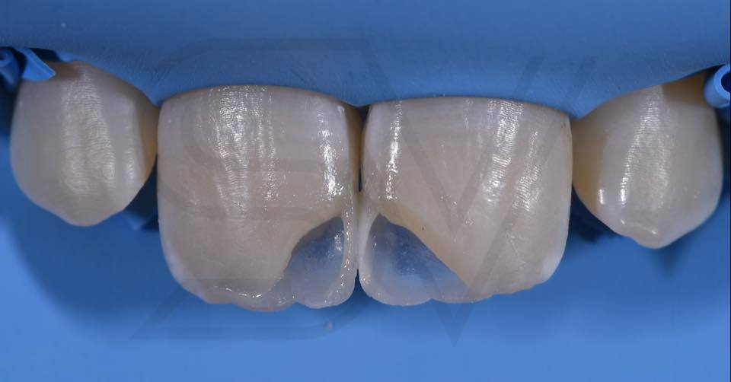
Figure 5: Incisal enamel shape was inserted11 and 21

Adhesive was then applied to the enamel and dentin and the preparation was gently air dried for five seconds, leaving a shiny surface. The adhesive was then light polymerized for 20 seconds. Figure-5
The teeth were restored with Εstelite Omega resin composite(Tokuyama dental America). Figure-6, Figure-7,
All restorations were finished and polished using an extra-fine finishing bur and rubber polishing bur. Finally, the restorations were checked for any traumatic occlusal adjustment. The follow-up visit after 11 months showed that the edges and marginal adaptation of the restoration were still good . Figure-8, Figure-9
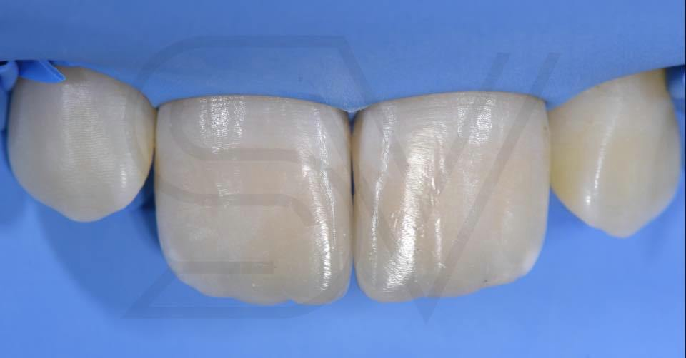
Figure 6: Final layer, Color intensifiers11 and 21

Discussion
Dental fractures consist of aesthetic emergencies that can cause physical and psychosocial discomfort
for patients [1, 9,11] and should, whenever possible, be solved in a single session. For these cases,
the restorative technique is relatively complex and requires great professional skill, so that the simplification of the techniques is highly desirable. [11,12] The immediate restoration without obtaining a dental cast for waxing-up, the beginning of the restoration should simulate the condition provided in cases where there is a pre-waxing, i.e., the construction of the palatine surface.[ 13,14, 15, 16]
This procedure must be performed with the digital technique, which the convexity of the palatine surface is simulated with the interposition of a polyester or Teflon strip or with the aid of the forefinger.[2,3,4,14]
Care must be taken during this step to maintain the correct anatomy of the palatal surface and
especially its inclination to provide the adequate space for the stratification of composite resin layers
for dentin and then enamel.[2,3] From the preparation of this surface, preferably with a more translucent or enamel resin, the restorative protocol becomes simpler, similar to a veneer that is, laminating resins with different opacities, mimicking the adjacent teeth, so that the restauration becomes indistinguishable.[4,5,6]

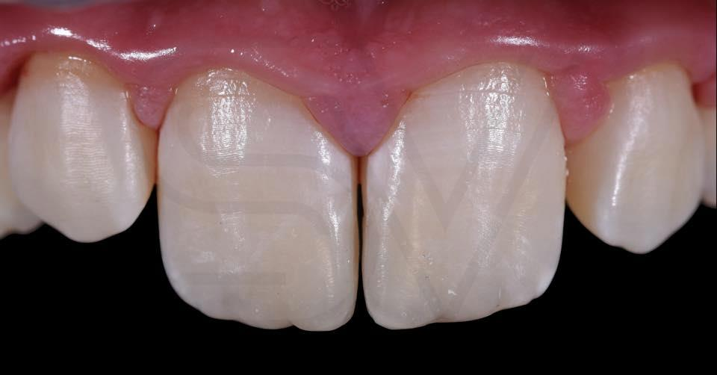
Figure 7: The restoration surfaces were polished with finishing discs

When a fracture creates a need for restoration, if there is no carious or pulpal involvement, a bevel isoften the only preparation necessary . A bevel preparation offers a well defined marginal area for ease of finishing and reduced risk of having “white lines” at the margins. [2,17]A bevel preparation also improves the etching pattern, causing transverse exposure of enamel prisms and increasing the area available for acid etching.[18] The exposure of the subsurface enamel layer is favorable to adhesion, possibly resulting in increased bond strength for the restoration and a better marginal seal. In the current case, the surface left after reduction was irregular, allowing for the restorative material to blend harmoniously with the tooth for esthetic reasons.[2,3,4] On the palatal surface, the bevel was extended no more than 1mm, as esthetic requirements are less important in this aspect and further extention has been shown to provide no additional strength. The incisal edge was wrapped palatally. The practitioner should be sure that the resin composite has enough thickness facio-palatally.[,3,19,20]
A microhybrid resin composite was selected because of having superior polishability due to a smaller particle size. A second polishing procedure was performed at the one-week recall, as most water sorption has been reported to occur during the first week. Another advantage of this procedure was to reduce chair time during the first visit.[ 2,21,22]
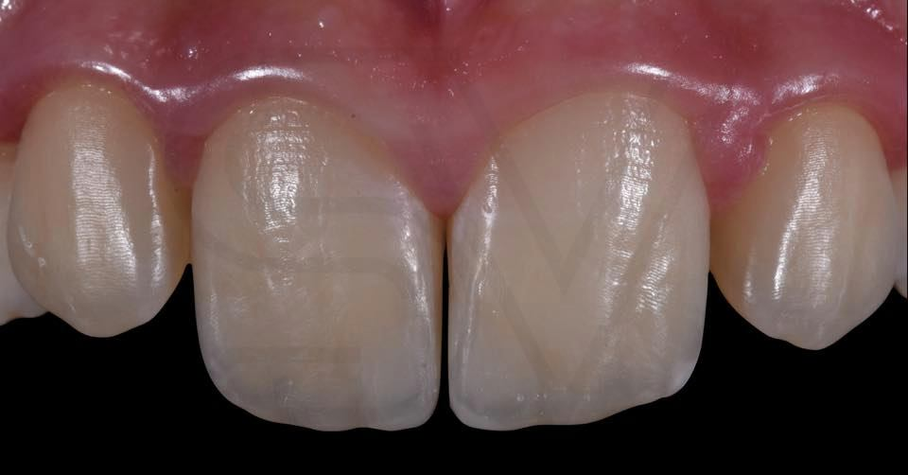

Figure 8: Final view of restoration11 and 21

The finishing and polishing process can affect many aspects of the final restoration, including surface staining, plaque accumulation and wear characteristics of the resin composite. Therefore, finishing and polishing procedures are of primary importance in terms of esthetics and clinical success of the restoration.[2,3,4,14,15] Figure-7, Figure-8
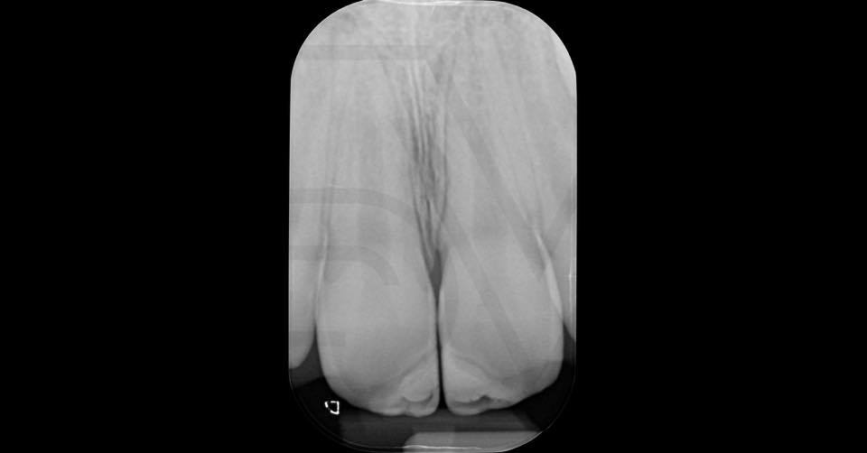
Figure 9: Post-operative periapical radiograph
In the present case, the location and aspect of the fracture combined with a balanced occlusion may have favored the clinical success .[14] Limitations of the adhesives Restoration techniques can be attributed to detachment of the restoration by a new trauma or the restoration does
not recover its original color. [15,16,23] With regard to the restorative procedure, the applied technique has facilitated the obtaining of dental contours and convexities, which would be more labored and lengthy in a direct restorative technique. [15] If handled properly, prognosis of the tooth, after traumatic crown fracture, is satisfactory .[17,24] Figure-1-8
Direct composite veneers are indicated for esthetic rehabilitation in these cases because of conservative tooth preparation and because they can be completed in single appointment, frequency of replacement or repair is less,they are strong and durable, no luting agent is required, and it is cost-effective. In addition, they have similar abrasion rates as that of natural tooth structures. [15-18] Figure-1-8
Direct restorative procedure was presented as an effective and safe alternative for oral rehabilitation. [2,3,4,15,19,21] Many factors, such as planning stage, knowledge and mastery of technique and finish and polishing materials decide the success of the restorations; monitoring and maintenance ensure the treatment longevity. [20,21] Figure-1-8
Conclusion
The composite resin restoration of permanent incisors with crown fractures is a simple procedure that should be planned and executed with attention to dental contoursand convexities, facilitating the reestablishment of function and aesthetics. Today for restorations on anterior teeth, the professional must learn the rules of aesthetics of natural teeth for the use of these materials. Treating that natural teeth are polychromatic, while composite resins are monochromatic. Given the existence of a wide variety of resins and technical possibilities, the following text proposes a clinical sequence of reconstruction of anterior teeth with compromised incisal angle due to fracture. The stratification with composite resin favors the naturalness so desired by the patient because the invisibility of the restoration is achieved, leaving the smile more harmonious and beautiful, which certainly improves self-esteem.With the evolution of adhesive dentistry, it is possible to perform aesthetic procedures with greater longevity and naturalness already mentioned.
CONFLICT OF INTEREST
The authors have no conflicts of interest to declare

References
1. Andreasen JO, Andreasen FM, Andersson L. Textbook and color atlas of traumatic injuries to the teeth. Blackwell Munksgaard 2007, chapter 8: 217-254.
2.Abu-Hussein Muhamad, et al. Anterior Esthetic Restorations Using Direct
Composite Restoration; a Case Report. Dentistry & Dent Pract J 2019, 2(1): 180008.
3. Abu-Hussein Muhamad et al.(2019), Restoring Fractured Anterior Tooth Using Direct Composite Restoration: A Case Report. Global Journal of Dental Sciences1:1
4.Abu- Hussein Muhamad Abdulgani Azzaldeen, Watted Nazer (2019) Restoring Fractured Anterior Tooth Using Direct Composite Restoration: A Case Report.Global Journal of Dental Sciences 1:1
5..Abdulgani Azzaldeen, Abdulgani Mai, Abu-Hussein Muhamad (2017) Fractured Anterior Tooth Using Direct Composite Restoration: A Case Report. IOSR Journal of Dental and Medical Sciences 16(10): 61-65
6.Abu-Hussein M, Abdulgani Az, Ziyad M, Watted N (2016) Autogenous Tooth Fragment Reattachment A 12 -Years Follow-Up. Journal of Dental and Medical Sciences 15(4): 85-90
7.Abu-Hussein Muhamad , Nezar Watted , Azzaldeen Abdulgani , Mai Abdulgani (2016) Prevalence of Traumatic Dental Injury in Arab Israeli Community. Journal of Dental and Medical Sciences 15(7): 91-98.
8.. Abu-Hussein Muhamad, Abdulgani Azzaldeen, Abdulgani Mai (2015) Step-by-Step Approaches for Anterior Direct Restorative. Int J Dent Health Sci
2(6): 1305-1310
9.Muhamad Abu-Hussein, Nezar Watted, Azzaldeen Abdulgani (2015) Gummy Smile and Optimization of Dentofacial Esthetics. Journal of Dental and Medical Sciences 14(4): 24-28.
10. Abu-Hussein Muhamad, Abdulgani Azzaldeen, Abdulgani Mai (2016) Esthetics of Class IV Restorations with Composite Resins. Journal of Dental
and Medical Sciences 15(1): 61-66.
11. Abu-Hussein M, Watted N, Abdulgani A, Abu- Shilabayeh H (2015) Anterior Dental Esthetics in Primary Teeth. International Journal of Public HealthResearch 3(1): 25-36.
12. Chan DCN, Cooley RL. Direct Anterior Restorations. In:Schwartz RS, Summitt JB, Robbins JW, editors. Fundamentals of operative dentistry. A contemporary approach. Illinois: Quintessence Publishing; 1996. p. 187–205.
13.Pontons-Melo JC, Furuse AY, Mondelli J. A direct composite resin stratification technique for restoration of the smile. Quintessence Int. 2011;42(3):205–11.
14.Maria Eduarda Barbosa Cardoso, Yan Lomba Ronchi, Idiberto José Zotarelli Filho and Taylane Soffener Berlanga de Araújo. “Direct class iv restoration: technical report”, International Journal of Development Research2020, 10, 07, 37717-37720.
15.Dietschi D, Fahl N Jr. Shading concepts and layering techniques to master direct anterior composite restorations: an update. Br Dent J. 2016;221(12):765771.do i:10.1038/sj.bdj.2016.9
16.Korkut B, Yanıkoğlu F, Günday M. Direct composite laminate veneers: three case reports. J Dent Res Dent Clin Dent Prospects, 2013;7(2):105-111.doi: 10.5681/joddd.2013.019
17.Barrantes JCR, Araujo JrE, Baratieri LN. Clinical Evaluation of Direct Composite Resin Restorations in Fractured Anterior Teeth. Odovtos-Int J Dent Sci, 2016;(16):47-62.doi: 10.15517/ijds.v0i16.20326
18,Nugrohowati CW, Hadriyanto W, Nugraheni T. Direct composite resin restoration of anterior maxillary teeth and esthetic smile design: A case report. J Dent Indones. 2020; 27(2):103-108
19.Yanikian C, Yanikian F, Sundfeld D, Lins R, Martins L. Direct Composite Resin Veneers in Nonvital Teeth: A Still Viable Alternative to Mask Dark Substrates. Oper Dent. 2019;44(4):E159-E166. doi:10.2341/18-220-T.
20.Paolone G. Direct composite restorations in anterior teeth. Managing symmetry in central incisors. Int J Esthet Dent. 2014;9(1):12-25.
21. Abu-Hussein M , Sarafianou A Abdulgani Az , Kontoes N ; The Color of Primary Teeth: A Literature ReviewInternational Journal of ProstheticDentistry.2013:4(2):70-74
22. Abu-Hussein Muhamad (2019) Reattachment of Fractured Anterior Teeth Fragments - Case Reports;Nessa J Oral Care and Dentistry2019,1,10,1-11
23. Abu-Hussein Muhamad, Watted Nezar, Abdulgani Azzaldeen. The Curve of Dental Arch in Normal Occlusion. Open Science Journal of Clinical Medicine2015. 3, 2, 47-54.
24.M. Abu-Hussein , Aspasia Sarafianou; MATHEMATICAL ANALYSIS OF DENTAL ARCH OF CHILDREN IN NORMAL OCCLUSION: A LITERATURE REVIEW. International Journal of Medical Dentistry2012,16,1,33-40

