INTERNATIONAL JOURNAL OF AGING AND REHABILITATION RESEARCH

THE HEALTH BENEFIT OF SLEEPING AND RELATED SLEEP DISORDERS.
¹H.K.Agyeman, ^{1, 2}E.O. Darko ^{1, 2} J. Owusu-Banahene, ¹B. K. Agyeman, ^{1,2}A. O. Adukpo, ¹Koffie. L.
¹Radiation Protection Institute, Ghana Atomic Energy Commission, P. O. Box LG 80, Legon-Accra.
²Graduate School of Nuclear and Allied Sciences, University of Ghana, Atomic Campus, Kwabenya-Accra.

Abstract
REM sleep occurs as blood flows through the arterial blood vessel, neuronal firing rates, and metabolism. This causes an increase in temperature in many parts of the central nervous system (CNS). However, REM sleep serves as a Homoeothermic use to produce heat in order to maintain a high, stable temperature in a restricted CNS core during sleep. REM sleep is a regulated mechanism for warming the CNS. The “selection “of the brain network appears as a result of REM sleep. Mostly, NREM and REM sleep have contributed to the overall function of sleep. There is an alternation between Non-Rem and REM sleep which contribute to the overall function of sleep. Basically, the function of sleep is to provide “recovery” after proceeding waking activities, the recovery process comes as a result of interconnected neural network. and this aid in information processing, synaptic plasticity and cellular maintenance thereby ensuring optimal functioning during subsequent wakefulness. If one of the functions of sleep is to conserve energy, then it is curious that energy is conspicuously expended in the vicinity of the central nervous system.

Keywords: Sleep Apnea, Narcolepsy, REM sleep, Non – REM sleep and Obstructive Sleep Apnea. And Insomia.

INTRODUCTION
The brain is divided into three main sections
- Cerebrum: is the largest part of the brain and is composed of right and left hemispheres.
- Cerebellum: is located under the cerebrum.
- Brainstem: acts as a relay center connecting the cerebrum and cerebellum to the spinal cord.

At night when an individual sleep, the brain moves through five various phase.
These phases are known as:
- REM Sleep
- The other four phases are known as NON – REM sleeps.
One of these stages which is known as REM sleep, which occurs when there is a rapid movement of the eye during sleeping. During this time and phase, the eyes move rapidly in various directions.
The other four phases are known as Non – REM sleep.
REM sleep occurs within the first 90 minutes when an individual falls asleep. Breathing can be fast and irregular during REM sleep. As the sleep cycle repeats throughout the night REM sleep occurs several times nightly. In adults REM sleep accounts for 20-25 % while in infants it account for 50%. It works so systematically that REM sleep is thought to help consolidate memories. People with REM sleep disorder act out of their sleep [1]. Drinking alcohol before going to bed reduces the amount of REM sleep the individual is supposed to have. Drockling confuses your body internal clock. (Circadic rhythm) so it’s hard to wake up refreshed. Lack of sleep have been linked to an increase in appetite Research have shown that lack of REM sleep can lead to lack of coping mechanisms and defensive responses in threatening situations. According to the National Sleep Foundation REM sleep have some benefits such as: Learning: Research shows that when people are unable to enter REM sleep [1]. They have difficulty remembering what they were taught before sleeping. Memory: Study shows that 4 days REM sleep deprivation affects cell profilation in the part of the brain that contributes to long-term memory Mood: Research shows it helps in the development of the Central Nervous System (CNS) that is it aid in neural stimulations
NON – REM SLEEP
Four stages are involved in Non – REM sleep. In phase 1 of Non – REM sleep: The individual falls asleep lightly. In phase2 of Non – REM sleep: The individual is in a slightly deeper sleep. While in phase 3-4 of Non – REM sleep: The individual get involve in what is called restorative sleep also known as slow wave sleep, delta sleep or a state of deep sleep[2]. There are Hormones released during Non - REM sleep. Energy are store and replenished. The muscles are relax, the supply of blood to the muscles increase. The body repairs and grows tissue. Other research on Non REM Sleep shows that the body experiences some Changes in temperature, Sexual arousal in both women and men. An increase in oxygen consumption by the brain and the brain activity is similar to that seen while awake.
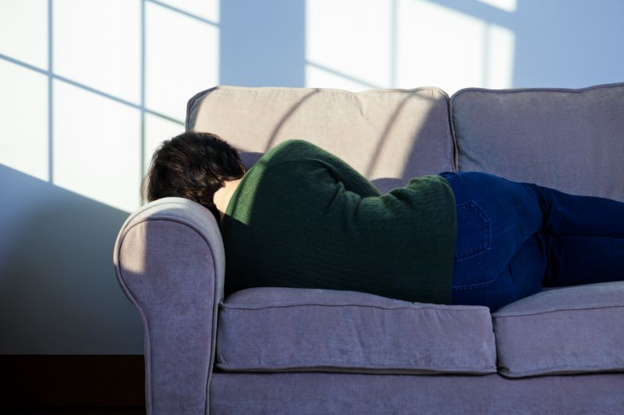
Fig 2: Picture of someone suffering from Alzheimer's disease.
Research says been sleepy during the day can cause Alzheimer Disease [3]. Other Researchers shows that Alzheimer's disease is caused by genetic factors. This contributes to degenerative brain disorder that robs people of their memory. A latest publication in the JAMA Neurology shows how some people reported day time sleeping as indicator to Alzheimer's diseases [6].
SLEEP DISORDERS
The three (3) most common types of sleep orders are named as:
- Insomnia.

- Narcolepsy.

- Sleep Apnea.
The first type Insomnia can be defined as the in ability to fall asleep or get the right amount of sleep. Insomnia can be acute or chronic, lasting for months or years.
The second type is known as Narcolepsy, this is a neurological disorder that affects a person's sleep cycle and wake cycle.
The third type which is known as Sleep Apnea occurs when there are pauses in breathing during sleeping.
THERE ARE TWO TYPES OF NARCOLEPSY
- Narcolepsy with cataplexy: occurs when people experience sudden muscle weakness and lose control of the muscles in their face, arms, legs, or torso.
- Narcolepsy without cataplexy: it has all the symptoms of narcolepsy but without muscle weakness triggered by strong emotions.
Narcolepsy is a sleep disorder characterized by excessive sleepiness, sleep paralysis or hallucinations. Narcolepsy occurs equally both in women and men. There are two main types.
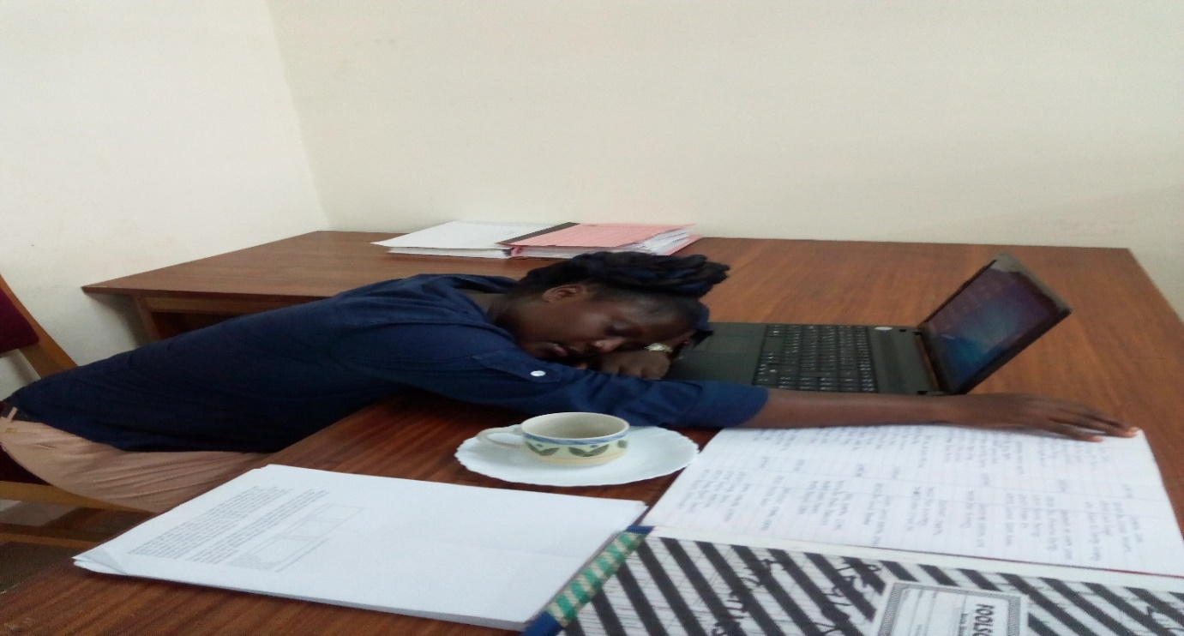
Fig 3: Picture of someone suffering from Narcolepsy sleep disorder.
SLEEP APNEA
This Occurs when there is pauses in breathing during sleeping [4]. It is a common condition in the United States and Germany. Each pause can last for a few seconds or minutes. This means that the brain and the rest of the body may not get enough oxygen.
TYPES OF SLEEP APNEA
There are three types of Sleep Apnea namely:
- Obstructive Sleep Apnea.
- Central Sleep Apnea.

- Mixed Sleep Apnea.

CHARACTERISTIC OF SLEEP APNEA
It is characterized by pauses in breathing or period of shallow breathing during sleeping [5].
The pauses may last for few seconds or minutes.
It happens many times at night (100 times).
It is followed by a loud snoring.
MECHAMISM OF SLEEP APNEA.
- When breathing is paused, carbon dioxide builds up in the bloodstream.
- Chemoreceptors in the blood stream note the high carbon dioxide levels.
- The brain is signaled to wake the person sleeping and breathe in air
- Breathing normally will restore oxygen levels and the person will fall asleep again.

DIFFERENCE BETWEEN OF OSA AND CSA
- In OSA, breathing is interrupted
- By a blockage of airflow.
- While in CSA breathing stops due to a lack of effort to breathe.
- OSA accounts for 84% and 0.4% for CSA
- 15% are for mixed.

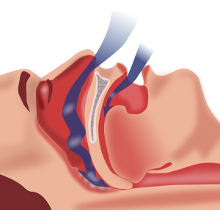
Fig 4: Picture of an Obstructive Sleep Apnea.

OBSTRUCTIVE SLEEP APNEA
It causes breathing to repeatedly stop and start during sleep. There are several types of sleep apnea, but the most common is obstructive sleep apnea. This type of apnea occurs when your throat muscles intermittently relax and block your airway during sleep. A noticeable sign of obstructive sleep apnea .
CENTRAL SLEEP APNEA
- It occurs when the brain fails to transmit signals to your breathing muscles.
- This means you make no effort to breath for a short time.
- This means the brain and the rest of the body is not getting enough oxygen.
- You find it difficult in sleeping.
MIXED SLEEP APNEA
- Is a combination of both obstructive and central sleep apnea?
- It often begins with CSA and develops into OSA.
- It is seen in infants who have abnormal control of breathing.
SLEEP RESTRICTION
- Sleep deprivation or sleep restriction is defined as not getting enough sleep or the right amount of sleep [6].
- It can lead to increased hunger and craving.
- That is the hunger hormone ghrelin is produced when there is lack of sleep.
It can lead to high intake of calorie food.
SLEEP SOLUTION
- Physicians provide sleep studies to diagnose sleep disorders such narcolepsy, sleep apnea and insomnia.
- An article was published by W. Christopher Winter in April 4, 2017 on why your sleep is broken how to fix it back[7] [8].
- The baby sleep solution: is a prove programme to teach your babies on how to sleep and it was originally published in December 5, 2006 by Suzy, Giordarro, Lisa Abidih.

BABY LULABIES
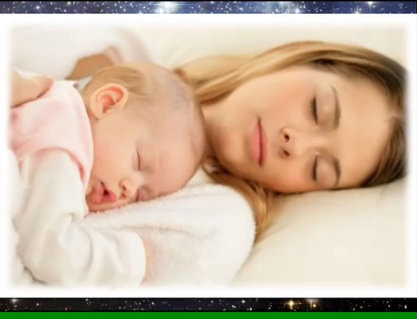
Fig 5: Picture of mother and child listening to baby lullabies.
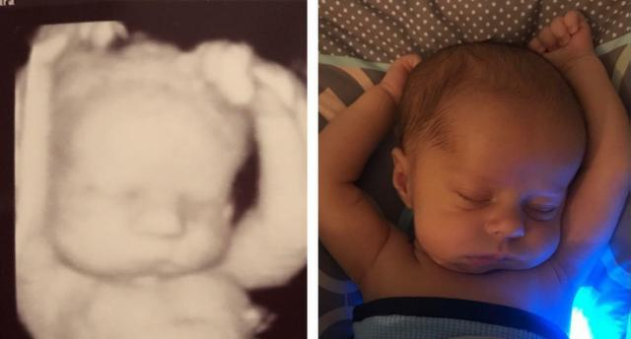
Fig 6: 3-week-old baby continues to sleep in the same position as in his ultrasound — and it's too adorable. On the left, Michael with three weeks left in his mom’s womb. On the right, he’s 3 weeks old. (Photo: reddit.com)

OTHER PREVENTIVE MEASURES

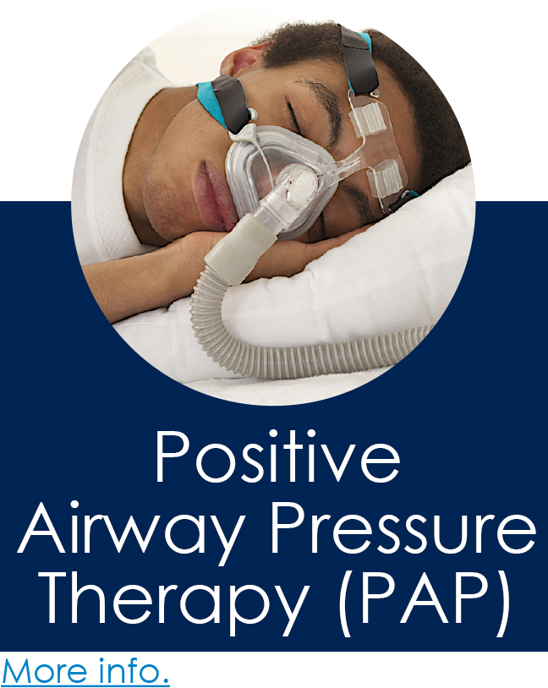
Fig 7: Picture of a Patient with a Positive Airway Pressure (PAP) Machine.
POSITIVE AIRWAY PRESSURE
Positive airway pressure (PAP) is one of the method used to treat sleep apnea. During treatment, an equipment is used to pump air under pressure via the airways of the lungs. Airway collapse is prevented by using continuous positive airway pressure to prevent blockage of airflow (breathing) in people with obstructive sleep [9].
CONTINOUS POSITIVE AIRWAY PRESSURE THERAPY (CPAP)
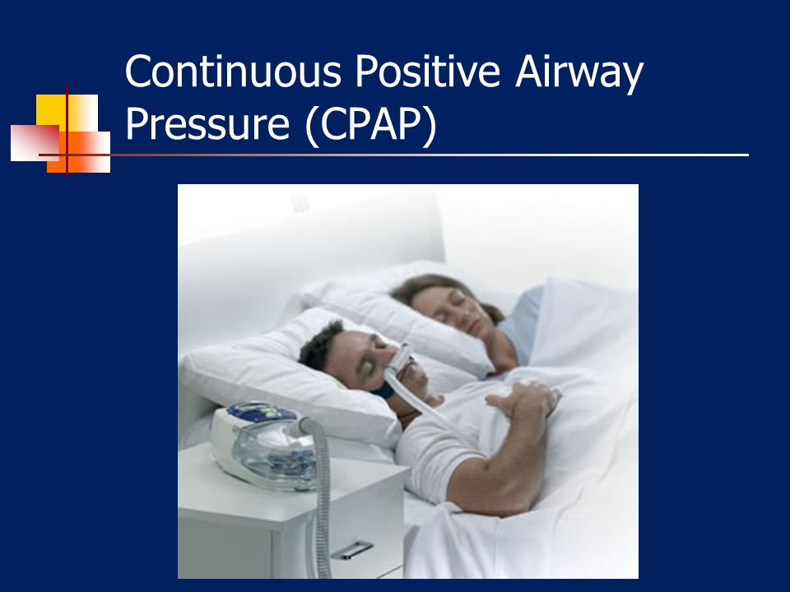
Fig 8: Picture of a Patient with a CPAP Machine.
Continuous positive airway pressure therapy (CPAP) is used to assist a person who have an obstructive sleep apnea to breath easily. The CPAP machine is used to prevent air collapse during breathing.

CHOOSE A BETTER PILLOW AND MATTRESS
- According to the Better Sleep Foundation, you should evaluate your mattress every seven years [10].
- If your mattress is not supporting you, replace it.
- If you think is time to upgrade your mattress, visit a mattress store and get the best fit for you
- Choose a pillow that can position your head in a neutral position.

WHAT IS TRENDING (TOG-ether bundle)
- TOG-ether bundle is two single duvets that is used on one bed.
- The idea behind the TOG-ether is that both people can sleep better.
- At present, the bundle is only available in UK.
- The cost of the TOG-ether is £40 or $57.
- It is now inspired by the Swedish practice of sleeping.
- It is manufactured by IKEA a Swedish furniture giant.
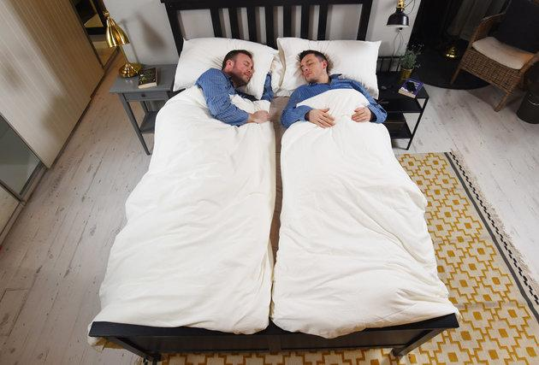
Fig 9: Picture of TOG-ether bundle.
BLANKET TENSION
- Blanket tension situation is a situation where there are few or many blankets.
- This can leave you either shivering or sweltering.
- Blanket tension must be one of the main reasons couple end up sleeping in separate rooms.
BOTTOM LINE
Get the adequate amount of sleep as recommend by the National Sleep foundation.
Consult your Doctor when you recognize any sleep disorders.
Keep the sleep environment in good conditions.
Use a sleep app call relaxation app.
Choose an appropriate pillow which keeps your neck in a neutral position, that conforms to your neck and head.
Get the right amount of sleep, this will help you start your day on a right foot and set you up for success.
For best sleeping results, make sure you combine all this factors into considerations when sleeping with a rounded diet and healthy lifestyle.

REFERENCES
[1] Agargun My, et al. (June, 1997). “Sleep Disturbances and Suicidal Behavior in Patients with Major Depression”. Journal of Clinical Psychiatry.Vol.58. No. 6, pp. 249-51.
[2] Breslau N, et al. (March 1996). “Sleep Disturbance and Psychiatric Disorders Longitudinal Epidemiological Study of young Adults “Biological Psychiatry. Vol. 39. No. 6 pp. 411-18.
[3] Charles LE, Burchfiel cm, et al. (2007). Shift work and Sleep: the Buffalo police Health Study. Policing an Int. S Police Strategies and Mgmt. Vol. 30(2) pp 215-227.
[4] Harvey AG (July 2008). “Sleep and Circadian Rhythms in Bipolar Disorder: Seeking Synchrony, Harmony and Regulation, “American Journal of Psychiatry. Vol. 165. No.7 pp 820-29.
[5] Nakata A. (2011). Work hours, sleep Sufficiency and prevalence of depression among full time employees. A community – base cross- sectional study. J Clin Psychiatry. pp 605-14.
[6] Plante DT, et al, (July 2008)” Sleep Disturbance in Bipolar Disorder: Therapeutic Implications,” American Journal of Psychiatry Vol. 165, No. 7 pp. 830-43.
[7] Ross, Jerilyn M.A et al. (2009). The Link between Anxiety and Sleep Disorders Health Central. http:// www. healthcentral. Com / anxiety/c/33722/54537/anxiety-disorder.

