Title: Comparative evaluation of effect of crude apple extract on Streptococcus mutans and Lactobacillus rhamnosus- An in vitro study
ABSTRACT
Background: Anticariogenic effect of apple polyphenols have been reported which can inhibit biofilm formation by Streptococcus mutans and Lactobacillus rhamnosus.
Aim: To evaluate and compare the effect of crude apple extract on biofilm formation of Streptococcus mutans and Lactobacillus rhamnosus to tooth surfaces, pH changes by S. mutans and L. rhamnosus in the presence of sucrose and effect on antimicrobial action.

Materials and methods: The effect of crude apple extract on the biofilm formation of S.mutans and L.rhamnosus was assessed using Tissue culture plate method by crystal violet assay. The effect of crude apple extract on pH changes caused by S.mutans and L.rhamnosus in the presence and absence of sucrose were assessed using a pH meter. Antimicrobial action of crude apple extract was measured by assessing the zone of inhibition.
Results: Crude Apple extract showed statistically significant difference on anti-biofilm formation of S.mutans and significant inhibitory action on pH drop was recorded with both S.mutans and L.rhamnosus. Significant antimicrobial activity with L.rhamnosus in the presence of crude apple extract was recorded.
Conclusion: The study concluded that crude whole apple extract has considerable anti-cariogenic effect on S.mutans and L.rhamnosus.
Key words: Adherence, Anti-biofilm formation, Crude apple extract, L.rhamnosus, pH changes, S.mutans, zone of inhibition.

INTRODUCTION
Numerous epidemiological studies showed that tooth decay is the most common affliction of mankind. Among the members of the oral bacterial flora, Streptococcus mutans which belong to streptococci of the mutans group has been confirmed to be a highly cariogenic pathogen in humans.^{[1]} Cell adhesion is considered an essential feature of microorganisms like Lactobacillus rhamnosus, as it promotes colonisation, stimulate contact between the bacterial cell membrane and the interacting surfaces and provides protection to the intestinal barrier through various mechanisms, including antagonistic activities against pathogens.^{[2,3]}

The glucosyltransferases present in S.mutans synthesize adhesive extracellular glucans from sucrose that facilitate adherence of S. mutans to the tooth surface.^{[3]} Studies show that the antioxidant and anti-inflammatory qualities of apple polyphenols have a wide range of health benefits, including protection of cells against oxidative damage that could cause cancer. Apple condensed tannins (ACT) in APP have been shown to display strong antiallergic effects such as inhibition of hyaluronidase activity and inhibition of histamine release from rat peritoneal mast cells.^{[1,3]}

Hence, the present in vitro study was carried out with the following aims and objectives:
- To evaluate the effect of crude apple extract on the adherence to tooth surface and pH changes of S.mutans.

- To evaluate the effect of crude apple extract on the adherence to tooth surface and pH changes of L.rhamnosus.

- To compare the antimicrobial effect of crude apple extract on S. mutans and L.rhamnosus.

METHODOLOGY
Source of Data
The study was performed in the Department of Pediatric and Preventive dentistry, College of Dental Sciences, Davangere in collaboration with the Department of Microbiology, Father Muller Medical College, Mangalore, Karnataka and Microbial Type Culture Collection (MTCC), Chandigarh, from where the maintained strains of Streptococcus mutans (MTCC 890) and Lactobacillus rhamnosus (MTCC 1423) was collected.

Study Subjects
Group I: Streptococcus mutans (MTCC 890)
Group II: Lactobacillus rhamnosus (MTCC 1423)

Sample Distribution
Crude apple extract | Effect on biofilm formation | Effect on pH | Antimicrobial activity
Group I  S. mutans | n = 10 | n = 10 | n = 10
Group II  Lactobacillus rhamnosus | n = 10 | n = 10 | n = 10

Study design: An in vitro study
Study duration: 1 month

METHOD OF COLLECTION OF DATA AND METHODOLOGY

Preparation of the crude apple extract
Kashmiri Apples (sourced from the local market) was transferred to the laboratory and washed thoroughly using 70% ethyl alcohol followed by distilled water, dried, and cut manually with a sterile knife into small pieces. Whole fruit extracts including the apple skin was obtained using a sterile kitchen-type juicer to obtain undiluted crude apple extract ^{[1]} (Figure 1).

Preparation of S. mutans and L.rhamnosus cultures
Standard strains of S. mutans (MTCC 890) and L. rhamnosus strain (MTCC 1423) maintained by Microbial Type Culture Collection (MTCC), Chandigarh, was used for the study.
A suspension of S. mutans was freshly prepared by inoculating the S. mutans and L.rhamnosus strain to Tryptone Soy Broth for 24 h and incubated at 37°C adjusting the turbidity to 0.5 McFarland (Group A and Group B respectively), later confirmed by MALDI-TOF.

- Determination of anti-biofilm formation of S. mutans and L. rhamnosus
Tissue culture plate method by crystal violet assay (Christensen et al) was used for biofilm detection ^{[4]} (Figure 2).
- Preparation of the growth control group (without apple extract): The strains were inoculated in Brain Heart Infusion (BHI) glucose broth and incubated anerobically at 37°C for 48hrs. Thereafter, 100µl of fresh BHI glucose broth and 50µl of culture broth (adjusted to 0.5 Mc Farland standard) were transferred to each well.^{[5]}

- Preparation of the study group (with apple extract): 50µl of BHI glucose broth was added to each well followed by 50µl of apple extract and 50µl of fresh bacterial suspension adjusted to 0.5 Mc Farland (Group A and Group B) was added to each well.^{[5]}

All the plates were sealed and incubated anaerobically for 48hrs at 37°C. After incubation, the contents of each well was removed gently and washed three times by dispensing 0.2ml Phosphate buffered saline (PBS) (pH- 7.0) along the walls of the well to remove free floating planktonic bacteria after which they were dried at 37°C for 1hr. The biofilm was fixed with 200µl of 2% sodium acetic acid (pH- 4.0) for 30mins and the plates were stained with 150µl of Huckers crystal violet (2% w/v) for 5mins. Excess dye was rinsed off thoroughly with PBS and drying them overnight. The optical density of the wells was measured at 570nm using a micro plate reader [BIORAD, USA].^{[5]}

- Determination of anti-biofilm activity: Based on the OD values, the percentage of biofilm formation was calculated using the formula as follows:
Anti-biofilm activity = $\frac{[OD growth control group -OD study group]}{OD growth control group}$ X 100, where,
OD growth control group- OD value of the biofilm formation of the organism
OD study group- OD value in the presence of apple extract.
The biofilm inhibition concentration was defined as the lowest concentration of the extract that showed 50% inhibition of biofilm formation.^{[5]}

- Effect of S. mutans and L. rhamnosus on pH
The pH changes was checked for five groups simultaneously. Each group contained the following:
Group I: Crude apple extract
Group II: Crude apple extract with S. mutans.
Group III: Crude apple extract with S.mutans and sucrose.
Group IV: Crude apple extract with L.rhamnosus.
Group V: Crude apple extract with L.rhamnosus and sucrose.
Crude apple extract was first added to all the groups. Following which, 2 ml of seed culture of S. mutans and L.rhamnosus and 1ml of sucrose (20%) was added to the respective groups. Thereafter, changes in the pH values were noted with a pH meter at baseline, 15min, 30 min and 1hr at 37°C^{[1]} (Figure 3).
- Screening of antimicrobial activity by disc diffusion
Bacterial isolates adjusted to 0.5 Mc Farland in BHI broth were streaked on the surface of supplemented Brucella Blood agar to obtain a lawn culture. Then the filter paper discs impregnated with the crude apple extract were placed on the lawn culture and the zones of inhibition corresponding to the degree of sensitivity of the antimicrobial agent was measured following 48hrs of anaerobic incubation (Figure 4). Results were interpreted in terms of the diameter of the inhibition zone described by Alves^{[6]} as: <9mm- Inactive
9-12mm- Partially active
13-18mm- Active
18mm- Very active

STATISTICAL ANALYSIS
The obtained data was entered into Microsoft excel and summary statistics were performed. The normality in data was checked using Shapiro-Wilk test. Mann-Whitney U test was used to check for the difference between the ‘with’ and ‘without’ crude apple extract sub-groups within S.mutans and L.rhamnosus groups. ANOVA and repeated measures ANOVA were used to compare the five groups for pH change (normally distributed) at each time point and different time intervals in each group respectively. A p value of <.05 was considered significant for all analyses.

RESULTS
1. Table 1 and Graph 1: Comparison of biofilm formation between S.mutans and L.rhamnosus with and without crude apple extract.
There was a significant drop in the mean value in the study group containing the crude apple extract suggesting anti-biofilm activity of crude apple extract on S.mutans and L.rhamnosus. Thus depicting a significant difference in the adherence between the two groups- with and without crude apple extract for both S.mutans and L.rhamnosus bacteria.

2. Table 2 and Graph 2: Comparison of pH changes among the five groups at each time interval.
It was observed that the pH values of all the five groups differed significantly at baseline, 15mins, 30mins and 1hr. There was a significant difference in between the groups with a significant p value of 0.000 for all the groups at baseline, 15mins, 30mins and 1hr. The pH values at baseline were significantly greater in the 2nd group than groups I, III, IV, and V. The pH values at 15 min, 30min and 1hr were significantly lesser in Group I than groups II, III, IV, and V.
3. Table 3 and Graph 3: Intra-group comparison of pH at different time intervals for the all the groups.
The pH values of Group I varied significantly at different time intervals- At baseline, 15mins, 30mins and 1hr (p=0.000) with the pH value increasing significantly from baseline to 1hr. The pH values of Group II varied significantly with a significant increase in the pH values of group II from baseline to 1hr; from 15 min to 30 min and 1hr; and from 30 min to 1hr, whereas, the pH initially dropped from baseline to 15 min, this can be attributed to the acid production by S.mutans. However, the pH increase depicts the effect of crude apple extract on the acid production by S.mutans.
The pH values of group III increased significantly at successive time intervals from baseline suggesting a decreased reduction of the sucrose substrate and decrease in acid production by S.mutans in the presence of crude apple extract.
The pH values of group IV increased significantly at successive time intervals from baseline suggesting a reduction of acid production by L.rhamnosus in the presence of the crude apple extract.
The pH values of group V increased significantly at successive time intervals from baseline. This suggests a decline in the sucrose reduction as well the acid production by L.rhamnosus in the presence of crude apple extract.

4. Comparison of antibacterial action of crude apple extract on S.mutans and L.rhamnosus
An active zone of inhibition of diameter of 14mm was observed in the presence of crude apple extract with L.rhamnosus whereas S.mutans showed an inactive zone of inhibition of 7mm.

DISCUSSION
Dental caries is one of the most common oral diseases comprising around 60-90% of the oral diseases prevalent in children and young adults. A number of surface-associated proteins such as glucosyltransferases (GTFs) (Gtf-B-C, and-D) help in adhesion and play an important role in the initiation of biofilm formation by S. mutans. Studies have revealed that S. mutans average from 20% to 40% of the cultivable flora in biofilms removed from carious lesions.^{[1,3]}

The dominant species in both adult and childhood caries include Lactobacillus rhamnosus, Lactobacillus gasseri, Lactobacillus casei, Lactobacillus salivarius, Lactobacillus plantarum, and, in lesser prevalence, Lactobacillus oris. In a study conducted by Caufield, in a survey of 38 children with severe early childhood caries (S-ECC) based on culture, it was noted that nearly 60% of L.rhamnosus was associated with severe early childhood caries (S-ECC).^{[7,8]} This formed the basis for choosing L.rhamnosus for our study.

In the previous years, multiple studies have been done to assess the antimicrobial and anti-cariogenic properties of various herbal and plant extracts. Ferrazano (2011), Masayoshi (1989) described that flavonoids in plant polyphenols have anti-cariogenic property.^{[9,10]} Parashkar (2011) showed anti-cariogenic effects against Streptococci by polyphenols from cocoa, coffee and tea.^{[11]} Anti-cariogenic active compounds of Psidium guajava and its inhibitory role on S.mutans in dental caries was explained by Bhagavathy (2018).^{[12]} Curry leaves, garlic and tea tree oil showed antimicrobial activity against S.mutans and Lactobacilli in children when used as a mouthwash according to the study performed by Prabhakar (2009).^{[13]} Shetty (2016) observed anti-cariogenic effects of hot ethanolic extract of Citrus sinensis peel followed by cold ethanolic extract.^{[3]} These findings paved way for the possibility of evaluating the effect of crude apple extract on cariogenicity in our study.

Boyer^{[14]} explained that apples contain various phytochemicals including quercetin, phloridzin and chlorogenic acid which are all strong antioxidants capable of a multitude of antimicrobial action. The amount of polyphenols in apple was described by Volstatova^{[2]} who observed greater amounts of polyphenols like catechin in apple peel more than apple pulp. Thus, it became the basis for utilizing crude apple extract for our study which comprised of both the peel and the pulp of the whole apple.

It was observed in our study that there was a significant drop in the mean value in the study group containing the crude apple extract for both S.mutans and L.rhamnosus. Thereby, suggesting the anti-biofilm activity of crude apple extract on S.mutans and L.rhamnosus. In a study conducted by Shetty et al ^{[1]}, they evaluated the effect of apple crude extract on adherence property of S. mutans. A significant decrease in the viable cell count of S. mutans was observed in the study after exposure to crude apple extract. Yanagida et al,^{[15]} demonstrated that apple polyphenols from immature apple extracts have inhibitory effect on synthesis of water-insoluble glucans by GTF of S. mutans and on the sucrose-dependent adherence of the bacterial cells. In another study conducted by Yoon et al,^{[16]} to assess the anti-cariogenic effect of unripe apple extract, it was descried that apple unripe apple polyphenols inhibited GTase activity of S.mutans 60% by 1mg/ml and 90% by 5mg/ml. As explained by Volstatova^{[2]}, catechins are one of the most important polyphenols found in apples which supports the finding by Yoon^{[16]} that inhibitory rate of catechin on GTase activity of S.mutans was found to be 62.25%, thus it was concluded in the study that unripe apple extract had anti-cariogenic effect.

Contradictory to the reduced adherence noted in our study, L. casei showed lower adhesion to the intestinal epithelial model cells than L. gasseri R in the control wells in the study conducted by Volstatova^{[2]}. According to the study conducted by Shinde^{[17]}, they examined the effects of ethanolic or aqueous apple skin polyphenol extract (ASPE) and six purified polyphenols (PPs), that is rutin, epicatechin, phlorizin, cholorogenic acid, quercetin and p-coumaric acid on the viability of probiotic bacteria (PB) Lactobacillus acidophilus in a PP-enhanced milk. Rutin and quercetin exerted the greatest and the least promotion, respectively, of both PB viability and attachment, therefore, it was concluded in the study that the use of apple skin as a source of PPs for enhancing PB functionality in dairy foods was a possibility.^{[17]}

Effect of crude apple extract on pH changes was noted for five groups using a pH meter at different time intervals. On introduction of fermentable sugar, sucrose the pH gradually reduced below the critical pH which follows the well-established Stephens curve^{[18]} which demonstrates the decrease in the pH in response to its exposure to fermentable carbohydrate. It was observed in our study that the pH values of all the five groups differed significantly at baseline, 15mins, 30mins and 1hr. Initial drop in pH at 15mins for group I. Increase in pH at 30mins for group I, II, III, IV and V. Significant increase in pH at 1hr was observed for group I, II, III, IV and V. Highest pH was noted with respect to group I at 1hr.

But it was noticed that group I, with only crude apple extract had a mean pH of 5.4910, which laid on the acidic side even after 1hr suggesting that crude apple extract alone could be acidic in nature. However, at all intervals, the pH remained always below the critical pH of 5.5 for all the groups. According to the observations by Nirmala and Subba Reddy^{[19]} it was pointed out that apple juice did not have any erosive effect on human enamel and apple was categorized as a highly cariostatic fruit due to the presence of traces of fluoride (0.41) and phosphorous (0.11). Mistry and Greenby^{[20]} tested the erosive effect of apple juice on rat’s teeth and concluded that there was no erosive effect and the pH was 5.64 which is mostly consistent with the pH obtained at 1hr in our study.

The results of our study revealed that crude whole apple extract showed inhibitory activity with S.mutans and L.rhamnosus when subjected to the agar diffusion test. A zone of inhibition of 7mm was observed for S.mutans and 12mm was observed for L.rhamnosus, suggesting active antimicrobial activity of crude apple extract on L.rhamnosus which is in par with the results obtained from the study done by Shetty et al where it was observed that S.mutans had no active anti-microbial action.^{[1]}
In a study done by Umoren et al, the synthesis of well-dispersed, single, structurally flower like silver nanoparticles was accomplished via one pot reaction involving the reduction of silver salt using aqueous extract of red apple fruit. They concluded in the study that aqueous extract of red apple fruit can be used efficiently for the synthesis of silver nanoparticles having a flower-like shape^{[21]}. Such studies reveal that incorporation of apple extracts is a possibility with a promising future.

CONCLUSION
- It was observed that S.mutans and L.rhamnosus had reduced adherence in the presence of crude apple extract.

- On comparing the antimicrobial effect of crude apple extract on S. mutans and L.rhamnosus, it was noted that L.rhamnosus had an active zone of inhibition.

Hence it can be concluded that crude apple extract had anti-cariogenic effect on both S.mutans and L.rhamnosus.

Why this paper is important to Paediatric Dentists?
Apple polyphenols can benefit Pediatric Dentistry through its incorporation by paving a way towards improved anti-cariogenic efficacy in mouthrinses, restorative materials, sealants etc.

REFERENCES

- [1] | ] Shetty V, Aswath NP, Hegde AM. Effect of crude apple extract on the cariogenic factors of Streptococcus mutans: An in vitro study. J Indian Soc Pedod Prev Dent 2018;36(2):135–41.
- Volstatova T, Marsik P, Rada V, Geigerova M, Havlik J. Effect of apple extracts and selective polyphenols on the adhesion of potential probiotic strains of Lactobacillus gasseri R and Lactobacillus casei FMP. J Funct Foods 2017;35:391–7.
- Shetty SB, Mahin-Syed-Ismail P, Varghese S, Thomas-George B, Kandathil-Thajuraj P, Baby D, et al. Antimicrobial effects of Citrus sinensis peel extracts against dental caries bacteria: An in vitro study. J Clin Exp Dent 2016;8(1):e71-7.
- Christensen GD, Simpson WA, Bisno AL, Beachey EH. Adherence of slime-producing strains of Staphylococcus epidermidis to smooth surfaces. Infection and immunity. 1982 Jul;37(1):318-26.
- Antony B, Pinto H. INTERNATIONAL JOURNAL OF SCIENTIFIC RESEARCH.
- Alves TM, Silva AF, Brandão M, Grandi TS, Smânia ED, Smânia Júnior A, Zani CL. Biological screening of Brazilian medicinal plants. Memórias do Instituto Oswaldo Cruz. 2000 Jun;95(3):367-73.
- Yang R, Argimon S, Li Y, Gu H, Zhou X, Caufield PW. 2010. Determining the genetic diversity of lactobacilli from the oral cavity. J Microbiol Methods. 82(2):163–169
- Caufield PW, Schön CN, Saraithong P, Li Y, Argimón S. Oral lactobacilli and dental caries: a model for niche adaptation in humans. Journal of dental research. 2015 Sep;94(9_suppl):110S-8S.
- Ferrazzano GF, Amato I, Ingenito A, Zarrelli A, Pinto G, Pollio A. Plant polyphenols and their anti-cariogenic properties: a review. Molecules. 2011 Feb;16(2):1486-507.
- Iio M, Uyeda M, Iwanami T, Nakagawa Y. Flavonoids as a possible preventive of dental caries. Agricultural and biological chemistry. 1984;48(8):2143-5.

- Parashar K. ANTI-CARIOGENIC EFFECTS OF POLYPHENOL PLANT PRODUCTS-A REVIEW Parashar Kshitiz. International Journal of Research in Ayurveda & Pharmacy. 2011;2(3):736-42.
- Bhagavathy S, Mahendiran C, Kanchana R. Identification of glucosyl transferase inhibitors from Psidium guajava against Streptococcus mutans in dental caries. Journal of traditional and complementary medicine. 2019 Apr 1;9(2):124-37.
- Prabhakar AR, Ahuja V, Basappa N. Effect of curry leaves, garlic and tea tree oil on Streptococcus mutans and Lactobacilli in children: A clinical and microbiological study. Pesquisa Brasileira em Odontopediatria e Clínica Integrada. 2009;9(3):259-63.
- Boyer J, Liu RH. Apple phytochemicals and their health benefits. Nutrition journal. 2004 Dec;3(1):1-5.0
- Yanagida A, Kanda T, Tanabe M, Matsudaira F, Oliveira Cordeiro JG. Inhibitory effects of apple polyphenols and related compounds on cariogenic factors of mutans streptococci. J Agric Food Chem 2000;48(11):5666–71.
- Yoon SY, Kim SH, Chung HL, Lee JJ, Huh CS, Baek YJ. Anticariogenic effects of unripe apple extract. Korean Journal of Food Science and Technology. 2000;32(1):168-73.
- Shinde TS, Brooks JD, Sun-Waterhouse D. Preparation and use of apple skin polyphenol extracts in milk: enhancement of the viability and adhesion of probioticLactobacillus acidophilus (ATCC 1643) bacteria. Int J Food Sci Technol 2015;50(6):1303–10.
- Stephan RM. Intra-Oral Hydrogen-Ion Concentrations Associated With Dental Caries Activity.
- Nirmala SV, Reddy VS. A comparative study of pH modulation and trace elements of various fruit juices on enamel erosion: An in vitro study. Journal of the Indian Society of Pedodontics and Preventive Dentistry. 2011 Sep 1;29(3):205.
- Mistry M, Greenby TH. Erosion by soft drinks of rat molar teeth assessed by digital image analysis. Caries Res 1993;27:21-5.
- Umoren SA, Obot IB, Gasem ZM. Green synthesis and characterization of silver nanoparticles using red apple (Malus domestica) fruit extract at room temperature. J Mater Environ Sci. 2014;5(3):907-14.

TABLES
Table 1: Comparison of adherence between S.mutans and L.rhamnosus with and without crude apple extract.

Main groups | Sub groups | Mean | SD | Z statistic (p value)
S mutans | Without AE | -0.1642 | .13171 | Z= -3.176
 | With AE | -0.0233 | .03084 | P = .001**
L rhamnoses | Without AE | -0.1121 | .06797 | Z= -2.873
 | With AE | -0.0601 | .16705 | P = .004**
Mann Whitney U test
* = significant
* * = highly significant
***= very highly significant

Table 2: Comparison of pH changes among the five groups at each time interval using ANOVA.
Time point | Groups | Mean | SD | F statistic (p value)
Baseline | 1 | 4.3440 | .13954 | 17.531 (.000)***
 | 2 | 4.7250 | .09583
 | 3 | 4.4110 | .11298
 | 4 | 4.4050 | .10680
 | 5 | 4.4100 | .11175
15mins | 1 | 4.2520 | .04709 | 78.646 (.000)***
 | 2 | 4.6100 | .05598
 | 3 | 4.6020 | .05181
 | 4 | 4.5890 | .06871
 | 5 | 4.6080 | .05371
30mins | 1 | 4.4130 | .13622 | 14.365 (.000)***
 | 2 | 4.7700 | .12850
 | 3 | 4.8240 | .14653
 | 4 | 4.8040 | .17852
 | 5 | 4.8260 | .14447
1hr | 1 | 5.4910 | .11010 | 6.389 (.000)***
 | 2 | 5.1430 | .25135
 | 3 | 5.4070 | .14252
 | 4 | 5.3250 | .24798
 | 5 | 5.1030 | .24833
ANOVA
* = significant
* * = highly significant
***= very highly significant

Table 3: Inter-group comparison of pH values of five groups at different time points.
Time point of comparison | Group 1 | Group 2 | Mean difference | P value
Baseline | 1 | 2 | -.38100* | 0.000***
 | 2 | 3 | .31400* | 0.000***
 |  | 4 | .32000* | 0.000***
 |  | 5 | .31500* | 0.000***
15 min | 1 | 2 | -.35800* | 0.000***
 |  | 3 | -.35000* | 0.000***
 |  | 4 | -.33700* | 0.000***
 |  | 5 | -.35600* | 0.000***
30 min | 1 | 2 | -.35700* | 0.000***
 |  | 3 | -.41100* | 0.000***
 |  | 4 | -.39100* | 0.000***
 |  | 5 | -.41300* | 0.000***
1 hr | 1 | 2 | .34800* | 0.005*
 |  | 5 | .38800* | 0.001**
 | 3 | 5 | .30400* | 0.018*
ANOVA
* = significant
* * = highly significant
***= very highly significant

GRAPHS

Graph 1: Comparison of biofilm formation by S.mutans and L.rhamnosus with and without crude apple extract.

Graph 2: Comparison of pH changes among the five groups at each time interval

Graph 3: Inter-group comparison of pH values of all groups at different time points.

FIGURES
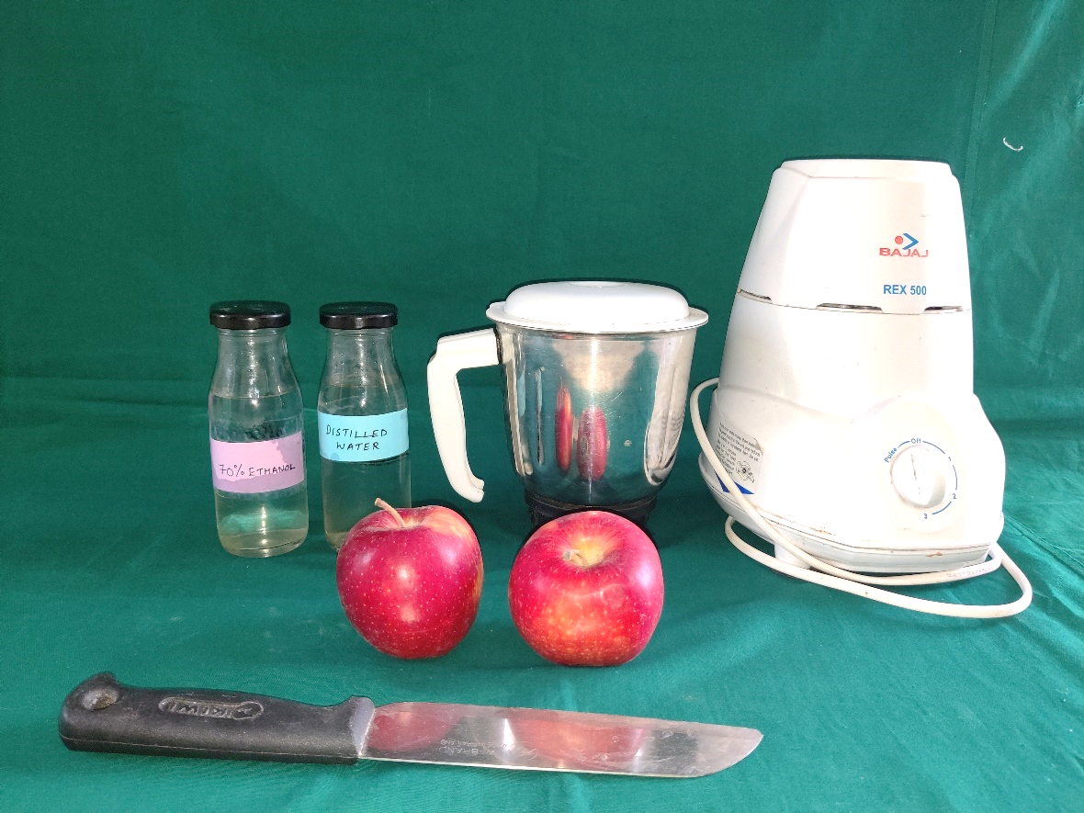
Figure 1: Armamentarium for preparation of Crude Apple extract

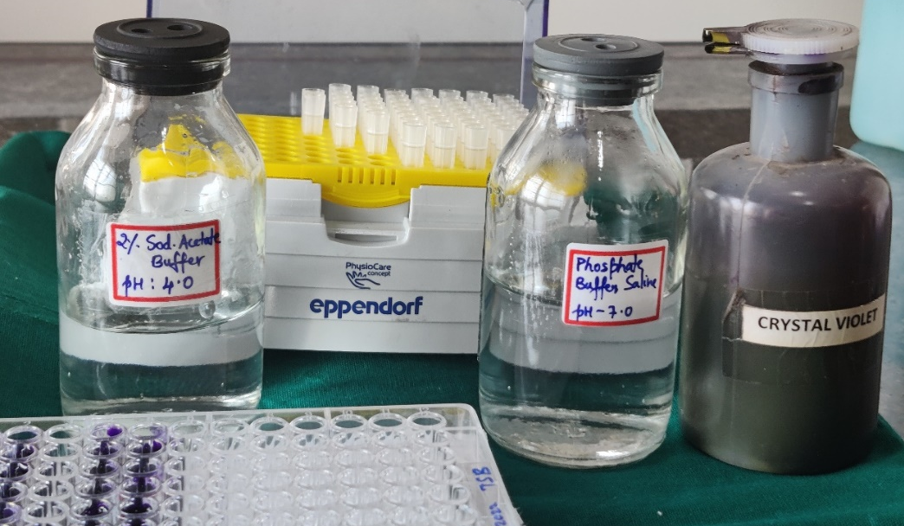
Figure 2: Armamentarium for Determination of Anti-Biofilm activity

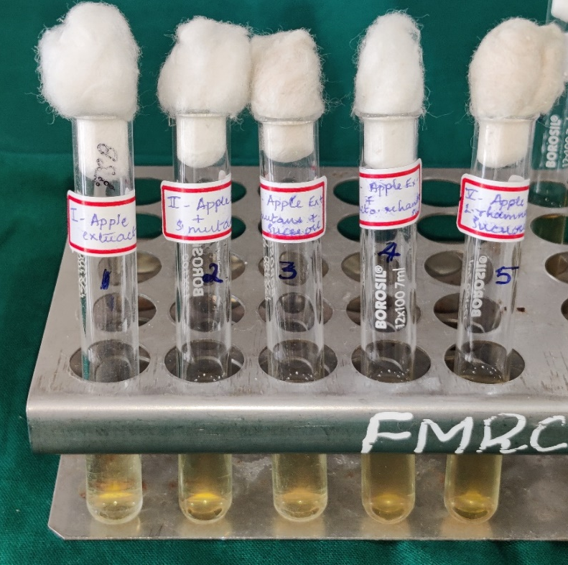

Figure 3: Armamentarium for Determination of effect on pH

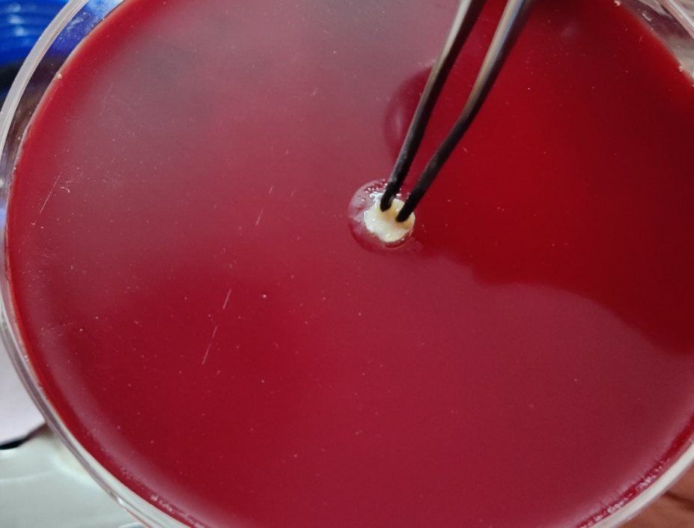
Figure 4: Screening of antimicrobial activity by disc diffusion method

